Place-based approaches for community change
QCOSS’ guide and toolkit

About QCOSS
We are QCOSS (Queensland Council of Social Service), Queensland’s peak body for the social service sector.
Our vision is to achieve equality, opportunity and wellbeing for every person, in every community.
We believe that every person in Queensland – regardless of where they come from, who they pray to, their gender, who they love, how or where they live – deserves to live a life of equality, opportunity and wellbeing.
We are a conduit for change. We bring people together to help solve the big social issues faced by people in Queensland, building strength in numbers to amplify our voice.
We’re committed to self-determination and opportunity for Aboriginal and Torres Strait Islander people.
QCOSS is part of the national network of Councils of Social Service lending support and gaining essential insight to national and other state issues.
QCOSS is supported by the vice-regal patronage of His Excellency the Honourable Paul de Jersey AC, Governor of Queensland.
Join us to mobilise a force for equality, opportunity and wellbeing. To join visit the QCOSS website (www.QCOSS.org.au).

Preferred citation: Queensland Council of Social Service, 2019. Place-based approaches for community change: QCOSS’ guide and toolkit. West End, Qld.
© 2019 Queensland Council of Social Service Ltd. This publication is copyright. Non-profit groups have permission to reproduce part of this book as long as the original meaning is retained and proper credit is given to the Queensland Council of Social Service. All other persons and organisations wanting to reproduce material from this book should obtain permission from the publishers.

Contents

_Toc25581234
Foreword 6
Acknowledgements 7
About the guide and toolkit 8
Who should use this guide and toolkit? 8
What is the purpose of this guide and toolkit? 8
Navigating the toolkit 8
Understanding place-based approaches 10
What are place-based approaches? 10
Why do we need place-based approaches? 11
How do place-based approaches generate change? 12
Supporting place-based approaches in Queensland 13
Support for place-based approaches across the Council of Social Service network in Australia 14
Features of place-based approaches 15
Agreed place 16
Shared vision and commitment to outcomes 17
Working together 19
Community engagement 21
Local collaborative governance 22
Cycle of integrated learnings 24
Continuum of place-based approaches 26
Principles of place-based approaches 31
Engaging with traditional custodians, Elders and Aboriginal and Torres Strait Islander people 32
Being citizen-led 33
Being inclusive 35
Being asset based and strengths focussed 37
Committing to place 38
Taking care to do no harm 39
Process of place-based approaches 40
1 Growing understanding of place 41
Scoping the place-based approach 42
Mapping a community 46
Initial relationship building 48
Digging into data 54
Take your time 56
2 Finding shared vision 57
Hosting conversations in place 58
Visioning 62
Identifying conditions for change 65
Committing to shared outcomes 68
3 Building a plan for change 69
Generate ideas for solutions 70
Prioritising and planning 72
Incorporating monitoring, evaluation and learning 74
4 Enabling local collaborative governance 75
Leadership structures 76
Capacity building for leadership 81
5 Enacting the plan 82
Project management 83
Maintaining momentum and engagement 83
Documenting and sharing the work 85
Reflecting and celebrating along the way 86
6 Reviewing and renewing 87
Reviewing 87
Renewing 88
Final thoughts 89
Tool - Community Mapping Checklist 93
Tool - Mapping relationships and influence 96
Tool – Starting conversations in place 97
Tool - How to facilitate a Check-in 98
Tool – Keeping meetings energising and engaging 99
Tool – Sample group processes and Terms of Reference 100
Tool – Interview vignettes 101

Foreword
Place-based approaches are important. They provide communities with the flexibility to make decisions that are in the very best interests of the people living there.
For several years now we have been working on some place-based approaches and have been able to use that experience to pull together this very valuable resource. In developing this guide and toolkit we drew on our own learnings, and tested ideas with our partners and colleagues, including in the Queensland Place-Based Community of Practice.
It brings together a wealth of information and tools to help and assist anyone interested in place-based approaches and explores in some detail the many and varied parts of approaching social change in this way. They are certainly not the only way to make social change but have been successful in working on addressing systemic barriers in many areas.
We support place-based approaches because they provide an opportunity to generate new ways of working: cross-community, cross-sector and cross-government; they promote devolved decision making and public service innovation; and they empower people in communities to be involved in their future and their communities.
Place-based approaches are an emerging method for social change. We hope this guide and toolkit will provide a framework to start a conversation around the practice of place-based approaches, and build shared understandings.
This resource has been possible because of the support of the Queensland Department of Communities and the Queensland Family and Child Commission. It is with this support that we have been able to test and learn about place-based approaches.
I hope you find something in our Place-based approaches for community change that will support you and your community on this journey.
Mark Henley
Chief Executive Officer
QCOSS

Acknowledgements
QCOSS acknowledges Aboriginal and Torres Strait Islander peoples as the original inhabitants of Australia and recognises these unique cultures as part of the cultural heritage of all Australians. We support the right to self-determination. We pay our respect to the Elders of this land; past, present and future.
This guide and toolkit was written by QCOSS.
Its development was partly funded by the Queensland Family and Child Commission as part of the Strengthening our place initiative.
Queensland Department of Communities, Disability Services and Seniors also partly funded the development of this guide to build capability and support the community and industry to actively engage in place-based approaches in Queensland.
We would like to thank the many people who provided feedback and ideas in the development of toolkit, including the Queensland and Australian Governments, people leading and evaluating place-based approaches in Queensland, citizens, community development workers, and academics.
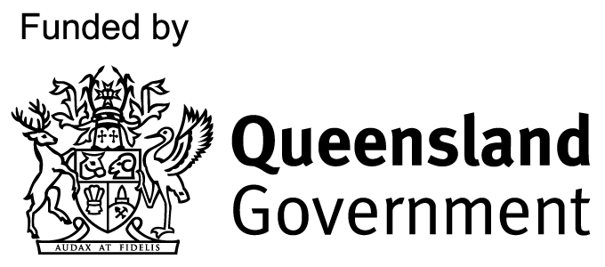

About the guide and toolkit

Who should use this guide and toolkit?
We hope that this toolkit will serve as a guide to anyone who wishes to initiate and work on a place-based approach. Place-based approaches are a team effort, and you do not need to have all the answers or be an expert facilitator, evaluator, or project manager to build a place-based movement for change in your region (although those skills can help!).
This guide and toolkit will benefit a range of people including: community members; leaders; all levels of government; non-government organisations (NGOs); community service organisations; philanthropic organisations; and businesses.
The guide is for anyone looking to work in a way that:
- focusses on the local level
- creates a shared, long-term vision and commitment to outcomes
- involves working differently together across the community
- creates governance at a local level
- embeds broad engagement with the community
- gives an opportunity to experiment, prototype, and learn through doing.

What is the purpose of this guide and toolkit?
This guide and toolkit is designed to support people working on or wanting to initiate a place-based approach. It provides some helpful tools and resources; shares how QCOSS has supported place-based approaches around Queensland; and offers some of our learnings from these experiences.
While this guide does include practical examples of how QCOSS has applied theory, and tools or samples of completed work, they are informed by our own experience, and are not intended as a ‘cookie-cutter’ approach to facilitating a place-based approach. The process outlined may not necessarily fit with the specific context of the community you are involved in, the context of your workplace, or your level of resourcing. Every place-based approach and every community is different. No one tool or framework will suit all communities.
This guide and toolkit has also been informed by a growing evidence base of others’ work and theories. Place-based approaches are an emerging practice, and the body of knowledge is rapidly evolving. This guide and toolkit is not intended to be a literature review. Rather, our aim is to provide a practical guide with, wherever possible, publicly accessible references and links.
The importance of place-based approaches being guided by sound principles cannot be over-emphasised. These same tools can be applied in harmful or helpful ways depending on the depth of the process, the level of relationship, and the level of respect and genuine intention to engage. For this reason, the principles underpinning place-based approaches have been explored in detail.

Navigating the toolkit
Throughout the guide, you will find the following headings to guide you:
Tip – this will provide a suggestion or idea to remember
Key Learning – this will provide some key learnings we have encountered while undertaking a place-based approach
Jargon Alert – this will alert you to a jargon word that may need to be further unpacked. Jargon words are special words or expressions used by a profession or group that are difficult for others to understand. We aim to minimise our use of jargon. However, where possible explanations of jargon are provided through Jargon Alerts to help people understand the terminology others may use. This is designed to ensure everyone coming to this document can easily share our understanding of place-based approaches.
Tool – an activity or checklist for use in practice
Template – a blank activity or form that can be used in practice
Sample – a sample of work or completed template
Film clip – a video of ideas and learnings tool
Case Study – this will offer a story from our work in place
Link – Links have been included as examples of projects and resources which provide useful context and further detail that you may wish to access to deepen your understanding. Links within this Guide and Toolkit direct you to various external sites. Projects and work described in many of these sites are not QCOSS projects and have not been funded by either the Queensland Family and Child Commission or the Department of Communities, Disability Services and Seniors.

Key feature – this symbol signifies a key feature of place-based approaches. These help to define what constitutes a place-based approach and create shared understandings.

Understanding place-based approaches

What are place-based approaches?
There are many ways of working in a ‘place-based’ way. Generally speaking, place-based work involves a focus on local needs, local solutions, and the unique attributes of a place. Several areas of policy and practice have adopted a place-based focus, including efforts to build neighbourhood cohesion; to improve facilities, the built environment, and economic opportunities in a region; to tailor operational structures and services to centre on regional or local perspectives; and innovative service structures that integrate or collocate services in localised areas. Community development has long held a focus on local needs and strengths and the importance and uniqueness of place.
Place-based approaches, also known as area-based initiatives or interventions, are a kind of place-based work with a long history of innovation in Australia and overseas. Place-based approaches are collaborative endeavours which seek to create systemic change by bringing together efforts across the community to work towards shared long-term outcomes. Place-based approaches have been used to address community need by harnessing the vision, resources and opportunities of community.
Department of Communities, Disability Services and Seniors (Queensland Government) have adopted the following definition:
“Place-based approaches are collaborative, long-term approaches to build thriving communities delivered in a defined geographic location. This approach is ideally characterised by partnering and shared design, shared stewardship, and shared accountability for outcomes and impacts. Place-based approaches are often used to respond to complex, interrelated or challenging issues—such as to address social issues impacting those experiencing, or at risk of, disadvantage, or for natural disasters.”

Link: Framework for Place-Based Approaches, Department of Communities, Disability Services and Seniors
https://www.communities.qld.gov.au/industry-partners/place-based-approaches
Place-based approaches tend to have the following features:
- a focus on the local level
- a shared, long-term vision and commitment to outcomes
- working differently together across the community
- governance at a local level
- broad engagement with the community
- experimentation, prototyping, and action learning.
Place-based approaches can range from small, locally resourced efforts, through to large actions involving multiple levels of government, business and community sectors. Place-based collective impact initiatives are one kind of place-based approaches at the more intensive end of a continuum. We explore the continuum on our website: https://www.qcoss.org.au/contents-page-for-place-based-approach-and-toolkit/continuum-of-place-based-approaches/.

Why do we need place-based approaches?
Place-based approaches are one way of working in place that empowers the broader community to collaborate and respond to their own unique challenges through locally tailored systems. Place-based approaches foster strong community partnerships, place-based planning and action, and flexible systems and responses. They employ systems thinking, which create opportunities for novel, collaborative efforts cross-community, cross-sector and cross-governments. They seek to embed devolved decision-making and support public service innovation, and enable civic empowerment, participation and discourse in communities where citizens may be despondent and disengaged.

A place-focus provides a helpful lens for looking at and interpreting systemic issues and creating locally-led solutions. Places are unique in their strengths and the barriers they face. For example, the experience of living in a mining town differs to that of people in remote Aboriginal communities, which differs again from the experience of young people in a regional area.
In some communities, people experience much higher levels of disadvantage. The Dropping of the Edge Report found that the experience of disadvantage tends to concentrate in a small number of locations, and that such disadvantage tends to persist over time. People living in locations of concentrated disadvantage tend to experience challenges that are generally interrelated and often become intergenerational.
Places have unique physical, historical, cultural, social and environmental characteristics, which can support or deter communities from achieving their vision for a better life. For example, some locations have lower employment opportunities, lower quality, quantity and diversity of education, housing, health services, a lack of affordable essential services, and a lack of infrastructure or support for community safety, public transport, and recreation. Some communities experience higher levels of disconnection, exclusion and isolation, and lower levels of civic participation. A place-based approach to working can support a whole of government, cross-sector and whole-of-community commitment to improve experiences for people living in these places.
Historically, place-based approaches have sought to overcome complex systemic issues, also known as ‘wicked problems’, affecting people on the margins. While well-intentioned, current structures do not always meet peoples’ needs. They may even contribute to deepening social exclusion and disadvantage and limit the ability of communities to respond to and resolve complex social issues and create change. Existing systems may entrench issues through:
- investment in solutions that do not address systemic issues
- lack of community input, empowerment and leadership
- fragmentation, siloing, duplication and lack of coordination of services
- short-time horizons for projects and initiatives
- lack of focus on prevention
- rigid grant conditions limiting flexibility or innovation
- constantly reinventing the wheel instead of drawing on learnings.
Systemic issues require a response that extends beyond more service provision. For example, in Hopevale, Queensland, 78 different services were provided by 46 different service providers through 44 different funding programs across 22 Queensland government departments to a population of 1,125 people. Despite a high level of service provision, people in Hopevale are still experiencing high levels of disadvantage.
While place-based approaches have traditionally focussed on complex systemic barriers, they also have the capacity to inspire change around a variety of themes, not just disadvantage and complexity. As a particular framework for place-based working, a place-based approach can provide communities with an opportunity to work together to achieve outcomes in a range of areas.

How do place-based approaches generate change?
Place-based approaches can bring about meaningful change in communities, through:
- identifying systemic and place-related causes of social issues
- developing a shared vision
- promoting social inclusion and overcoming social division
- ensuring government policy, systems, programs and services are driven by the aspirations and needs of the local community and environment
- increasing motivation for change
- generating diverse and innovative solutions and alternative ways of thinking and working
- embedding evidence-based, outcomes-focussed approaches and a cycle of learning to monitor impacts
- maximising mix and distribution of resources available in community
- building leadership, capacity and resilience in the community
- developing integration across the service sector
- building partnerships and integrated responses across levels of government and between government and community
- involving industry in influencing social impacts, and creating suitable or value-based work in the community.
The impact of place-based approaches can be difficult to measure because community change is a complex process. Population-level outcomes from systemic approaches can take time to emerge and may be difficult to attribute to any one process. Place-based approaches can be resource intensive and require sustained motivation and investment from multiple stakeholders to be successful.

Nevertheless, place-based approaches in Australian and overseas have demonstrated impacts on community, sector and government dynamics (process) and a range social and health outcomes (impact). These effects depend on the focus of the initiative and include some evidence for improvements over time in social inclusion and cohesion, civic participation, multisector working, physical and mental health, education, employment, and housing.
Factors that contribute to the success of place-based approaches include having a clear rationale for working in place; a systemic analysis of issues and levers for community change; long time-frames and lead times; and broad collaborative working across the community, coupled with a recognition of the barriers to joined-up working.
Film clip: #3 Strengthening our place vignette - #3 - What have been some opportunities? https://youtu.be/bUXpzPo7FRE

Supporting place-based approaches in Queensland
QCOSS is the Queensland state-wide peak body for individuals and organisations working in the social and community service sector and a voice for people experiencing poverty and disadvantage. By working with communities during the last 60 years, QCOSS has drawn upon a range of strategies and tools to empower communities, build better service systems, and promote social inclusion and citizen governance.
QCOSS supports locally led change in communities and supports place-based approaches through partnering with organisations in the region to form part of a ‘container for change’. Our approach is to build on existing strengths in a community and support the development of local leadership that can progress the work.
We are physically based in Brisbane and our approach is inherently shaped by our perspective as an organisation and as workers that are often external to the regions we work in. We acknowledge there are both benefits and disadvantages from being external to regions outside Brisbane.
Some of place-based approaches QCOSS has supported include:
- 2016 - 2019 – Strengthening our place [https://www.qcoss.org.au/project/strengthening-our-place/] – Alongside the Queensland Family and Child Commission (QFCC) and in-community partners, QCOSS supported people in Capricornia and Fraser Coast to achieve their vision of ‘Working together so all children can reach their full potential.’ Over nearly four years, this initiative has supported community identification of priorities, assisted in establishing local devolved governance structures, and built local leadership capacity.
- 2016 - 2018 – Bringing the NDIS to Life – Townsville [https://www.qcoss.org.au/story/changing-lives-changing-communities/] – In 2016, more than 100 Townsville community members created a shared vision at the Changing Lives, Changing Communities event around what it would take for the implementation of the NDIS to support Townsville to become a truly inclusive community. A Leadership Group was established to drive initiatives through a range of projects designed to “probe the system”, and additional large community meetings were held in 2017 and 2018 to review and renew progress, with many projects being implemented from the ideas generated.
- 2014 - 2015 – Home for Good [https://www.qcoss.org.au/project/home-for-good/]– QCOSS partnered with the QLD Government and 17 communities across Qld to conduct Registry Weeks to to understand the experience of homelessness, which included identifying each person and family experiencing homelessness in their community. The most vulnerable were then prioritised for urgent assistance in housing and ongoing support. The coalition worked with the community to build relationships, used data to inform practice, and established new ways of working and systems which continue to develop. The collaborative impact approach used included a common assessment tool and was based on the successful 500 Lives 500 Homes project led by Micah Projects in Brisbane.
- 2010 – 2014 – Homelessness Planning and Coordination Initiative [https://www.qcoss.org.au/project/homelessness-planning-and-coordination-initiative/] – This initiative was funded through the National Partnership Agreement on Homelessness and delivered in partnership by the Queensland Government and QCOSS. Fourteen locally-based coordinators (including seven QCOSS workers embedded in the community sector, and seven Queensland Government coordinators) worked in seven Queensland communities experiencing high rates of homelessness. They brought together local stakeholders to develop and implement Homeless Community Action Plans (HCAPs) centered on working collaboratively to drive change across the sector and government, and delivering positive outcomes for people experiencing or at risk of homelessness.
QCOSS has also supported a number of initiatives building community readiness for place-based approaches, through undertaking collective visioning, building citizen-led and place-based leadership, and prototyping collaborative projects:
- 2018 – 2019 Changing Lives, Changing Communities and the Community Champions [https://www.qcoss.org.au/project/changing-lives-changing-communities/] – these initiatives in 14 communities across Queensland bring together people to create communities where “everyone contributes, matters and belongs”. The Changing Lives, Changing Communities and Local Champions project has supported communities to identify priorities, seeded a range of community projects, and is developing citizen leadership in communities.
- 2017 – Live Well Hervey Bay - Ngala Gambay (Butchulla for We All Together) was initiated to build local capacity to support healthy ageing in Hervey Bay. Supported by the Queensland Mental Health Commission (QMHC), this project unearthed local challenges to mental health including loss of connection across generations and to culture.
In partnership with the Queensland Government, QCOSS is bringing together leaders and practitioners around Queensland to support and enable place-based approaches. Some of these initiatives include:
- Thriving Communities Roundtables – 2018 [https://www.qcoss.org.au/publication/creating-thriving-communities-in-queensland-roundtable/]- Together with Minister O’Rourke, Minister for Communities, Disability Services and Seniors, we brought people together from across Queensland to discuss the potential of place-based approaches to help build thriving communities throughout the state.
- Movement for Change, 2018 QCOSS State Conference - focussed on changing the stories we tell about ourselves and our communities to change lives. Recognising that this is done best at a community level, QCOSS made a commitment to take the concepts of the conference to regional Queensland. These conversations have continued throughout Queensland as part of the Changing Lives, Changing Communities events.
- The Queensland Place-Based Community of Practice [https://www.qcoss.org.au/our-work/place-based-approaches/queensland-place-based-community-of-practice/] was launched in November 2018. It has been established to strengthen and consolidate Queensland’s place-based knowledge-base, to generate new ideas, promote learning and peer-support among practitioners working on or interested in place-based approaches, and build relationships and promote collaboration across Queensland.
Given our unique position in Queensland, QCOSS has articulated our role in place-based approaches through our Place-Based Action Plan. The plan articulates four roles:
- Doing – working directly with communities to support place-based approaches and civic leadership
- Learning – building Queensland’s collective knowledge base relating to place-based approaches
- Changing – facilitating systems development and changes which better support place-based approaches across Queensland
- Leading – bringing together key influencers to plan, collaborate and enable place-based approaches across Queensland.

Support for place-based approaches across the Council of Social Service network in Australia
QCOSS joins our colleagues in the Council of Social Service (COSS) network in supporting place-based approaches, embedding greater citizen-led participatory processes, and advocating for local collaborative governance across Australia.
Link: Emerging voices project by Tasmanian Council of Social Service (TASCOSS) http://www.tascosslibrary.org.au/node/79/
Link: ‘Unleashing the power of communities’ by the Victorian Council of Social Service (VCOSS) https://vcoss.org.au/analysis/unleashing-the-power-of-communities-a-social-innovation-fund-for-place-based-initiatives/

Link: ‘Engagement in place-based co-design’ by the West Australian Council of Social Service (WACOSS) http://wacoss.org.au/wp-content/uploads/2017/07/Tool-11-Engagement-in-Place-Based-Co-Design-1.pdf

Features of place-based approaches
Defining a place-based approach can be challenging because in one sense, any work that occurs in place could be described as ‘place-based’. However, there are several features that QCOSS believes are critical components of a place-based approach, namely:
- agreed place
- shared vision and commitment to outcomes
- working together
- community engagement
- local collaborative governance
- a cycle of integrated learnings
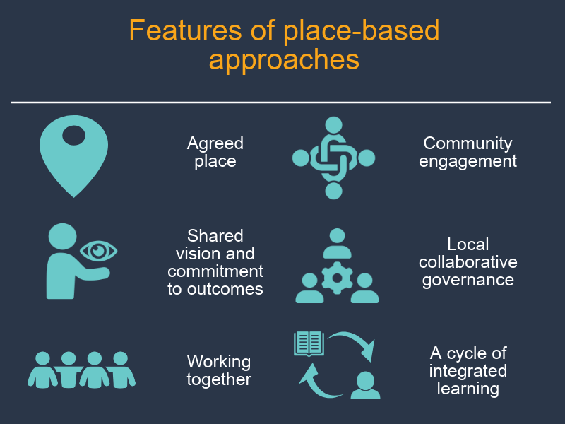

Agreed place
The first feature of a place-based approach is that a sense of place is embedded in the work and shared amongst participants. Place-based work, and place-based approaches in particular, are inherently spatially and geographically bound and embed localism in the ways of working and governing.
Place is more than just the physical or geographical forms of an area. Tuan (1977) argued that places were essentially "centres of meaning constructed out of lived experience". People are attached to place; build memories and identities in place; and are shaped and affected by the natural and built environment around them. In the Australian context, understandings of the importance of place are strongly influenced by Aboriginal and Torres Strait Islander knowledge around connection to ‘country’, the interdependence and reciprocal relationship between the land and the people. This is reinforced by the isolation of, and distance between, many communities in Australia.

Recent reflections on place have shifted to thinking not just about place, but community-in-place. This perspective acknowledges that within place there may be multiple experiences of place and multiple communities within place, rather than one cohesive place-based community. Generally, place-based approaches focus on localised areas, rather than large regions or entire states.
Defining and agreeing upon place can be less straightforward than it looks. Some understandings of place are influenced by government boundaries or defined regions, while local perspectives may differ about where actual suburban or regional identities begin and end. In many instances it may not be necessary to be as proscriptive as to draw lines on a map, but to explore and build shared understandings of a generalised and shared understanding of community in place. The decision to work in place, and the decisions and criteria that define the boundaries of place, should be clear and transparent.
Key features: Place-based approaches have…
… a focus on place and community-in-place
Link: Connection to country https://www.commonground.org.au/learn/connection-to-country
Link: Project for Public Spaces, “What is Placemaking”: https://www.pps.org/article/what-is-placemaking

Shared vision and commitment to outcomes
Place-based approaches involve bringing key stakeholders and community members together to establish a collective vision for the future, and to commit to changing to achieve that vision. It also involves creating accountability through committing to shared outcomes or impacts. This requires a shared understanding about the systemic causes of social issues, and agreement around the need for change and the future direction needed.
Shared vision is essential to place-based approaches. Focussing on a future vision galvanises people around a central goal and sustains motivation. It builds collective efficacy and supports collaborative action by bringing disparate parties together around a superordinate goal. Place-based approaches also tend to have a long-term view of change and rely on community energy and urgency for change. The emphasis on shared purpose and collective change ensures a continued focus on improving conditions in the community and avoids fragmented efforts that may have little impact in the long run.
Shared outcomes help us to make a vision tangible. Outcomes we are working towards can include; population-level outcomes– the change people wish to see in their community; as well as process outcomes - such as changes in service delivery data, collaboration, trust, and shared governance. It can be helpful to have specific, measurable outcomes indicators – that is, some way to operationalise your outcome and measure progress towards the outcome. Some of the more complex place-based approaches track progress towards outcomes through shared measurement systems, often involving standardised ways of gathering, recording and analysing service data and reporting – although shared measurement is not necessary for a place-based approach, and can be resource intensive to establish. More on this in committing to shared outcomes.
Effecting change at the population level can be hard, and often takes a long time to achieve. It is important to have a process and designated time-points to track progress of different activities contributing to the initiative – more on this in a cycle of Integrated learnings.
Key features
Place-based approaches have…
- a shared vision for change
- a long-term view of change
- energy and urgency for change
- a collective commitment to generating change for the community
- shared outcomes
- shared understanding of the issues.
Jargon alert: A stakeholder is someone who might have an interest in how a place-based approach develops or the issues it seeks to address. In a place-based approach, stakeholders include anyone who the initiative might affect – community members, government representatives, industry and businesses, services and community groups, sporting, parent and peer support groups, and so on. Stakeholders in a community might also wear multiple hats. For example, they might be a business owner, a mother and the president of their sporting club. Everyone is a community member, first and foremost, regardless of positions they hold.

Jargon Alert: In research language, when we operationalise an outcome, we find a way of measuring something that may be hard to measure. For example, we may have a vision for everyone to feel secure in their home. We may therefore commit to achieving a specific outcome of improving housing stability in your are. We may then operationalise this into an outcomes indicator such as an increase in the number of dwellings reported as fully owned. In this way, we can measure the outcome and track progress towards the vision.

Jargon Alert: Shared measurement systems require diverse organisations to employ the same techniques for gathering, analysing and reporting data. All project members agree to measure particular activities and outcomes through standardised ways of recording services or outcomes. This can involve establishing new data collection systems such as a shared databases, and sharing data regularly or in live-time with other project members.
Link: Paper ‘Shared Measurement: The Why is Clear, the How Continues to Develop’ by Mark Cabaj (2017) https://www.tamarackcommunity.ca/library/shared-measurement-paper
Jargon Alert: Collective efficacy refers to a group or community’s belief or confidence in their own ability to succeed.

Jargon Alert: A superordinate goal is a term from psychology for goals that are big enough and compelling enough for individual parties to overlook differences and work together in pursuing them.

Jargon alert: Collective impact is a collaborative approach to addressing complex social problems in communities. According to Kania and Kramer (2011), collective impact requires stakeholders from across sectors to work together towards a common agenda and to use a shared measurement system to remain aligned. It includes stakeholders engaging in mutually reinforcing activities and engaging in continuous communication. Finally, it includes establishing a backbone support or container for change - a separate organisation or group of organisations and staff with a very specific set of skills to drive collaboration across the initiative.
Link: Article – Collective Impact by John Kania and Mark Kramer https://ssir.org/articles/entry/collective_impact

Link: Article – Collective Impact 3.0 by Liz Weaver and Mark Cabaj https://www.tamarackcommunity.ca/library/collective-impact-3.0-an-evolving-framework-for-community-change
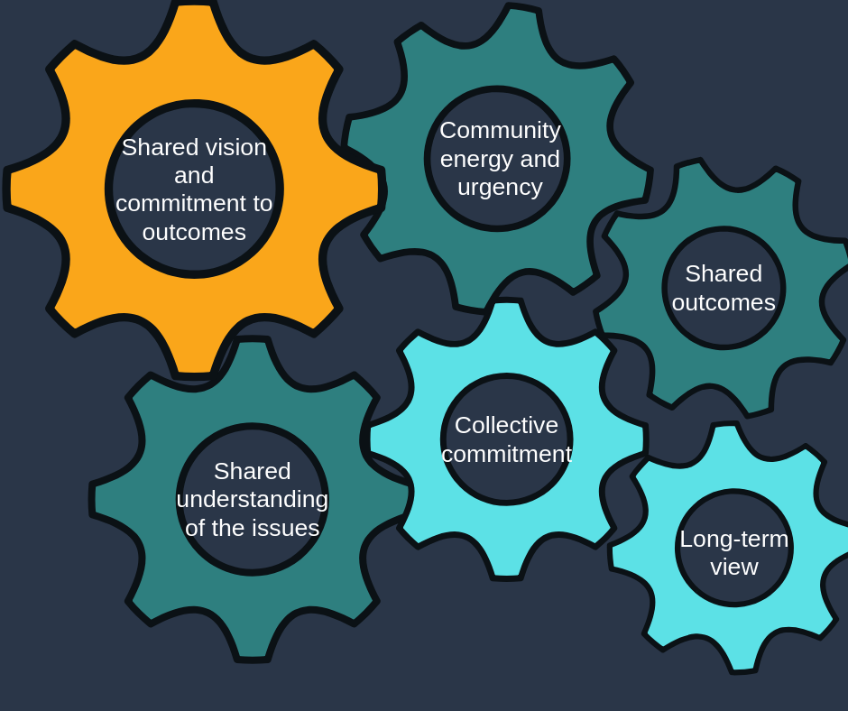
Figure 1 a diagram of how all the features of place-based approaches work together

Working together
Place-based approaches involve a commitment to working together to achieve a shared vision. By nature, place-based approaches are collaborative, bringing together skills, assets and resources across the community. They often involve community members, the community sector, industry, universities, all levels of government and different government departments all working together in new and different ways. A collaborative approach is essential to overcome fragmentation, siloing, duplication and lack of coordination in existing systems, as well as identify where new or different resources may need to be invested.
Place-based approaches go beyond networking or service integration within a sector. They involve thinking outside the box about who might not ordinarily be involved in responding to a particular social issue, but still has a role to play - for example, businesses, recreational groups, or traditionally unrelated government departments. In this way, place-based approaches require both working together and working differently.
The extent of working together will depend on the place-based approach. Across a continuum of place-based approaches, working together might involve increased collaboration between parties and agreeing to apply separate resources to achieve a shared vision. It might not be necessary to tightly collaborate on individual activities – people may have different ways of reaching the same goal.
At higher levels of complexity, working together is more likely to involve systemic changes, such as a highly planned approach, the sharing and pooling of resources across sectors, and reforming service systems to be more supportive and integrated across sectors. More complex place-based approaches will generally require governments to work cross-portfolio, to collaborate between different levels of government, and to work in partnership with the community and private sectors and citizens. At its highest level, it might involve changes to commissioning such as pooling of government investments across different levels of government or across government portfolios, although this high level of collaboration has not yet been trailed in Australia (see also the place-based feature of Local collaborative governance)
Key features

Place-based approaches…
- include thinking innovatively about who contributes to generating social change
- include a commitment to working together across community, governments, industry and universities.
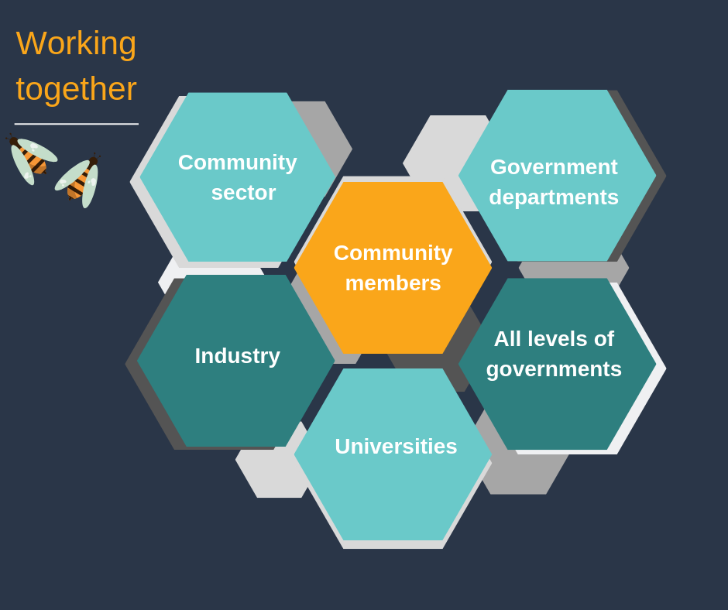
Jargon alert: Commissioning
Commissioning is a cycle through which services are planned, developed, resourced and delivered based on need, and evaluated to inform delivery.
Link: Commissioning engagement cycle https://www.england.nhs.uk/participation/resources/commissioning-engagement-cycle/
Link: Framework for Place-Based Approaches, Department of Communities, Disability Services and Seniors
https://www.communities.qld.gov.au/industry-partners/place-based-approaches

Community engagement
In our experience, genuine community engagement is a fundamental and essential feature of an effective place-based approach. Through genuine engagement of the public, systems and programs are more likely to respond to community needs and therefore be more effective. Furthermore, partnering with community members builds social inclusion, self-efficacy and civic empowerment.
Without community engagement, there is likely to be little buy-in from those working in place, or from the people the initiative is designed to support. Failing to properly engage people with a lived experience and citizens in place is also a lost opportunity to harness the assets and strengths of those most affected by policies and programs. Indeed, practitioners in collective impact approaches have reflected that a key shortcoming in past projects has been a failure to genuinely engage with intended beneficiaries of initiatives.
Finally, but most importantly, it is the right of citizens to be engaged in initiatives, policies and systems that affect them. When undertaking community engagement, QCOSS draws upon our Principles of place-based approaches, including engaging in the first instance with Traditional Custodians, being citizen-led, inclusive, assets based, being committed to place and aiming to do no harm.
In our experience, genuine community engagement starts early and takes a long time. Always, always longer than you think! It involves building relationships, building capacity, and leveraging off existing strengths. The level of community engagement undertaken will depend on the scope and resources of the place-based approach. It is essential to factor time and resources into your planning to enable meaningful engagement.
When undertaking community engagement, it is important to remember that community members may have wide-ranging barriers to participation and may struggle to be involved in standard, formalised processes. They may require resourcing to join in, and their level of participation is likely to vary over time. Ongoing systemic barriers can prevent participation, and understandably individuals can have limited time for long-winded processes. They will often come to systems and engagement processes with a specific issue they need solved. It is important to determine clear roles to community members to sustain their engagement and offer opportunities for community members to work on parts of the system that are important to them. We call this “going with the energy”.
It is also essential to partner with different organisations in community who may be led by community members and/or have strong relationships with the community they serve.
Key features: Place-based approaches have…
Genuine engagement with the broader community, including local people, groups and community-based organisations
Link: Putting Community in Collective Impact by Rich Harwood www.ssireview.org/blog/entry/putting_community_in_collective_impact
Link: Community Engagement Matters Now More than Ever by Paul Schmitz and Melody Barnes https://ssir.org/articles/entry/community_engagement_matters_now_more_than_ever
Link: Paper: Community engagement: A key strategy for improving outcomes for Australian families by Child Family Community Australia https://aifs.gov.au/cfca/sites/default/files/cfca39-community-engagement.pdf
Link: Article: ‘Most public engagement is worse than worthless’ by Ruben Anderson https://www.strongtowns.org/journal/most-public-engagement-is-worse-than-worthless

Local collaborative governance
Another key feature of a place-based approach is the emphasis on local decision-making, and the development of citizen-led collaborative governance mechanisms. Drawing on the principle of being citizen-led, local people take the lead in the collaborative governance of a place-based approach. An emphasis on localism invites a different kind of power - where centralised power is “impersonal, uniform, abstract, rule-oriented”, decentralised local power is “personalistic, relational, affectionate, irregular and based on a shared history of reciprocity and trust.” This requires some level of devolution of authority and responsibility to locally based and highly engaged leaders, and leadership capacity building of people in community.
Where community engagement empowers citizens to have a say, local governance ensures that regionally-based leaders and concerned community members are engaged in the actual decision-making processes. This embeds local knowledge in systems, ensuring they are tailored and responsive to the people they effect. It increases community buy-in, thereby securing a mandate for change, building a community-wide movement for change, and creating local ownership of initiatives. It builds capability, leadership and resilience in communities, restores community confidence in processes, and helps to overcome public disillusionment.
The Governance Models for Location Based Initiatives report (2011) by the Australian Social Inclusion Board recommended a community governance mechanism, comprising of representatives for diverse interests across the community. This includes citizens, not-for-profits, business (particularly major employers), all levels of government, philanthropy and special interest groups. They also recommended, “a level of devolution that allows significant and meaningful local involvement in determining issues and solutions, [and] capacity building at both local level and in government, without which greater community engagement or devolution of responsibility will be impossible.”
The Australian Social Inclusion Board also noted one of the barriers to successful place-based approaches is an inability of governments to coordinate effort across portfolios, jurisdictions, and levels of government. They recommended improved mechanisms for coordinating government efforts, such as a coordinating role across levels of government, location-based coordination teams across governments and agencies, or even co-location of different levels of government and government agencies. They also recommended devolvement of responsibility for spending and decision-making to senior public servants located in place. There is a movement in public policy towards greater local decision-making, and even major restructuring of commissioning processes (such as pooling of government investments).
In our experience, where possible, governance structures should include representatives from institutions with multiple levels of influence. Systemic change is complex, and regardless of what theme or type of issue you are hoping to address, the issues and solutions will almost always span across many parts of the system. It is useful to recognise the supporting roles and responsibilities of existing democratic decision-making structures that manage public resources and establish rules. This may include Ministers or Departmental staff, Mayors or Council delegates; and also those who are leaders in other governance and government structures, such as community and industry boards, Commissioners, and Native Title holders.
It should also include citizens with a broad a range of experiences. Public participation in decision-making and governance processes exists on a spectrum, from informing citizens or consulting them, through to collaborating with them in decision-making, or at the highest level, empowering them to make decisions themselves. A place-based approach should aim to involve as high a level of citizen participation as possible.
When involving citizens, it is important to remember the purpose of citizen involvement is not to make citizens responsible for problems they didn’t create. Instead, involvement empowers them to hold a central role in developing solutions to issues that affect them. It is also important to remember that the same barriers for participating in community engagement activities apply to inclusive governance activities.
At its simplest, place-based approaches should involve governance structures with representation from government, services and the community. At its most complex, place-based approaches might involve a Cross-sector Leadership Table with devolved responsibility to manage major localised system reform, planning for the region, pooled resources and joint commissioning.
Key features: Place-based approaches have…
Collaborative, local governance structures with multiple levels of influence and strong community representation
Jargon alert: Governance can be defined as the structures, processes and relationships that determine how a group of people organises itself and makes decisions. In a practical sense, the umbrella of governance might include the rules that need to be followed in a situation or process, and how they are enforced. These rules might include information about who make decisions about activities and resources (including money) and manages risks; and the processes they use to get input that guides their decisions – such as talking to people, calling meetings, and conducting surveys and research. Good governance ensures a place-based approach stays on track, makes it clear who is authorised to make decisions and manage risks associated with them. It also ensures those making decisions have good ways of involving relevant opinions.

Collaborative governance includes stakeholders who are representative of the beneficiaries of the work you are doing together, and is consensus based rather than managerial or authoritative. Setting up and maintaining collaborative governance in a place requires some participatory processes. QCOSS has been using and refining participatory processes for a long time and have several resources to assist this part of your practice. See Facilitate conversations in Finding shared vision for more information.
Link: Article - 'Collaborative Governance in Theory and Practice' Ansell, Chris &, Alison Gash (2008). (Ansell, 2008) https://sites.duke.edu/niou/files/2011/05/Ansell-and-Gash-Collaborative-Governance-in-Theory-and-Practice.pdf

Link: People Power: Summary Report by Locality https://locality.org.uk/wp-content/uploads/2018/03/LOCALITY-LOCALISM-REPORT-1.pdf
Film Clip: Strengthening our place Vignette - #8 - What steps could government take? https://youtu.be/HyenEc4H31E

Cycle of integrated learnings
The final feature of place-based approaches is that they involve a cycle of iterative, integrated learnings. This is underpinned by a strong focus on evidence-based practice, and a commitment to constantly reviewing the approach to ensure it is effective, flexible and adapted to the needs of place. This way of working on a place-based approach based on a body of work called Action Learning or Action Research.
Place-based approaches are used to help address the most complex and entrenched challenges for which the solutions are unknown and where current activities and services have been unable to shift the dial. In the context of the Cynefin framework, this is a place of complexity – where there are no right answers but where you can start to see patterns of success emerge through undertaking small scale projects that probe the system and are “safe to fail”. In this environment continuous monitoring and learning is critical to ensure you continue to make progress
Evaluating the effectiveness of place-based approaches is challenging because, by nature, connections between people and changes in systems are hard to measure. Resourcing can come and go, and structures and processes may change over time. It may take a long time before any major changes are visible.
Developmental evaluation is one method that can be helpful in evaluating impact where changes are needed in complex systems. It involves testing, experimenting and prototyping activities, and monitoring processes and progress right from the beginning of an intervention.
While population level outcomes are seen many years after you begin, close monitoring and continuous learning and research throughout the life of an initiative is important to ensure that the model is fully effective. There is a whole body of work emerging around seeing that a place-based approach is on course. Place-based approaches can track early and emerging trends, such as outcomes for smaller groups of people in a community, or changes in leadership, resourcing, practices, norms and policies. Those who are resourcing the work either with their effort and energy, or finances, will also want to know that the initiative is on the right track.
Data plays an important role in place-based approaches. It can help to identify and understand specific community needs and opportunities, and can unpack where experiences might be unique to smaller regions or specific groups in a community. Data can also help to measure whether and where progress is being made. It is also important to look for opportunities to understand what is happening in a community and measure changes through qualitative measures – listening for the stories of people in place.
At their simplest, this feature of place-based approaches involves taking an evidence-based approach to designing interventions, reviewing activities throughout the process and being prepared to adapt to the local environment, and evaluating outcomes at the end of an agreed time. At their most complex, place-based approaches involve ongoing monitoring, evaluation and learning, prototyping and reviewing, with agreed mechanisms to track progress and agreed measures for population-level impacts of an initiative. They may even include shared measurement of data across services.
Place-based approaches have…
… a commitment to being informed by data, research and story
… evaluation across processes, activities and long-term outcomes
… a cycle of continuous learning and points of reflection embedded throughout the practice.
Jargon Alert: Developmental evaluation is an approach that acknowledges many things can lead to social change in complex systems and calls for innovation and iteration in developing initiatives for social change. The role of the evaluation is to monitor and record the process of innovation.

Jargon Alert: Cynefin, pronounced kuh-nev-in, is a Welsh word that signifies the multiple factors in our environment and our experience that influence us in ways we can never understand. The cyefin framework is used to aid decision-making by sorting issues into five situational contexts.
Link: Cynefin Framework Introduction by Dave Snowden http://cognitive-edge.com/videos/cynefin-framework-introduction/

Link: A Developmental Evaluation Primer - Jamie A.A. Gamble: https://cdn2.hubspot.net/hubfs/316071/Resources/Publications/Developmental%20Evaluation%20Primer.pdf?t=1542902059328z
Link: Evaluating social innovation https://www.fsg.org/publications/evaluating-social-innovation#download-area
Link: Action research and action learning for community and organisational change by Bob Dick http://www.aral.com.au/
Link: Presentation - Implementing shared measurement https://www.fsg.org/tools-and-resources/implementing-shared-measurement
Link: Paper ‘Shared Measurement: The Why is Clear, the How Continues to Develop’ by Mark Cabaj (2017) https://www.tamarackcommunity.ca/library/shared-measurement-paper

Continuum of place-based approaches
Place-based approaches can exist on a continuum, from small, low intensity approaches with a specific focus, through to high level integrated place-based collective impact initiatives. Place-based approaches range in terms of the scope of the focus of the approach, the level of complexity of the issues they seek to address, the breadth of stakeholders involved, and the length of time and resourcing required. However, the features and principles of place-based approaches should be included at all levels.
The below continuum provides examples of where a place-based approach might sit on each feature at varying levels of intensity. It should be noted that different features of a place-based approach might develop at different times. For example, an approach may have reached a high level of agreement around shared vision and have secured commitment to change, yet there may still be work needed to develop local governance structures that are truly collaborative and representative.
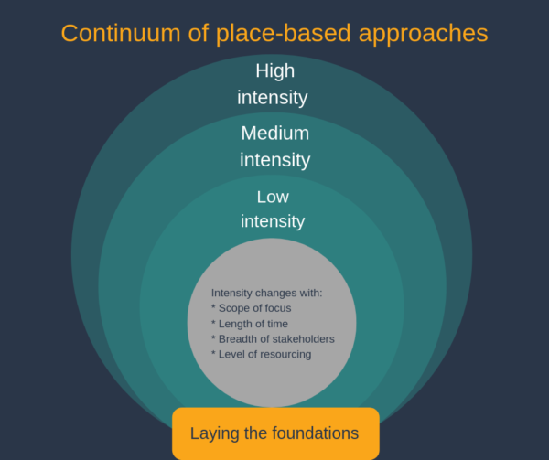

Features of place-based approaches | Laying the foundations | Low intensity place-based approach | Medium intensity place-based approach | High intensity place-based approach
Focus | Focus can be on one or multiple factors, depending on the level of complexity of potential future place-based approaches. This forms part of the building understanding of place. | Focus is often on one specific social need or contributing factor (e.g. mainstream disability inclusion). | Focus may be on one or two contributing factors to systemic disadvantage (e.g. education and parenting). | Focus is across many contributing factors to systemic disadvantage including education, housing, employment, health, as well as cultural and systematic inequality and disadvantage.  Although focus is broad, the approach is sometimes targeted at one part of the life span (e.g. early childhood development).
Level of resourcing | Light | Moderate | Heavy | Intensive
Agreed place | Occurs in a geographically bound location and involves a focus on local needs, local solutions, and the unique attributes of a place. | Occurs in a geographically bound location and involves a focus on local needs, local solutions, and the unique attributes of a place, and systemic level factors impacting uniquely on place. | Occurs in a geographically bound location and involves a focus on local needs, local solutions, the unique attributes of a place, and systemic level factors impacting uniquely on place. | Occurs in a geographically bound location and involves a focus on local needs, local solutions, the unique attributes of a place, and systemic level factors impacting uniquely on place.
Shared vision and commitment to change | A specific group come together to identify a specific social need or contributing factor and agree to work together to create change. | Select stakeholders from some sections of the community, government and/or industry come together to find common ground, create a shared vision for the future, and commit to changing to achieve a shared outcome. | Stakeholders broadly from across community, government and industry come together to find common ground, create a shared vision for the future, and commit to changing to achieve a shared outcome. | A large group of stakeholders from across extensive areas of community, government and industry work across sectors to find common ground, create a shared vision for the future, and commit to changing to achieve a shared outcome.
Working together | Working amongst a specific group of stakeholders to create shared understandings and new connections.  Light planning associated with specific actions arising from community priorities. | Increased collaboration between select stakeholders from across select parts of the community, government and/or industry.  Development of a combined action plan which may outline shared vision, shared outcomes, governance mechanisms, and projects that contribute to achieve the vision.  Working together includes identifying overlap with organisational role and purpose and community priorities, and allocating existing resources to achieving shared vision. | Stakeholders broadly from across community, government and industry work together to identify key community challenges and responses.  Development of combined action plan which outlines shared vision, shared outcomes, governance mechanisms, and projects that contribute to achieve the vision. May also identify targets and measurements, and evaluation approaches.  Working together may include sharing resources or reforming services and partnerships to better match community priorities and achieve shared vision. | A large group of stakeholders from across multiple sectors, cross-community and cross-government collaborate and work differently.  Development of one community action plan outlining shared vision, shared outcomes, governance mechanisms, projects that contribute to achieve the vision, targets and measurements, and evaluation approaches. Action plan also often includes joint, standardised reporting or even shared measurement, and may include resourcing for a structure to support collaboration, such as a backbone support or container for change.  Working together may involve pooling of resources or restructuring or reforming systems to better match community priorities and achieve shared vision.
Community engagement | Engagement that may be time-limited and involve consultation or involvement only .  E.g. Town hall style meetings.  Local media. Information through local community service networks. | Engagement that may be time-limited but involves some degree of involvement of and collaboration with the public²³.  E.g. Two-day forums.  Focus groups.  Local media. Information through local community service networks. | Engagement is ongoing and includes involving, collaborating with and empowering the public²³. E.g. Workshops and multi-day forums.  Focus groups.  One-on-one meetings.  Local media. Information through local community service networks. | Once established, the backbone support is responsible for implementation of a broad and deep engagement strategy that seeks to include deeply excluded members of the community and those with lived experience, as well as business, government and the community sector.  Engagement is ongoing and includes involving, collaborating with and empowering the public²³.
Local collaborative governance | Establishment of local structure for the duration of the initiative such as a local working group.  Terms of Reference or MOU used to outline stakeholder roles and responsibilities.  No change in service commissioning process. | Establishment of a local structure to support coordination, such as a local working group.  Terms of Reference or MOU used to outline stakeholder roles and responsibilities.  No change in service commissioning process. | Establishment of a local structure to support collaboration, such as a local leadership group and associated working groups.  Terms of Reference or MOU used to outline stakeholder roles and responsibilities.  Potential review and restructure of the commissioning of services. Dependent on agreement between government and community sector. | Establish a backbone support or container for change, and establish a governance structure to support the container for change, such as a  Cross Sector Leadership Table and a range of working groups.  Formal roles and responsibilities agreed between government, community sector and community stakeholders.  May be aspirationally moving towards joint commissioning of services.
Cycle of integrated learnings | Initial use of data to highlight specific issues relevant to the local community. Evaluation of value of building shared understandings and connections. | Use of data to identify and understand specific issues relevant to the local community. A cycle of learning and innovation to prototype new ways of working. Evaluation of value of place-based approach. | High ongoing use and analysis of data to identify and understand specific community needs and opportunities, and likely to be aiming for shared population-level outcomes, while tracking early and emerging trends. A cycle of learning and innovation to prototype new ways of working. Evaluation of value of place-based approach. | Ongoing use, interrogation and sense making of data to identify and understand specific community needs and opportunities, and evaluate progress towards outcomes and inform planning; shared measurement of indicators for activity and population-level outcomes are common, as well as tracking of early and emerging trends. A cycle of learning and innovation to prototype new ways of working. Evaluation of value of place-based approach.
Timeframe (approx.) | 12 months | 12 months - 2 years  (potentially ongoing) | 12 months – 3 years  (potentially ongoing) | 10 years +
Current Project Examples | Changing Lives, Changing Communities forums.  Townsville NDIS Disability Project. | QFCC – Capricornia.  QFCC - Hervey Bay. | Every Child Central Queensland.  Cairns South Collective Impact. | Logan Together (Qld)  Hands Up Mallee (Vic)  Go Goldfields (WA)  The scale of the above Collective Impact project examples varies significantly.  The commonalities reside in the key features, structure and purpose.

Jargon alert: Backbone supports or containers for change are key structures in collective impact initiatives. They facilitate the process of building shared vision and implementing shared plans. A backbone organisation might be an independent organisation with dedicated resources to support a place-based or collective impact initiative, whereas backbone support and containers for change might include roles embedded within other organisations, or where various functions of the backbone support move between people and organisations at different times.
Link: Article – Collective Impact by John Kania and Mark Kramer https://ssir.org/articles/entry/collective_impact
Link: Article – Collective Impact 3.0 by Liz Weaver and Mark Cabaj https://www.tamarackcommunity.ca/library/collective-impact-3.0-an-evolving-framework-for-community-change
Link: Article – Understanding the value of backbone organizations in collective impact by Shiloh Turner, Kathy Merchant, John Kania & Ellen Martin https://ssir.org/articles/entry/understanding_the_value_of_backbone_organizations_in_collective_impact_2

Principles of place-based approaches
The key principles we draw upon when working on place-based approaches are:
- engaging with traditional custodians, Elders and Aboriginal and Torres Strait Islander people
- being citizen-led
- being inclusive
- being asset based and strengths focussed
- committing to place
- taking care to do no harm

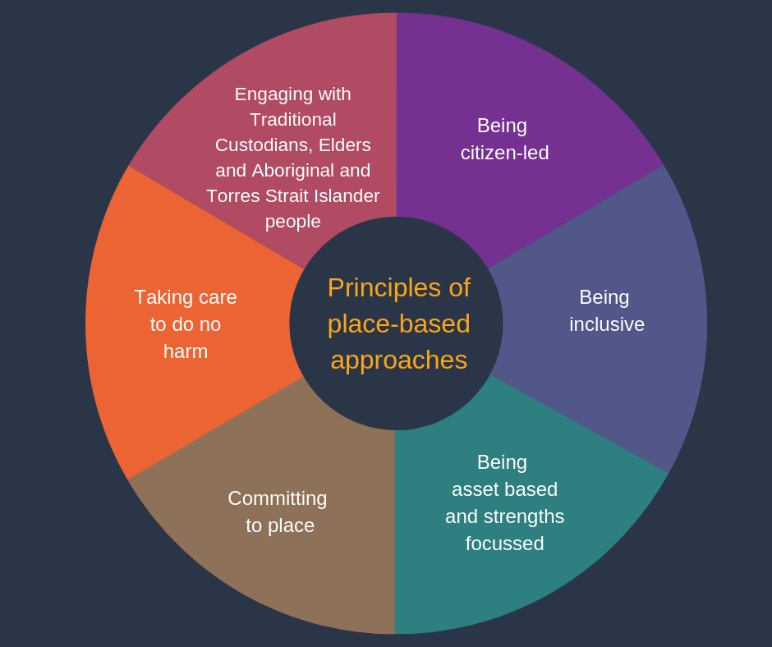

Engaging with traditional custodians, Elders and Aboriginal and Torres Strait Islander people
QCOSS recognises the Traditional Custodians of country on whose land we work and their continuing connection to land, sea and community. We are committed to walking alongside Aboriginal and Torres Strait Islander peoples in a journey to build stronger relationships, understanding and recognition of the history, cultures and diversity that make up Australia's First Nations peoples. QCOSS endorses the Uluru Statement from the Heart, which calls on the Australian Government to:
- establish a First Nations Voice enshrined in the Constitution, and;
- establish a Makarrata Commission to supervise a process of agreement-making between governments and First Nations and truth-telling about Indigenous history.
Collaborating with Traditional Owners and Elders of the place is a key aspect of working in the Australian context. Aboriginal and Torres Strait Islander perspectives and knowledge are marginalised and ignored in mainstream Australia, which is unacceptable given their unique status as First Nations people of Australia. Furthermore, while their communities have many strengths in their Indigenous knowledge, cultural heritage, and deep understandings of place, country, family and community in Australia, they are often over-represented in the social disadvantages and inequity that place-based approaches seek to address. It is for these reasons that partnering with Traditional Custodians, Elders and Aboriginal and Torres Strait Islander people is essential when developing place-based approaches.
Link: Uluru Statement from the Heart https://www.referendumcouncil.org.au/final-report#toc-anchor-ulurustatement-from-the-heart

Link: Uluru Statement: A quick guide https://www.aph.gov.au/About_Parliament/Parliamentary_Departments/Parliamentary_Library/pubs/rp/rp1617/Quick_Guides/UluruStatement

Link: Queensland Productivity Commission, Service Delivery in Queensland’s Remote and discrete Indigenous Communities https://www.qpc.qld.gov.au/inquiries/service-delivery-in-queenslands-remote-and-discrete-indigenous-communities/
Case study: Relationships with Traditional Custodians in place, part of the Strengthening our place project (Capricornia) https://www.qcoss.org.au/publication/place-based-in-capricornia-a-case-study-on-relationships-with-tradition-custodians-in-place/

Case study: How the Butchulla people are re-visioning an ancient rite of passage, part of the Strengthening our place project (Fraser Coast) https://www.qcoss.org.au/publication/place-based-in-fraser-coast-a-case-study-how-the-butchulla-people-are-re-visioning-an-ancient-rite-of-passage/

Being citizen-led
Citizen and/or community led processes and outcomes are fundamental to place-based approaches. This principle is shaped from learnings around participatory and deliberative democracy. Being citizen-led is essential to creating positive community change because:
- people have the right to inform, influence and challenge the systems and policies that impact their lives
- community-led responses lead to better outcomes. People are the experts in their own lives, including knowing what adversely affects them and how things could be improved. Solutions generated locally are relevant to the people, context and community
- working alongside people to create the community they want builds personal and community agency and capacity that supports long-term change.
By citizens, we mean all people who live in our community regardless of formal immigration or citizenship status. We define it broadly, in the sense of social citizenship, wherein all people in a community have an intrinsic right to full civic participation, empowerment, and belonging.
Citizen-led principles seek to rebalance power around how decisions are made in a place, demand that there transparency and a mandate from citizens for decision-making. This requires working with, not in or for, communities, building relationships with the people who live and work in the place, and allowing them to step into leadership. Rather than framing community members as service users or clients, this approach considers all people (whether a service user, service provider, or leaders) as members of the community actively working to improve the community, each contributing their skills, knowledge, and relative access to resources and power. It draws on the theories of pluralistic leadership, in which there can be many leaders at different times and in different ways, or servant-leadership, where leaders prioritise the movement and citizens they represent.
When building citizen-led structures and processes, QCOSS also draws on learnings from participatory leadership and the Art of Hosting. This framework provides tools for powerful conversations and asserts that people do and will give their energy and lend their resources to what matters most to them; in work as in life. Participatory leadership offers processes that invite people to step in and step up to take charge of the challenges which face them.
Jargon alert: Participatory and deliberative democracy encourages more involved forms of citizen participation in political systems and processes. Rather than simply voting for a representative and leaving decision-making to them, participatory democracy is about involving and empowering citizens to engage in decision-making and governance processes.

Jargon alert: Pluralistic leadership is the idea that everybody has the capacity to lead at different times and in different ways. No-one has a monopoly on leadership, regardless of background, education or formal title – instead, as Paul Schmitz said, ”everybody leads.” Leadership is a quality that people take on at different times when part of a movement for change.
Link: Pluralistic Leadership https://ssir.org/book_reviews/entry/pluralistic_leadership
Link: Book: Everybody Leads, by Paul Schmitz
Jargon alert: A servant-leader focuses primarily on the growth and well-being of people and the communities to which they belong. While traditional leadership generally involves the accumulation and exercise of power by one at the ‘top of the pyramid,’ the servant-leader shares power, puts the needs of others first and helps people develop and perform as highly as possible.
Link: What is Servant Leadership by the Greenleaf Center for Servant Leadership https://www.greenleaf.org/what-is-servant-leadership/
Jargon alert: Participatory leadership and the Art of Hosting is a framework for facilitating and hosting conversations that encourages equal participation in processes and creating opportunities for open and meaningful dialogue. The tools and processes invite people to step in and take charge of the challenges facing them, therefore making them ideal tools for facilitating place-based approaches. It supports people to work together and design new ways of working to achieve outcomes.
Link: What is Art of Hosting http://www.artofhosting.org/what-is-aoh/

Link: New Democracy Australia https://www.newdemocracy.com.au/

Being inclusive
A core principle underpinning work on a place-based approach is being socially inclusive and valuing the lived experience of people. This principle is closely related to being citizen-led, and requires an awareness of privilege, power and exclusion.
Social exclusion occurs where, “people, families or groups are somehow shut out of, or become remote or disengaged from, normal participation in some or all of the economic, social, cultural, civic and political activities and relationships available to a majority of people in a society of which they are part, [resulting] in a loss of status, power, self-esteem and future expectations”. Social inclusion is defined as the opportunity for people to learn, work, connect with others and have a voice.
Being socially inclusive is the act of bringing those who are excluded back into civic participation through a process of active, intentional engagement, and rebalancing of power. People with lived experience expertise are regularly excluded from mainstream society or processes. The people most severely impacted by the challenges conditional to their place are often least empowered to influence or respond to those challenges. The term ‘nothing about us without us’ encapsulates the thinking that counters this and emphasises that people are the experts in their own lives and have the right to have a say in what happens to and for them. They are more likely to know what is needed to improve their lives and improve the systems and institutions they use and are likely to be motivated to improve their community due to having 'skin in the game'. People excluded from mainstream conversations come from a range of experiences:
- First Nations people
- people from a culturally and linguistically diverse background
- people with disability, mental health issues or other chronic or severe health issues
- people experiencing poverty, unemployment, underemployment and unstable housing
- people experiencing violence or recovering from trauma
- people with lower literacy or low educational attainment
- young people and older people
- one parent families
- lesbian, gay, bisexual and transgender communities
- people living in rural and remote communities.
They may be excluded for a range of reasons: racism, prejudice and stigma, barriers to communication and mobility, lack of suitable employment, limited access to services, health care, housing, and so on. These risk factors all contribute to their difficulty participating fully in civic life.
Intentional and culturally sensitive engagement is necessary to effectively include the diverse groups that make up a community. This involves consulting and engaging with diverse parts of the community and actively working with people with lived experience or context experts to develop initiatives and make decisions. It involves including them in the conversation and making room for them at decision-making tables. Valuing existing expertise within the community ensures that the voice of lived experience is embedded in projects, policies and initiatives, and builds sustainability for the long-term.
Building capacity of context experts can be important to ensure they are effectively supported and can continue to advocate for themselves and their issues, and build sustainability of place-based approaches. This can include training in public speaking, media training, hosting community conversations meeting and engagement frameworks.
Link: 10 – Engaging people with a lived/living experience: A guide for including people in poverty reduction by Alison Homer http://www.tamarackcommunity.ca/library/ten-2019

Link: Social inclusion and social citizenship: towards a truly inclusive society, by Buckmaster and Thomas (2009) https://www.aph.gov.au/About_Parliament/Parliamentary_Departments/Parliamentary_Library/pubs/rp/rp0910/10rp08

Link: The Context Experts, Lisa Attygalle, Tamarack Institute, 2017,
https://www.tamarackcommunity.ca/hubfs/Resources/Publications/The%20Context%20Experts.pdf?hsCtaTracking=56bc3396-2e91-49d8-8efc-95fa20b82878%7Cbddea62d-6f5b-4aa4-8b0d-292bbd5c5b9b

Jargon alert: Lived experience / context expertise is the kind of knowledge someone has by having a particular life experience. ‘Context expertise’ stands in contrast to academic or ‘content expertise’. For example, a context expert might have experience living in a social housing estate; a content expert may have conducted research into the mental health impacts of living in a social housing estate. Lived expertise is as valuable as other types of expertise, but factors such as stigma, trauma and/or chronic adversity resulting from the lived experience and unbalanced power, can limit people being able to share this expertise and influence policy decisions.
If you are looking to include people with lived experience, it is important to remember that people can only speak from their own experience. It can be useful to include a number of different people with a similar experience to avoid tokenism. Looking at multiple stories and discerning themes can be a useful way of reducing reliance on a single story and has the added benefit of providing support and empowerment to the context experts. It is also important to remember that while people may all have experience with a particular issue, they may not have the same perspective or be coming from the same level of disadvantage, and therefore cannot speak for all experiences. For example, someone may be a carer of someone with a disability, and therefore have great insight into the needs of carers and the needs of people with disability. But as they do not have a disability themselves, they cannot speak on behalf of people with disability.

Being asset based and strengths focussed
Place-based approaches harness the knowledge, skills of people and resources preexisting in the place. They require a focus on assets and opportunities, respect for existing structures, and valuing of and building upon the existing knowledge and efforts. Being asset based does not mean shying away from talking about inequality and disadvantage. Rather, it is about recognising the skills and values of people in place. People deserve to be valued for their strengths, not defined by their problems and experiences of disadvantage.
Being asset based and strengths focussed requires changing the narrative and asking ourselves, ‘what is the story we are telling about communities? Do we assume they are helpless and incapable of knowing what works?’ In our experience, community members have lots of ideas about what might improve their lives and communities. In some cases, communities already have enough resources. In other cases, the resources they need are not the ones that people insist on giving them.
Being asset based is about moving beyond ‘needs’ based thinking. Kretzman described the difference in perspective that comes from taking an asset-based approach rather than a needs-based one. In a needs-based approach, usually the work starts by mapping all the needs, issues and deficits in an area; the community is then labelled as needy and deficient. The people in community internalise this portrayal and start to see themselves as deficient and their community as unsafe and toxic. They experience shame or become scared of their fellow community members, and relationships deteriorate. Funding that comes into the community starts to go to professional helpers and external services, for externally designed and narrowly defined programs. Increasingly, the best way to get funding in the community is to emphasise the community’s problems and ‘how bad things are here’.
An asset-based approach would instead start by asking community members themselves, ‘what are your strengths? What do you like best about this place? What do you do well?’ It would involve searching out and emphasising local institutions, existing networks, programs and services, and organisations, and building on existing work – not coming over the top or replicating work. It would require valuing the positive aspects of a place and building on them. While still acknowledging the challenges some communities face, being asset based may mean drawing more on the language of possibility and opportunity, rather than the language of needs and deficits.
The key planning questions of Asset Based Community Development (ABCD) are:
- ‘What do community members do best for themselves and others?’
- ‘What do community members need help from organisations and programs to do?’ We broaden this question to ask: ‘What do community need from systems?’
- ‘What do organisations and programs do best for community members?’
Link: Asset Based Community Development on Community Door https://communitydoor.org.au/Asset Based-community-development-abcd

Link: A good summary of Asset Based Community Development by Dr Graeme Stuart https://sustainingcommunity.wordpress.com/2013/08/15/what-is-abcd/

Link: Deficit Discourse and Strengths-based Approaches: Changing the Narrative of Aboriginal and Torres Strait Islander Health and Wellbeing by William Fogarty, Melissa Lovell, Juleigh Langenberg and Mary-Jane Heron at the Lowitja Institute https://www.lowitja.org.au/page/services/resources/Cultural-and-social-determinants/racism/deficit-discourse-strengths-based

Link: Asset Based Community Development site www.abcdinstitute.org

Link: Article - Possible by Paul Born https://cdn2.hubspot.net/hubfs/316071/Engage/Engage_Magazine_2015/Possible_by_Paul_Born.pdf?t=1539806267760

Committing to place
The principle of committing to place is about committing to developing a relationship with place over a long period of time. It is about valuing the local, empowering projects and initiatives that occur in place, and amplifying work-in-place. It means taking the time to genuinely understand the needs of communities in place and building on relationships and assets. The phrase ‘think global, act local’ is at the core of this work.
Underlying place-based approaches is the dynamic and unique nature of communities, and a recognition that current models of system design and governance have failed in their ability to respond to community need and possibilities. At their core, place-based approaches must adapt and respond to community-in-place, remaining flexible and allowing for change in scope (if necessary) as the place-based approach evolves. They must be committed to the long-term vision that emerges in place rather than a particular set of activities.
The ways place-based approaches can commit to place include: deep listening and long-term engagement with the community; building community leadership, community resilience and community connections; supporting projects on-the-ground to be emergent and developmental rather than predetermined with rigid outcomes; and supporting greater devolved decision-making and administrative freedom.
It also means being clear about resourcing in place and, wherever possible, working towards long-term resourcing. It can be difficult with funding cycles for any one person or organisation to commit to place in the long term, and it is difficult for any single organisation to have strong connections to all people and to many different regions. This is why effective coalitions and partnerships with other organisations and individuals is essential to implementing a place-based approach.
Link: The Localist Revolution by David Brooks https://www.nytimes.com/2018/07/19/opinion/national-politics-localism-populism.html

Link: Strengthening neighbourhood resilience
https://resilientneighbourhoods.ca/wp-content/uploads/2017/03/Strengthening-Neighbourhood-Resilience.pdf

Taking care to do no harm
Do no harm is a principle in medical ethics, and forms part of the Hippocratic Oath used by medical practitioners for thousands of years. It has also been used in aid contexts to understand the impact of aid on conflict. It applies to working in community and place.
This principle recognises that all initiatives in a community have an impact, even where they are sensitively designed to work alongside existing structures and build on existing strengths. Despite best intentions, working in communities can have unintended and damaging impacts. Communities can be sensitive ecosystems. This is particularly so in communities facing complex issues, and where there may have been multiple failed attempts at collaborative working. Poorly planned and rushed initiatives can deepen divisions within a community or result in apathy where initiatives over promise and under deliver.
Everything you do has an effect. Think carefully about your approach and mandate to be in community before beginning work. Focussing on doing no harm does not mean inaction. Rather it means all of the unintended consequences of an action must be carefully considered, and the initiative must demonstrate that, on a whole, it will do more good than harm within the situation.
It also emphasises the need for integrated learning and reflection. When you are working in place and in an environment of complexity, each action you take affects the system in which you are working. It is critical that you are taking an action learning approach as you go, noticing your impact (positive and negative), and amending the approach in response.
Link: From Principle to Practice: A Users Guide to Do No Harm https://www.cdacollaborative.org/publication/from-principle-to-practice-a-users-guide-to-do-no-harm/

Process of place-based approaches
How you work on a place-based approach will depend on many things, such as your existing relationship with community, where the place-based approach sits on the continuum of place-based approaches, and what level of resourcing you have to do this work. Your activities may look different in each community, but this section of the Guide and Toolkit explores some of the activities QCOSS engage in when supporting a place-based approach in a region. These actions tend to happen in broad phases, however, it is important to note that these ‘phases’ do not necessarily follow each other in a truly linear fashion.
These include:
- growing understanding of place
- finding shared vision
- building a plan for change
- enabling local collaborative governance
- enacting the plan
- reviewing and renewing.
Remember the process is always guided by the principles of place-based approaches.
Film Clip: Strengthening our place Vignette - #7 - What is your advice to communities? https://youtu.be/fRTypK9dvpU
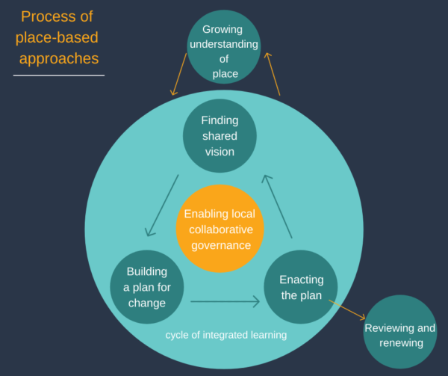

1 Growing understanding of place
The first phase of developing a place-based approach involves assessing community readiness and scope, mapping the community, and starting initial engagement with key stakeholders. This phase also involves making a decision about whether the community is ready and willing to support a place-based approach.
Growing your understanding of the community, and making initial connections with key stakeholders, needs to take place before the next phases in which a community is brought together to create a vision, look at systemic barriers, and create a plan for change.
The activities in growing understanding of place tend to occur simultaneously. Often you cannot start to engage with key stakeholders until you have started to research who is working in place, but you also will not be able to fully map a community’s assets without talking to key stakeholders. Understanding is also not finite or time-limited, meaning that understanding will continue to grow over the life of the place-based approach. It is nevertheless useful to pause and collect as much information as possible before deciding to continue with the approach.
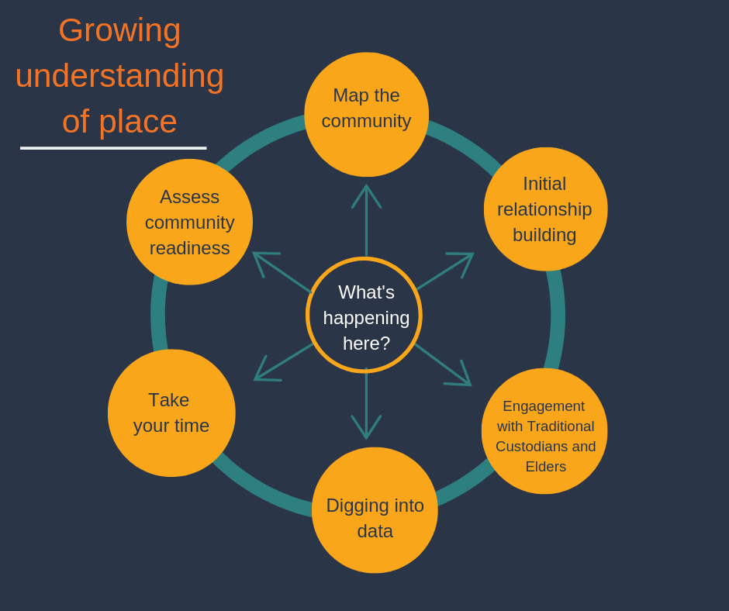

Scoping the place-based approach
Scoping involves thinking about whether the community has an appetite and is ready for a place-based approach. It also involves considering your ability to support the initiative, and what your role will be.
Some communities may not have the energy or resources to commit to a place-based approach at a particular time, for any number of reasons; other priorities, local political climate, Sorry Business, major organisational changes or natural disasters. Even changes in staff in key partners can impact on the relationships and motivation required to sustain a place-based approach.
When assessing community energy, it can be useful to consider the Five Stages of Community Life, identified by the Harwood Institute:
- Waiting place - people feel disconnected, limited community conversation, limited leadership, community has given up hope for a better future, looking for someone to provide answers.
- Impasse - lack of trusted leadership, mistrust, battles over money and who takes credit, rock bottom, stuck with no path forward, no obvious champions to lead the way.
- Catalytic - people discover shared vision, locally led action emerges with energy to take action, lots of promise, awareness of problems, appropriate leadership in place to move from inertia to action.
- Growth - community members progress actions, sense of community spirit and connection, visible leaders, people gain confidence from initial wins, there may be splintering of networks and drops in participation.
- Sustain/review - sense of common purpose grows, community may be ready to take on more deep-seated issues, engagement into hard-to-reach areas deepens, there may be difficulty maintaining momentum, leadership needs to use insights from the past to determine the path forward.
Source: Adapted from Community Rhythms: Five Stages of Community Life
Disruption can present an opportunity for change and may create motivation for more change, or it may present a barrier due to energy and resources being diverted elsewhere. In these circumstances it may be helpful to delay commencing a place-based approach. This is not to say that work cannot occur in a community that is struggling with low levels of leadership and high despondency, but rather that it may take more time and require more capacity building to develop the conditions for change.
Link: The Funders Roadmap, a useful guide aimed at funders but applicable more broadly, identifies different action to support place-based approaches at different stages of Community Life, by Ten20, Opportunity Child and the Harwood Institute
https://ten20.com.au/wp-content/uploads/2016/10/Funder-Roadmap.pdf
Key learning
During Strengthening our place, some people in the Child and Family Sector admitted they were ‘change fatigued’ and felt they had little energy to offer a place-based approach as their sector felt unsteady enough without trying to implement more change, even if they could see the long-term benefit.

Before starting a place-based approach
Before starting a place-based approach, it is essential to consider the following key questions.

Does the community want a place-based approach?
It is important to consider whether a community is ready and wanting to engage with a place-based approach.
You might start with an idea of which place to work in based on funder desire, or due to some initial data showing that a particular region experiences high rates of a particular issue or demonstrates complex issues. There is a risk that this can be experienced as a deficit-based approach, impacting on community self-perception and agency. Ideally, appetite and need are driven by the community itself. The reality for QCOSS has often been that resourcing comes from government, and a community is identified before the work even begins. Selection of place is often based on evidence of need (community disadvantage) and policy priorities (particularly government).

If this is the case for you, and you are coming into a community from the outside, we do recommend advocating for a lengthy engagement period before launching any complex place-based approach, to ensure there is energy and interest within a community for that kind of work to occur. To be genuinely place-based, community stakeholders themselves must be empowered to consider the pros and cons of investing in a place-based approach in their region. Decision making and the motivations to undertake place-based approaches must be clear and transparent to all parties. If a community is asking for some structure and assistance to work in this way, the energy may be easier to harness. It may be that a community is interested, but it is not the right time, and it is useful to know that before you get started with any concrete plans.
If you are from community, you will have some sense about your fellow community members’ enthusiasm for working in this way. You will have started to engage across your community – building community connection and agreement for continuing the work.
The work of assessing community readiness takes place throughout the initial engagement with the community; mapping the community to understand its current assets, evidence of need; and continues throughout the visioning, planning and actioning stages of a place-based approach.
Generally speaking, all communities can benefit from place-based approaches at the lower end of the continuum. These types of initiatives build community cohesion, drive civic participation, and empower individuals and communities. However, not all communities require higher complexity place-based approaches, such as collective impact which particularly focusses on communities that may be experiencing high need.

How is place, or the geographic scope, defined - and does it consider community views?
Some place-based approaches may start with a predefined boundary for the work. Funders may prefer definitions of place that align with their own jurisdictions (typically electoral and administrative geographical boundaries, instead of community led definitions of place). However, in our experience, when defining where a place begins and ends (the geographic scope of the initiative), it has been critical to work with the communities to understand what they see as their ‘place’ and to define their own boundaries. It is also important to map the regions assets before defining place. Often communities have their own definitions of place, and unique regional or suburban identities. Communities can vary in scale, from a small neighbourhood surrounding a single service site, to large departmental regional boundaries. Furthermore, geographic boundaries may fail to consider major infrastructure and institutions outside the boundaries that are still considered key assets by community members.

Limiting definitions of place to formal boundaries may limit buy-in from community members and can oversimplify the lived experience of communities-in-place.
Film Clip: #1 Strengthening our place Vignette - #1 - How did you agree on a place? https://youtu.be/jxtHX0S7VT4
Key learning

From Rockhampton to Capricornia
When developing the Strengthening our place initiative in Central Queensland, QCOSS started with Rockhampton. However, as QCOSS talked to services and community members, and developed the leadership group, we realised that there were strong links between Rockhampton and the surrounding region, particularly with many community members living on the coast but working and interacting with those living in Rockhampton. Those involved in Strengthening our place voiced that it was important to include close townships such as Yeppoon, Gracemere, Emu Park and Mt Morgan. As a result, the Strengthening our place leadership group changed the name and the scope of the initiative to Strengthening our place Capricornia.

Are themes for change emerging from the community itself?
Similarly, many place-based approaches are initiated by funders and facilitators with a predefined desire to address an issue in a community – such as homelessness, childhood development, or public safety. The demographics of the target cohort, and themes for change (what issues are we seeking to address?) might already be predetermined.

However, some practitioners would argue that for an initiative to be truly place-based, the community must be engaged and committed to the themes for change. It may be that a community has other priorities than those determined by facilitators or funders. Engagement of the community must start early, and the community must be involved in framing the scope of the initiative to enable broad ownership of the initiative. It may be that the rationale for focussing on a particular theme is not clear to stakeholders, and an ongoing conversation needs to take place to develop shared understandings of the issues. It may be that the focus of the place-based approach needs to be reframed or broadened to multiple issues to harness community energy. Involvement of community continues in the following stages when Finding shared vision.

Does the place-based approach have time, resources, and energy, both from within and outside the community?
It is important not to over-promise to a community which may already be over-consulted and have experienced repeated failed attempts at change. The place-based principle of Do No Harm applies here – if you are unable to adequately resource and sustain the project, it may be better to wait until you can.

This does not mean you need to have enough resources to drive the whole Place-based Action Plan, as some activities might be resource-neutral, or resources might emerge or be re-aligned to support activities. In place-based approaches, the path forward is often not clear, making it difficult to quantify resources required, particularly over the long term. Nevertheless, at a minimum, place-based approaches require a minimum amount of time, some kind of internal (within region) or external facilitation to maintain momentum, and a group of people with the energy and resources to work together on at least some place-based activities.
Do you have enough time to build a movement for change? In our experience, even the simplest of place-based approaches tend to take more time than anticipated to build genuine engagement and buy-in from the community. If you have already worked with or in this community over time, your pre-established relationships might fast-track some of the time needed to build trust and commitment to change. Nevertheless, the energy for change will ultimately come from the community themselves.

Is there a sense of urgency about needing change? Is there some degree of collective efficacy about being able to make a change? Are key stakeholders and their senior executives willing to share power and undertake the cultural shifts necessary to drive systemic reform? See the Key Learning: Finding the right time.

A second consideration, if you are from outside community, is whether there are enough resources to devote to supporting a place-based approach. This is a good place to stop and consider your or your organisation’s relationship to the region, your role in the place-based approach, and your ability to support the place-based approach into the future:

- Do you have resources inside the community?
- Is there financial support devoted specifically to the initiative?
- Will you be facilitating the initiative alone, in partnership, or will the responsibility for facilitation shift between partners over time or for different aspects?
- Is there someone better in the community to lead the project?
- Who can you partner with locally to deliver the project? What value or benefit can you bring to the project/community?

While not essential to all initiatives, high-level complex initiatives such as place-based collective impact projects will require significant energy, commitment and resourcing from all stakeholders, as well as a strong authorising institutional environment (such as support from government to make what may be significant changes to decision-making and commissioning). Not all of these elements will be in place when you start the initiative. However it is worth having these in mind as you commence work and revisit them in the context of your integrated learning and future planning.

Key learning

External or internal facilitation?
In our experience, successful place-based projects involve both strong in-region partnerships, and independent facilitation. The ways of resourcing these two priorities are many and there is no single answer. Whether facilitation of the work is provided by developing a fully-fledged independent backbone organisation, or through a combination of external facilitation and in-region coordination, will depend on the scale and aims of the initiative.
At QCOSS we have regularly considered the opportunities and issues with our role as an independent or external facilitator of a place-based approach. Not living in community and not being directly affected by work on the ground may affect the energy, commitment, scepticism or willingness to take risks. Those who live in community are inherently affected by the issues at hand – they are context experts, have ‘skin in the game’, and unlike others, they do not have the option of walking away from the community and the issues that affect it. They are likely to have strong relationships within the community, and some people will have lived experience expertise. They may be best placed to build on existing relationships, saving time and resources in the critical work of creating and maintaining relationship in the community.
On the other hand, external facilitation of place-based approaches by people outside the region brings a valuable impartial view; are not influenced by local ‘politics’; and are outside competitive tendering processes. This independence mitigates issues of perceived conflicts of interest or indeed vested interest. It also may bring contacts and ideas to the region from other places and, in return, spread the news of the initiative outside of the community. Depending on the organisation, it is also possible for an external facilitator to provide a critical link between the initiative and the policy reform required to make systemic change.
Leadership group members in the Strengthening our place initiative commented that, “the external support is part of the success,” and, “it is good to... have independent support and views”. Participants in the Fraser Coast community spoke of external QCOSS workers as, “roaming motivators” who helped to bring the big picture and fresh ideas, facilitation and administrative support.
Link: ‘Why is local context a critical success factor in community change efforts?’, commentary by Liz Weaver and Max Hardy (2016): https://www.tamarackcommunity.ca/perspectives-from-the-field

Link: Tools for Backbones on the Collective Impact Forum website: https://collectiveimpactforum.org/resources/tools-backbones

Mapping a community
Mapping a community is useful to start to understand who is working in place and what is already occurring in place. One way of thinking about community mapping is called Asset Mapping, which aims to identify all the strengths and possible opportunities in an area.

Collectively there needs to be an understanding of a place’s points of pride, its past struggles, the Aboriginal and Torres Strait Islander history, and the story that makes that place unique. The comprehensiveness of your initial mapping will depend on your time and resources.

Mapping can be done in partnership with others – part of your mapping may even involve an event where you ask a group of stakeholders to start the map together, or you may share your evolving map with people as part of Initial relationship building. The results of your mapping can become a community resource that is shared and added to over time.

Mapping a community’s assets
There are a number of resources available on ways to map community strengths and assets. We have developed a checklist, Tool: Community Mapping Checklist which covers the following assets to consider:
- Traditional Custodians, Elders and Aboriginal and Torres Strait Islander people and culture
- you and your organisation
- previous mapping and planning work
- geography, infrastructure and environment
- current government agendas and announcements affecting this community
- history
- cultural resources and key events
- political representation and activity
- institutions
- programs and services
- networks and relationships
- community and cultural groups
- business and industry
- informal leaders.
As you gather your data, you might map the information on a large blown up geographical map of the region or a spreadsheet.
Asset mapping is an iterative and ongoing process. It is highly unlikely that you can completely map the community straight away. Your asset map will continue to build as you undertake your community engagement and relationship building (see below).
Tool: Community Mapping Checklist

For more on asset mapping, see:

Link: Participatory Asset Mapping by http://www.communityscience.com/knowledge4equity/AssetMappingToolkit.pdf

Link: Asset Based Community Development on Community Door https://communitydoor.org.au/Asset Based-community-development-abcd
See also Principles: being asset based and strengths focussed
Tip: Community leaders might not be elected officials, be holding any particular position of authority, or even be associated with any one organisation. Sometimes the only way to hear about them is to ask around - who are the most influential people in this area? Who do people turn to for advice? Who is supporting the community?

Initial relationship building
This initial stages of working in a community involves what we call ‘light-touch’ engagement.
This engagement is intended to develop an initial understanding of people in place, build relationships and trust, and float the potential for a place-based approach. This stage also involves laying the groundwork for key partnerships in the region. If you are already working in place, you will have already started the process of developing relationships on the ground.
Relationship building should start as soon as you feel you have adequate sense of the place to know a few key stakeholders and general understanding about the place. You do not need to have completed all mapping before getting out into community – in fact, many answers to the questions contained above in Scoping the place-based approach can easily or even exclusively be found through talking to local people. Often, we ask ourselves, ‘how will we know what is happening for people in the community?’ and the answer is often simply ‘ask them!’ If you are part of the community, or already doing work in the community, you might already have a good idea and will be able to start reaching out to people immediately.

Engagement with Traditional Custodians and Elders
It is important to seek permission from traditional custodians and Elders to work in place and explore opportunities to partner in a place-based approach. This is essential to pay respect to First Nations people, and to ensure Aboriginal and Torres Strait Islander perspectives and approaches are included in the visioning, planning and implementation of the work. In our experience, traditional custodians have been generous in their time, guidance and provision of connections that can progress place-based approaches and associated projects.
The work of connecting can be complex, requiring careful thought and research. In some communities, there will be a group who have been successful in claiming Native Title. This can make work more straightforward, providing some clear direction towards who you should be contacting initially to establish relationships in a region. However, it is important to acknowledge that Aboriginal and Torres Strait Islander peoples in a community may not all be represented by Native Title, and that it is important to include a variety of community leaders and voices.
Where initiatives are based in Aboriginal or Torres Strait Islander communities, or where Aboriginal and Torres Strait Islander people are significantly affected by an issue the place-based approach seeks to address, it is important to carefully consider you or your organisation’s role and mandate to work in that community. There may be other organisations, including Aboriginal and Torres Strait Islander organisations, who are better suited to facilitate the place-based approach. At a minimum, creating formal partnerships with key Aboriginal and Torres Strait Islander Elders and organisations is highly recommended.
Case study: Relationships with traditional custodians in place, part of the Strengthening our place project (Capricornia) https://www.qcoss.org.au/publication/place-based-in-capricornia-a-case-study-on-relationships-with-tradition-custodians-in-place/

Case study: How the Butchulla people are re-visioning an ancient rite of passage, part of the Strengthening our place project (Fraser Coast) https://www.qcoss.org.au/publication/place-based-in-fraser-coast-a-case-study-how-the-butchulla-people-are-re-visioning-an-ancient-rite-of-passage/

Who are the Traditional Custodians?
To find out who are the Traditional Custodians for the place you wish to work, you might consult the Department for Aboriginal and Torres Strait Islander Partnerships in your state or territory. Land councils and native title support services around Australia can provide guidance around who has land rights and native title determinations in a particular region. Other places to enquire might be a local community or neighbourhood centre, council, early childhood services or schools.

Link: Department of Aboriginal and Torres Strait Islander Partnerships (Queensland) https://www.datsip.qld.gov.au/department-aboriginal-torres-strait-islander-partnerships

Link: Native Title Representative Bodies and Service Providers https://www.pmc.gov.au/indigenous-affairs/land/native-title-representative-bodies-and-service-providers
In some regions, there may be more than one language group who has Traditional Custodianship. It is also possible that there is no native title determination in a region, or it may be disputed. Furthermore, even where native title determinations exist, it may be contested.

Protocols for working in place
It is important to observe proper protocols when working in any place. It is best to ask those who you make connections with about what protocols they prefer you to follow when working in place. Common protocols include arranging a Welcome to Country from Traditional Custodians or acknowledging Traditional Custodians and Elders.

Welcome to Country
A Welcome to Country should be the first part of the program for significant events, including large community engagement forums, conferences, award programs, and festivals. A Welcome to Country is a ceremonial protocol where the Traditional Custodians of the Country welcome guests to the land of their ancestors. Inviting Traditional Custodians to provide a Welcome to Country is the respectful way to begin any formal events or proceedings.
Before a Welcome to Country, it is respectful to briefly explain the intentions of the meeting to Traditional Custodians, invite them to be involved in the proceedings, and meet them face-to-face prior to an event, on the morning or if time permits, in the lead up to the event. Check with the person providing a Welcome to Country to see how they would like to be introduced, and if you need to check the pronunciation of any words you may be unfamiliar with.
It is common practice to provide remuneration for giving a Welcome to Country. The level of remuneration will depend on the ceremony, with ceremonies that include a traditional dance or smoking ceremony involving a higher fee. Organising Welcome to Country can take some time, so this should not be left as a last-minute task. Prioritising the organisation of a Welcome to Country also communicates to Traditional Custodians that you value their presence and contribution as part of your engagement.

Acknowledgement of Traditional Custodians
An acknowledgement of Traditional Custodians should be made before any significant meetings or group activities are held in place. There is no hard rule for what constitutes a ‘significant meeting’ – it may be the first meeting in an important process, or where people are meeting from different organisations, or where there are more than a handful of people catching up.
Sample

Acknowledgement of Traditional Custodians
I would like to start by acknowledging the Traditional Custodians of the land on which we meet, the _____ people (optional of the ___ Nation), and pay my respects to their Elders past, present and emerging. We recognise their enduring connection with land and sea, and it is a privilege to be standing on ____ country.
It is respectful to pause after acknowledging Traditional Custodians, before continuing with the program.
Once Traditional Custodians have been acknowledged, it is not necessary for every speaker in the program to acknowledge the Traditional Custodians, although some speakers may like to do so.

Other protocols
There are many other protocols for working on country that are specific to each region. It is always respectful to ask Traditional Custodians and Aboriginal and Torres Strait Islander people about proper protocols. There are also some guides available for different regions.
Link: Protocols for working with Aboriginal and Torres Strait Islander people https://www.datsip.qld.gov.au/people-communities/protocols-consultation
Link: Cultural protocols for the Torres Strait Islands http://www.tsra.gov.au/__data/assets/pdf_file/0005/1778/tsra20cultural20protocols20guide.pdf
Link: Working with Aboriginal people and communities: A practice resource by NSW Dept of Community Services www.community.nsw.gov.au/__data/assets/pdf_file/0017/321308/working_with_aboriginal.pdf
Link: Reconciliation Australia https://www.reconciliation.org.au/

Link: Empowered Communities Report – an indigenous empowerment agenda https://www.pmc.gov.au/resource-centre/indigenous-affairs/empowered-communities-report

Relationship building with key stakeholders
Relationships are the foundation of any place-based approach. Relationships take time and energy to build, and they need to be based on high levels of trust. Relationships should also be purposeful and founded in shared vision, values and investment in the community.
Start with building relationships with people and organisations on the ground and respectfully offer yourself as a resource to further the work that is already happening in place. Many organisations will have existing relationships, projects and knowledge that are invaluable in driving change in the community. It is highly likely that there are organisations and community leaders already working in the region on community development, community engagement and community visioning projects.
“You really need to understand who is the community that you’re working with so they can trust you… [with that understanding you can] bring in those people who need to be part of the picture, or at the table, so to speak, to make those outcomes happen. … It comes back to building those relationships. If you don’t know your community, that placed based stuff, you’re going to make mistakes along the way,” - James Mundy, community consultant with Strengthening our lace in Capricornia.

Contact key formal and informal leaders you have identified in the Tool: Community Mapping Checklist [https://www.qcoss.org.au/contents-page-for-place-based-approach-and-toolkit/tool-community-mapping-checklist/]. If you can, go and spend time in place at key community hubs and centres, and start conversations with as many people as you can. We like to call this ‘loitering with intent.’ In particular, key people you may wish to start talking to and building relationships with are:
- neighbourhood or community centre
- local council
- local networks you have identified
- anyone with ‘community development’ in their title – they will have useful skills and are likely to have a good sense of the pulse of a community
- contact person for government services and departments
- school principals
- police liaison officers
- National Disability Insurance Scheme Local Area Coordinator
- key health organisations such as community health centres and the Primary Health Network
It is important to consider you and your organisations’ existing relationships with the community, as well as the quality of relationships between people and workers in the community. Where there are existing networks in a region who work well together, and are well aligned, less work is needed initially to bring people together and move forward with a place-based approach.
For better or worse, working relationships are built on one-on-one connections between people. While organisations can form partnerships and establish trust, ultimately working relationships occur person to person. When a worker leaves the project, relationships need to be re-established before work can progress – often slowing down the work considerably.
Tool
Starting conversations in place
Film Clip #2 Strengthening our place Vignette - #2 - Experiences with local engagement? https://youtu.be/-9vtwpWV8Ds
Key learning: Addressing concerns around place-based approaches
The goal of the initial relationship building stage is to gather information and build understanding of the place, rather than propose particular activities or projects. Nevertheless, people will understandably be curious or even wary about your intentions and motivation for contacting them, and particularly busy people will want to know the purpose of meeting. It is important to be transparent about why you are hoping to connect.
In our experience, key stakeholders are generally excited about place-based approaches. Many stakeholders are already purpose-driven and relish the opportunity to improve systems and outcomes for the people they serve. They see the benefit in planning and working together and want to understand how they can better achieve outcomes. They see the opportunity for change, and they are particularly excited by the possibility of change in traditionally rigid and permanent systems, such as government institutions and processes.
There are, however, some concerns you may come across including: misunderstandings of the motivations behind the work; the potential impact of a place-based approach on existing arrangements; the resourcing to support and drive place-based approaches particularly over the long term; and consultation fatigue or apathy around collaborative processes. These are legitimate concerns, and there are no simple answers to these questions as they will be different in each circumstance. It is appropriate to be prepared to work through these questions and concerns with community members in an open and considered manner.
Be aware of your vested interest and the interest of others involved. It is also important to acknowledge the extensive and ongoing work that community members, neighbourhood centres and other community-based organisations already do in their regions to build a better community, and not to ‘cut across’ or claim this work. Rather, start with relationships and offer yourself as a resource to help bring about the aspirations and visions of the place in which you are working. Consider the distribution of resources needed to both facilitate a place-based approach and to implement the activities of a place-based plan which will ultimately drive change in the region.
“We need to look at what we’re doing already, so we’re not duplicating and replicating the work [that is already being done]. But [instead ensuring that we’re] tapping into the best pieces of each of the parties,” - Anita White, place-based leadership group member in Strengthening our place.

Establishing key partnerships
As you are building relationships, you may start to identify organisations, government departments and people who you would like to partner with more formally on the place-based approach. Place-based approaches need effective coalitions or partnerships between key community stakeholders. You may have already started the place-based approach in partnership with an organisation, government department or other funding body.
Partnering formally can have many advantages – increasing trust, developing clear ways of working together, and opportunities to promote your collaboration. There are many tools and resources around partnering and developing Memorandums of Understanding to support partnerships.
Thinking through your partnership early in the piece is an important foundational step. Using good process helps articulate shared outcomes; individual and collective value of the partnership; expectations around practice and behaviour; and any resource commitments.
Key Learning: What we learnt through our partnership, part of the Strengthening our place initiative https://www.qcoss.org.au/wp-content/uploads/2019/06/Strengthening-our-partnership_what-we-learned-REVIEWED.docx
Link: Collaboration and collaborative practice on Community Door https://communitydoor.org.au/collaboration

Link: Collaboration decision support tool on Community Door eTraining https://etraining.communitydoor.org.au/course/view.php?id=15

Link: Collaboration for Impact’s Collaboration Health Assessment Tool https://www.csi.edu.au/chat/about/

Link: What is a Memorandum of Understanding? Community Door
https://communitydoor.org.au/collaboration/memorandum-of-understanding

Link: Partnering Toolboxes by the Partnering Initiative
https://thepartneringinitiative.org/publications/toolbook-series/

Link: The Partnerships Analysis Tool by VicHealth https://www.vichealth.vic.gov.au/~/media/.../Partnerships_Analysis_Tool_2011.ashx

Link: Brokering Better Partnerships on the Partnership Brokers website: http://partnershipbrokers.org/w/wp-content/uploads/2011/04/Brokering-Better-Partnerships-Executive-Summary.pdf
Key Learning: Neighbourhood centres and place-based initiatives
Neighbourhood centres have been operating in Australia from the 1960s with an emphasis on community development approaches, location, social cohesion and community learning. There are 124 neighbourhood centres funded by the Queensland Government throughout the state. Many are run by local volunteer management committees and are essential place-based infrastructure in communities. In Queensland, QCOSS’ Neighbourhood Centres Community Consultation Results outlined the range of outcomes neighbourhood centres achieve, and there is research demonstrating the significant social and economic impacts of neighbourhood centres around Australia. Neighbourhood centres play an essential role in building the social capital of place. Neighbourhood centre knowledge and experience provides critical support for place-based approaches, as described below:
Agreed place
Neighbourhood centres operate in geographical localities. Their funding is for specific catchment areas and because many have been operating for several decades within spatial areas, they have gained specialised local knowledge of the communities in which they operate. They feature multiple services and activities that are often specifically relevant to the local neighbourhood in which they are located. Centres are often also involved with ‘communities of interest’ in geographical spaces, such as Aboriginal and Torres Strait Islander Elders, migrant communities, young people, and older people.
Shared vision and commitment to outcomes
Neighbourhood centres operate from a community development approach, identifying opportunities for collective purpose and building community projects. Many have long-term experience in supporting communities to come together around a vision and supporting action.
Working together
Neighbourhood centres often establish local networks between services to respond to community needs as they are identified, or bring services together as hubs to offer wrap around services. Additionally, their relationships are not limited to the human services sector and they will have relationships with local business, government, politicians, schools, community groups, academics and faith-based organisations. Neighbourhood centres are collaborative by nature and are often the ‘poly filler’ that fills gaps between services. Given neighbourhood centres key role and relationships in many communities across Queensland, they are key place-based partners.
Community engagement
Because neighbourhood centres have offered local responses to local needs for long periods of time, they have an intimate knowledge of local community issues. Many are involved in collecting demographic data and are involved in ongoing discussions with community stakeholders on social issues. They often have a strong volunteer base and highly developed processes for meeting people ‘where they are at’. They are also aware of community assets, well informed of referral pathways and utilising professional community volunteers.
Local collaborative governance
Community development and strengths-based principles are often key for neighbourhood centres, providing a basis for emphasising the need for self-determination for individuals and communities. Many have a demonstrated ability to involve local people in developing local solutions, and processes for involving the local community (organisations and individuals) through consultation and active involvement in decisions.
Cycle of integrated learnings
Many neighbourhood centres have an embedded practice of adaptive, iterative co-design. Their community building approach and program delivery is based on principles of flexibility to meet the needs of the community and build on strengths and aspirations of presenting community members.
Link: QCOSS Community Consultation Report https://www.qcoss.org.au/queensland-neighbourhood-centres-community-consultation-results-paper

Digging into data
Data! Some people love it, some people hate it. For some, a good Excel spreadsheet is their idea of heaven, for others it is hell. This part of building understanding of place involves starting to scope data sources and researching available data to build a profile of the community. Data can provide context, build a common understanding of the issues and a baseline measurement for the initiative, and which may later help you to measure whether your project has made a difference (outcomes indicators). Demonstrating changes in data can help you build an evidence base for the work that you do. Digging into data can reveal surprising results, where what is commonly believed is happening in a community may not be borne out in statistics. It can support thinking about a problem differently and looking for novel ways to generate change.
On the flipside, data that is available about the community may not be comprehensive, or the collection methods may not have been perfect, so data should be used with caution. Data also tends to lead to deficit conversations, often measuring what is lacking rather what is there.
Numbers are also never the full story – it is often missing perspectives and will never have the nuance and quality of information held in people’s stories. It is important to seek out qualitative data too, and always ask ourselves, is this data useful, or is it blurring our vision?
The presentation of data on its own is not sufficient to progress a place-based approach. To be truly valuable it is important to accompany the data with conversation in which the data is explored further, and with stories of lived experience. Qualitative insights should be combined with quantitative data. This allows for the combination of content and context expertise to provide a full picture of what is happening in a community.
Data you may be interested in might include:

General
- Total Population
- Number and % of population via age groups compared to the state or national %
- Number and % of Aboriginal and Torres Strait Islander Population – compared the state or national %
- Number and % of people who speak a language other than English at home – compared the state or national %
- Population Growth Rate - compared to the state or national Average
- Areas with the fastest population growth rate
- Projected population
- Number and % of homeless persons compared to the state or national %
Department of Social Services
- Number and % of population receiving:
  - the age pension,
  - disability support pension
  - Newstart allowance
- Number and % of people needing assistance with a profound or severe disability – compared to the state %
Income
- Median total personal income per year compared to the state or national median
- Median total family income compared to the state or national median
- Number and % of low-income families compared to the state or national average

Employment
- Largest industries in terms of employment as a % of total employment in area – compared to the state or national
- Most common occupations as a % of all occupations – compared to the state or national average
Unemployment
- Number and % of unemployed persons compared to the state or national %
- Comparison of current unemployment rate with previous years
- Number and % families with children under 15 with no parent employed
Housing
- Median dwelling sales prices compared to the state or national average
- Housing Tenure (such as ownership status) compared to the state or national %
Family Composition
- Number and % of couple families with children and one parent families with children compared to the state or national %
- Number and % of households with one family, lone person households, group households and multiple family households compared to the state or national %.
- Number and % of people who undertake volunteer work compared to the state or national %
Early Childhood Development (AEDC)
- Number and % of developmentally vulnerable children in one or more development domains compared to the state or national %
- Number and % of developmentally vulnerable children in two or more development domains compared to the state or national %
- Development domain(s) with highest percentage of developmentally vulnerable children
NAPLAN
- NAPLAN results by age groups compared to the state or national averages
School Completion
- Number and % of people via highest level of schooling completed compared to the state or national %

Qualifications
- Number and % of population who have received qualifications compared to the state or national % via type of qualification
Mental Health
- Number of admitted patients with a principal diagnosis of mental and behavioural disorders compared to the state or national %
- Any other health related statistics, for example rates of cardio-vascular disease, type 2 diabetes, obesity, death by suicide compared to the state or national %
Crime
- Number and % of reported offences compared to the state or national average
- Number and % of offences against the person compared to the state or national average
- Number and % of offences against property compared to the state or national average
Domestic and Family Violence
- Number and % of DFV orders compared to the state or national average
- Number and % of DFV breaches compared to the state or national average

There are several places where data is recorded – some data is already published, while other data is held by public institutions and available on request.
Key learning: Data and disadvantage
Data can be a useful tool for getting to the bottom of an issue, and sometimes what we think is happening in an area isn’t borne out in the statistics. Evidence of disadvantage can provide evidence of a need and justify investment in a certain place or theme. It might also galvanise people behind a particular cause, create a sense of urgency, and help build a movement for change. However, in our experience, it can also be disheartening, and further entrench negative perspectives about a region. We use data about disadvantage with caution – our message is always, “Here are our strengths, and here are our areas for improvement that present an opportunity for change.” This may not seem like a big change, but it will help to reframe and balance the discussion.

Link: Australian Bureau of Statistics
Maps – http://stat.abs.gov.au/itt/r.jsp?ABSMaps
Data by region - http://stat.abs.gov.au/itt/r.jsp?databyregion
SEIFA (Socio-Economic Indexes for Areas) - http://www.abs.gov.au/websitedbs/censushome.nsf/home/seifa
For more additional breakdowns of data, you can submit a data request to the Australian Bureau of Statistics via their Contact Us page. There is sometimes an associated fee.

Link: Australian Institute of Health and Welfare
www.aihw.gov.au

Link: data.gov.au, www.data.gov.au

Link: profile.ID for community profiles, https://profile.id.com.au/

Link: Queensland Government Statistician’s Office, https://statistics.qgso.qld.gov.au/qld-regional-profiles

Link: Queensland Regional Database, formerly known as Queensland Regional Statistical Information System (QRSIS) http://www.qgso.qld.gov.au/products/tables/qld-regional-database/index.php

Link: Community profiles by the Queensland Department of Aboriginal and Torres Strait Islander Partnerships (DATSIP) https://www.datsip.qld.gov.au/people-communities/know-your-community

Link: Queensland Crime Statistics QLD
https://www.police.qld.gov.au/rti/published/about/Crime+Statistics.html

Link: Queensland State School statistics
https://www.qld.gov.au/education/schools/information/research/statistics

Link: Australian Early Development Census (AEDC)
https://www.aedc.gov.au/data-users/about-the-aedc-data

Link: NAPLAN (National Assessment Program Literacy and Numeracy) data
http://www.acara.edu.au/contact-us/acara-data-access
Tip: If you are looking for some data that doesn’t appear to be publicly available, it is worth checking with relevant government departments and agencies. Sometimes data can be released in response to specific simple data queries. Complex population health data is available to authorised researchers, for example, through the Secure Unified Research Exchange (SURE), the Australian Data Archive Dataverse and the Multi-Agency Data Integration Project (MADIP).
Jargon alert: A baseline measurement is a record of where a community starts on a particular outcome indicator. It is helpful to decide on a few key overarching outcomes that you are hoping to achieve in the place-based approach, and at the start of the initiative, record or measure the ‘baseline’ status of the outcome - that is to say, where is the community starting? Otherwise, you might get to the end of the project and have evidence of good outcomes through lots of great stories and narratives, but without a baseline, you haven’t got data on how things have changed.

Jargon alert: Outcomes indicators are tangible measurements of an outcome – that is, an actual piece of data that provides evidence of an outcome. For more, see Committing to shared outcomes in Building a plan for change.

Take your time
The above might seem like a daunting list of things to do and questions to ask in building your understanding of place, which serves to demonstrate the amount of time required to prepare to work in place. How long this stage takes will depend heavily on whether a community strongly resonates with the data and stories you find. If this is not the case, more time will be needed for you to make sense of the landscape before you get to action. Initial community engagement is also a key step and should not be rushed. As always, building understanding and relationships takes time!

2 Finding shared vision
Once you have grown some understanding of the place, the next step is to start to engage the broader community to find a shared vision and commit to shared outcomes.
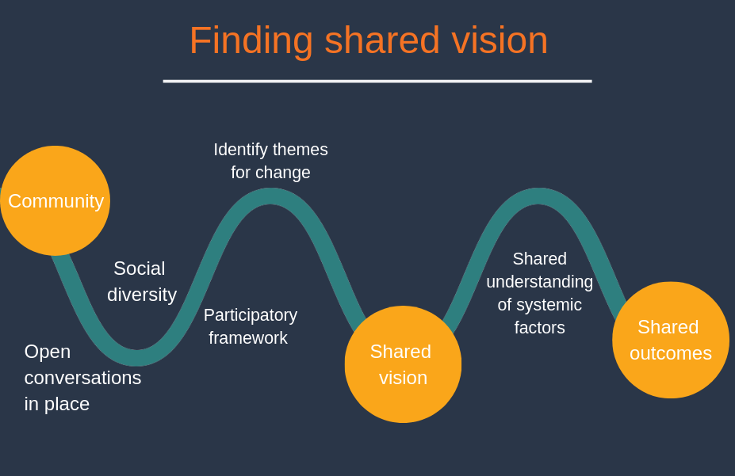
The purpose of this phase is to host open conversations in place, ensuring social diversity and a participatory framework. The community comes together to identify issues, generate a shared understanding of the systemic factors that have led us to where we are now, and agree upon a shared vision for the future.

Hosting conversations in place
One method used successfully by QCOSS in this phase is to conduct a facilitated community forum involving a wide range of interested community members to build on the process of visioning. Depending on the length of the forum, it can also support the generation of ideas and planning – part of the next stage of Building a plan for change. The forum can be as long as is needed, but in our experience, a two-day forum lends itself to the outcomes including relationship building, trust and moving from talk to action.
An event is a good starting place for hosting community conversations in place, and you might hold several different movement building events over a period of time. A forum is just one part of the process – it is not the only way to engage people, but it forms a good entry point to start working with people in community. In the planning it provides a focus of activity to help build the leadership group in place; in delivery it connects people across the community to build trust; by moving to action, it provides focus post forum. Those who cannot attend might still be interested in being involved in the place-based approach and want to hear about how the forum went. It is also important to be aware that some communities can experience consultation fatigue. It is important to leverage off existing work, work alongside other organisations conducting community engagement, and not duplicate efforts.
Community engagement is a skill which is covered extensively through many online resources, including Community Door.
Link: Community engagement on Community door https://www.communitydoor.org.au/community-engagement

Link: Community Engagement Toolkit http://www.collectiveimpactforum.org/resources/community-engagement-toolkit
Jargon alert: Consultation fatigue is where key stakeholders and informal community leaders might have participated in many forums, surveys, roundtables and community meetings, without seeing any substantial change to the way systems operate or any additional resourcing
Tip: Scheduling community forums
You should know what the key events in the life of a community are from your mapping checklist. Make sure you don’t schedule a community engagement opportunity at the same time of a major event! However, major events can instead be opportunities to promote your place-based approach and engage broadly with the community, for example by hosting market stalls, or even asking to be part of the program.

Establish a Hosting Team
Drawing on the relationships built in your initial engagement, you might start to bring together a group of people to facilitate a community event designed to engage the public and bring together stakeholders from across the community. We call this a ‘Hosting Team’ or a ‘Leadership Group’. A Hosting Team might consist of four to fifteen people who are interested in a proposed place-based approach and have strong connections to the place. They might be key formal or informal leaders, individuals from the community, or representatives from key organisations in place.
The Hosting Team might meet several times in the lead up to the event, to decide on the invitation list and promotion activities, plan the agenda and processes for the forum, invite speakers, and prepare the venue and catering. They also act as the local face of the forum, promoting the event and acting as a catalyst for change. This ensures a diversity of perspectives to create the most successful forum possible, and leverages off the collective wisdom and contacts of all those on the Hosting Team.

Bring people to the conversation
The conversation should include as wide a cross-section of the community as possible, including anyone with passion, interest and/or lived experience. To do this, it is important to cast a wide net. Invite a broad range of people to be part of the place-based approach in their community and diversify engagement methods to include people who may not ordinarily hear about such initiatives. Remember that people often play a number of roles within their community and may have relevant lived experience or know others who do.
Tip: Socially inclusive engagement
Community members, especially those experiencing marginalisation, require support to engage in the process. Remember that not everyone is used to meetings! Knowing the process, group norms and opportunities they will have for input can help break down power differences and set up clear expectations. It helps to provide clear information on the purpose of meetings and groups.
Specific groups may also need practical assistance to participate. For example, culturally and linguistically diverse (CALD) communities may need interpreter services to participate; people living with a disability may require adaptations or assistance such as an AUSLAN interpreter to participate, and people with limited income may require assistance with travel and food to enable them to engage. Ask people what would help them to engage and be prepared to resource them properly.
Tips for promoting your event to reach ‘hard to reach’ people
Engage community services that have relationships with people to talk about the best ways to include citizens and to broker relationships. Ask workers in community organisations to think of people they have worked with recently who might be interested and ask them to support them to attend.

Contact local interest groups and consumer-led groups and ask for a citizen or consumer representative to attend.

Attend upcoming community events and promote your initiative with flyers, a stall, or a slide or brief speech as part of the event.

Meet people where they naturally gather - go to parks, neighbourhood centres, groups, wherever people that are relevant to your project gather. Attend the local neighbourhood centre, other community centres and services and (with permission from the service) talk to people using them, attend group programs and talk about the event and why people might like to come.

Promote the event with collateral in the right places – ask to put up posters in the local neighbourhood centre and other community centres and services, take out an advertisement in the local paper, place an ad on community radio, ask community organisations to share in their newsletters to their clients and friends.

Use your Hosting Team to help with these actions to build connections and buy in for the forum.

Invite formal and informal leaders
Based on your Community Mapping Checklist, you should also have a good idea of who the formal and informal leaders in a community are. From this, you can develop an invitation list for the community forum. Your Hosting Team is critical in helping to pull together the invite list and in doing so, helps you build your Community Map.
Tips: Getting to VIPs
Aim high – do not be afraid to contact ‘Very Important Persons (VIPs)’ or other people who you think might not be interested in the initiative. Our experience is that community leaders and key influential people in communities are grateful for the opportunity to connect with their community and be part of a movement for change. If their contact details are not publicly available, you can contact their organisation and ask how the best way to invite them would be.
You might start with a written invitation via email or post, and follow up with a phone call to them or someone in their organisation who supports them. The more time you have to prepare an event, the more likely that busy people will have room in their diary to attend, so try to start planning your event early and send invitations at least two months before the event.
Another tip is that if you have already connected with one ‘VIP’, you might ask them to talk to the people they know and join you in encouraging people to attend. Influential, powerful and busy people might be more likely to attend if they know that other people are taking the process seriously, and that it will be an important event in the life of the community. Again, the Hosting Team are critically important – many will have existing relationships with key people and can facilitate introductions and help get people to agree to participate.

Facilitate conversations
While conversations seem simple enough, there are many different processes for facilitating community conversations. Most impactful conversations and meetings will have had a lot of thought put into how they are run! Facilitation involves creating safe and comfortable spaces, creating opportunities for different ways of thinking, doing, and learning, and managing divergent ideas and interests.
Developing the agenda and processes you will use can take lots of time and thought. You may wish to talk to or even hire someone who has experience facilitating groups or meetings. This might be because of their skill and experience, but it can also be a good idea if you want to participate in the discussion rather than ‘holding the space’ for everyone else.
You can also create opportunities to co-facilitate with other members of the group, or move responsibility for facilitation around. For example, different members of the Hosting Team might facilitate different sections of the conversation.
Participatory leadership and the Art of hosting practices support people to share their voice and become leaders in change. Participatory leadership assumes that people give their energy and lend their resources to what matters most to them; in work as in life. It draws upon principles that align with community development, such as engaging people where they are at; that power should be diffused, and community members developed as leaders; and that solutions should be co-produced with the communities that are affected.
A key concept of Art of Hosting is ‘host yourself first’. This means anything you are prepared to encounter in conversations in the room, you must be prepared to encounter and host in yourself first – conflict, frustration, ego, fear, anger, weariness, envy, injustice and so on. Similarly, the presence, compassion, resolution and self-care required to host difficult conversations, you must show to yourself first.
Generally speaking, our events include some kind of check-in and check-out, some presentations and speakers, some kind of group process or activity, and methods to harvest the learnings from the day.
Some things to remember when facilitating and hosting conversations include:
- Create a comfortable space (physically and emotionally) for the conversation to take place
- Introductions, check-ins and getting to know people is important
- Gently keep the group focussed on the question
- Be mindful of how power is operating in the room. Ensure everyone is heard and listened to with respect and curiosity
- Pass a talking piece to keep focus on one speaker at a time (optional)
- Look for opportunities to reflect back and distil key concepts as the conversation progresses
- Capture or harvest key messages and actions/ideas that emerge
- Pay attention to time and purpose of the session.
Checking in and checking out are processes used to open and close a meeting. The purpose of checking in is to ensure everyone in the group is seen, heard and acknowledged, but it also helps people leave their busyness behind and be fully present at the meeting they have come to. Simply put, check in helps to focus everyone and lets every voice be heard from the start.
It is an important part of hosting conversations to feed back to attendees what has occurred and next steps. For more on this, see Documenting and sharing the work in Enacting the plan.

Capacity building for inclusive facilitation
The creation of Hosting Teams provides an opportunity to capacity build people in the region in inclusive facilitation practices and design and delivery of group processes. Building capacity in the region supports sustainability of the initiative going forward and build confidences in the Hosting Team to play an active role in the event itself. This can be particularly important when context experts are engaged as part of the Hosting Team. There are extensive resources available around facilitation, group processes, participatory leadership and Art of Hosting.
Link: Participatory leadership and Art of Hosting on Community Door: https://communitydoor.org.au/participatory-leadership-art-of-hosting-and-harvesting-conversations-that-matter

Link: The Art of Hosting Fieldguide, a free e-book available for download: http://www.dialogicod.net/practitioner_papers/Corrigan%20-%20Art%20of%20Hosting%20Fieldguide.pdf.

Link: Art of Hosting website: http://www.artofhosting.org/what-is-aoh/

Link: A short video on the art of hosting: https://www.youtube.com/watch?v=FWodPL9C1UI&feature=youtu.be

Link: Core Art of Hosting Practices: http://artofhosting.ning.com/page/core-art-of-hosting-practices

Link: Collective Story harvest: http://www.plays-in-business.com/collective-story-harvesting

Link: First Time Facilitator Podcast and blog by Leanne Hughes: https://www.firsttimefacilitator.com/

Link: ”Getting Our Act Together: How to harness the power of groups” by Glen Ochre: https://groupwork.com.au/product/getting-our-act-together-how-to-harness-the-power-of-groups/.
Tool: How to facilitate a Check-in
https://www.qcoss.org.au/contents-page-for-place-based-approach-and-toolkit/tool-community-mapping-checklist/

Tool: Keeping meetings energising and engaging
https://www.qcoss.org.au/contents-page-for-place-based-approach-and-toolkit/tool-community-mapping-checklist/
Tip: Socially inclusive facilitation
Being inclusive extends not just to the people you invite to a conversation, but to the way you host a conversation. People can feel excluded by many things – the structure of the meeting, the language used, or the way of thinking about an issue. Here are some tips for keeping processes inclusive:
Acronyms: Try to avoid acronyms when speaking, and if others use them, it can be helpful to ask them to spell them out or spell it out for the room.
Jargon: You will notice throughout this document we have included Jargon Alerts. In a similar way, it can be helpful to keep track of jargon used in community meetings. Try to avoid using it yourself; if others use it, you might gently interrupt them and ask them to define it for the room, or define it once the person has finished speaking.
Prior knowledge: During the conversation, people might bring up things that have happened in the past, but not go into enough detail to explain it to people who weren’t there. For example, one participant might say to another, “Remember that meeting we went to? They explained everything there.” In that circumstance, you might ask them to go into more detail for the room about the meeting, and what was explained.
Check for understanding: It is important when facilitating that everyone understands the process. Do not assume that everyone understood what was said, or that they were able to concentrate and listen all the time. If several people look confused, it is probably because they are. Pause and re-explain.
There are many more techniques to being inclusive and making people comfortable during processes.
Link: Facilitators can infuse diversity and inclusion in everything by Facilitating XYZ
http://www.facilitating.xyz/facilitators-can-infuse-diversity-inclusion-everything
Tip: Create a facilitation kit
If you’re holding regular meetings you can save yourself time and stress as a facilitator by having a ‘facilitation kit’ packed and ready to go! For us this includes; label stickers and a sharpie for name badges; sign-on sheet; whiteboard markers and duster; post-it notes and felt tip pens; blu tack; and butchers paper. There is a whole podcast about this very topic on First Time Facilitator by Leanna Hughes.
Link: Ultimate facilitator packing checklist on the First Time Facilitator Podcast: https://www.firsttimefacilitator.com/ultimate-facilitator-packing-checklist/.

Visioning
Visioning is a process of making sense of the way things are, identifying emergent themes for change, and creating a vision for the future.
It can help to begin with making sense of available data and stories and what they mean, in the form of presenting what is currently happening in the community. You might do some sense-making by presenting some data or existing research and stories from the region. If presenting data and stories from the region, ensure that there is time for checking with those present to see if this information rings true for them. Data and numbers are sometimes presented without context, and this can be detrimental. Remember the principles of place-based approaches here, as they will assist in treating data and stories with care.
Tip: Communicating data
In general, our experience is that most people switch off when we talk about data. Here are some tips to keep people engaged:
Less is more – choose the key data points that demonstrate your message
Tell a story – Intersperse the data with stories of real people. This helps people connect with an issue, and makes the data real
Infographics – people use them because they work. Combine data with images, icons and arrows – it will help people process the information
Raw numbers – We have found that raw numbers can mean more to people than percentages. For example, it is easier to understand that there were 300 more young people graduating school, than saying there was a one per cent increase
Make a comparison – Are you trying to communicate something huge? We have found it helpful to compare it to something people are familiar with. Some examples: 25,000 – 50,000 people in a football stadium (look up the local one to make it relevant);
Focus on strengths and opportunities – see Key learning: Data and Disadvantage in Digging into Data
Tip: There are some fantastic and easy to use online graphic design tools that can make presenting your information much simpler and more enjoyable. We particularly like Canva and Piktochart.
Link: Canva: www.canva.com

Link: Piktochart: https://piktochart.com/
Once the scene is set you might ask community members to reflect on what is currently occurring in the region (the good things and the bad things) and what their priorities are for the future. Encourage big dreams! Some example questions you might ask include:
- What would your community look, feel and sound like at its best?
- What might it take to create a community where everyone feels safe?
- Imagine the year is 2050, and we are in a resilient, connected community. What can you see?
- What does it look like when things were working well here?
- We envision a community where everyone feels mentally healthy and well. What do we have in our community that supports that? What other things might we need to get there?
These are just some of the questions we have used to get people thinking about the community they would love to live in. Part of developing a process for visioning is framing powerful questions, a type of strategic, open-ended question that stimulates reflection and creative thinking in an audience. Powerful questions create space for options, empowers, and asks us to think outside the box. They enable us to look at new ways of working and thinking and look at what is possible.

A related framework for asking transformative questions in a strength-based way is that of appreciative inquiry, while World Café is a way to host the conversations where people can more deeply explore a set of questions together. There is more information about each in the links below, alongside a sample workshop process that QCOSS uses for community visioning which draws upon all three practices.
Link: The Art of Powerful Questions http://www.ncdd.org/exchange/files/docs/powerful_conversations.pdf

Link: Appreciative inquiry by AI Commons https://appreciativeinquiry.champlain.edu/learn/appreciative-inquiry-introduction/

Link: Hosting Tool Kit for World Café: http://www.theworldcafe.com/tools-store/hosting-tool-kit
Sample: Group process for creating a shared vision from Strengthening our place https://www.qcoss.org.au/wp-content/uploads/2019/11/Sample-group-process_creating-shared-vision-REVIEWED.docx

Some tips to support visioning:
- It is helpful to be as visual as possible when creating a vision. Writing words up on a whiteboard, or even having someone with graphic skills ‘drawing’ the vision is powerful. Wherever possible, try and use the words of community members themselves, rather than relying heavily on your own interpretation. Sometimes facilitators use resources such as cards to assist in getting a conversation flowing. You could check out the cards from Lighthouse Resources which are available on their website
- Visioning will be difficult if those participating in the visioning do not feel connected to others there, or safe to share their biggest dreams. Invest a good amount of time at the beginning of your process to ensure people feel safe and connected.
Link: Lighthouse resources
https://www.lighthouseresources.com.au/bookshop/cards/
It is rare to have representation of all sub-groups of a community at a forum, meeting, or event. You might intentionally invite or target particular people and sectors, or even reserve places to ensure equal representation from certain sectors and groups of people. You might ask those participating if there are any views that might be missing from the conversation. How can you find out more about the missing voices? Are there any barriers to their participation that need addressing?
Building a shared vision with a group of people takes time, patience and intention. The work of visioning isn’t limited to community forums – it can be done in small groups and individual conversations, so be sure to follow up with key groups and individuals to ensure their voice is represented in the vision.
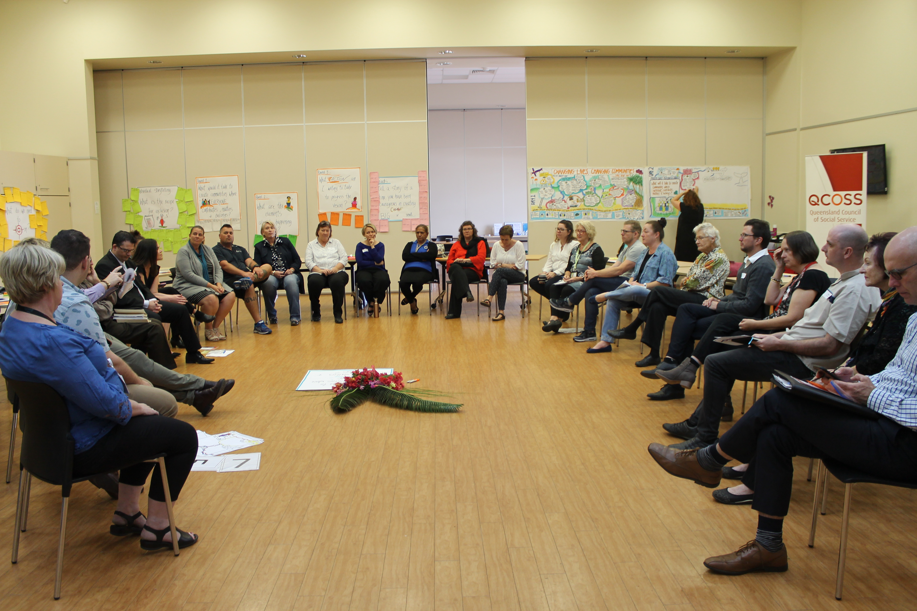
“What would it take to create a community where everyone contributes, matters and belongs?” – Fraser Coast, August 2018

Identifying conditions for change
Part of creating a shared vision and commitment to change is identifying the systemic factors that have contributed to creating or maintaining the current situation, and creating a logical theory of how future actions might change those factors. We recommend doing this in collaboration with the broader community. While you may have some understanding of the current system from your work Mapping the community, you will need people looking at the system from a range of perspectives before you can get a full picture.

Systems thinking
Systems thinking is a way of seeing overall structures, patterns and cycles in systems, rather than seeing only specific events in the system. It is a way to think about the world not by reducing it into small parts but by embracing the complexity that emerges from the interconnection of parts. Systems thinking has been used by fields such as public health, management, organisational behaviour, and sustainable development. This broad view can help you to quickly identify the real causes of issues and know just where to work to address them.
A ’systems thinking’ approach involves mapping relationships and interconnectivity, articulating assumptions about how change occurs and how the social ‘problem’ is being addressed by an initiative that is part of a larger system. It involves thinking about the barriers to change, and the interventions to change the system. It also involves thinking about current structures and ways of working that exclude certain voices, create differential advantage, and maintain current dynamics and power relations in place.
One useful model for thinking about the different sites for change is the Water of Systems Change model. This model describes three levels of systems change, starting with traditional mechanisms of social change such as policy, practice or resource shifts; down to transformative change at a fundamental level, which requires shifting the mental models operating in a circumstance.
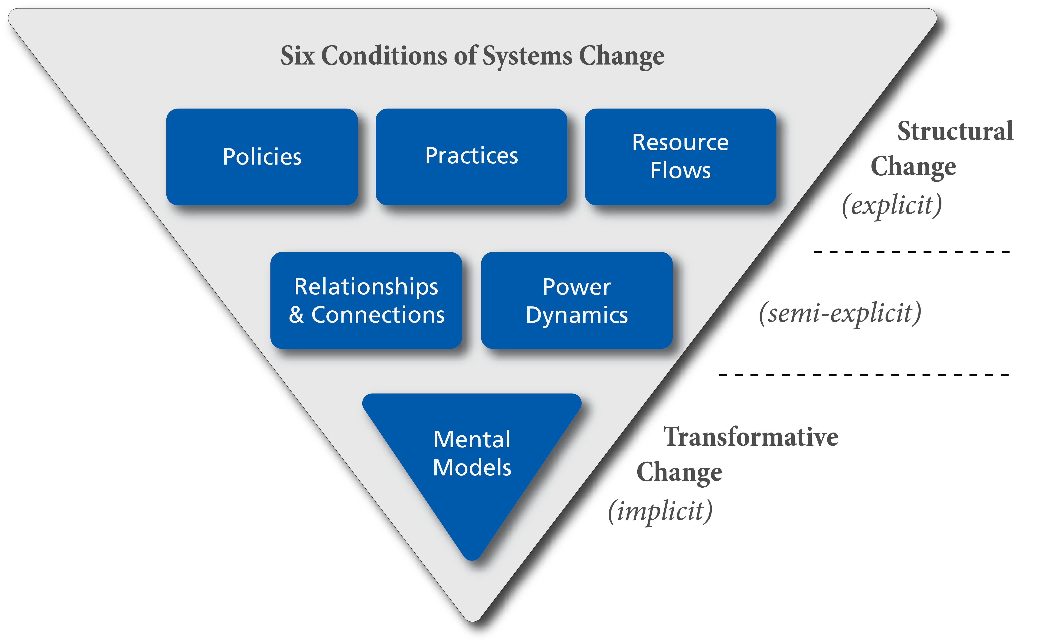
Source: Water of Systems Change by John Kania, Mark Kramer, Peter Senge
Link: The Water of systems change, by John Kania, Mark Kramer, Peter Senge https://www.fsg.org/publications/water_of_systems_change
Part of understanding our outcomes includes work with leaders and community members in place to identify what the factors and levers are that are contributing to maintaining existing systemic barriers and issues, and what needs to be leveraged to generate the change we want to see.
Tool: Water of Systems Change Action Learning Exercise to support individuals and organisations to reflect on how systems change occurs https://www.fsg.org/tools-and-resources/water-systems-change-action-learning-exercise
Link: Theory U, a useful resource for reflecting on how change happens by Otto Scharmer. http://www.ottoscharmer.com/

Theory of change and program logics
Once you have identified the factors or levers that are contributing to the situation you would like to change, it is useful to develop a theory of change or program logic for how you might make a change in the community.
One way to map links between activities and outcomes is a program logic, which generally specify more direct causative links and include resources required. A program logic model is helpful when you are looking at a defined piece of work that has clear resources and inputs and defined outcomes.
Another way to understand how certain activities might lead to change is a theory of change. These are generally more helpful if the systems are complex, the work is less defined, and therefore less known. Developing a theory of change or a program logic is a participatory process where stakeholders in a project identify the conditions required to reach their shared vision. The process of change is arranged graphically in a change model, which shows the pathways and interventions required to realise the change.
A theory of change or program logic is:
- the process of working out the theory, in participatory group sessions involving the people who will undertake the activities and;
- the product of that process, a document of the change model showing how and why a goal will be reached.
“One of the best aspects was when we did the program logic. That really gave us a clear understanding of where everyone was, it found the common themes, but again it led back to the strengths of each person in the group and how they could contribute or how we could leverage their take,” - Strengthening our place leadership group member.

Having a theory of change enables us to understand the systemic factors impacting on the place, what broad level activities might help us to reach our shared vision, and what resources might be needed to implement those activities. It also provides a basis for measuring progress towards and achievement of agreed outcomes.
There are a number of processes that can be used to analyse systems and create a theory for change, including the Five Whys (or Socratic questioning) approach, and creating maps or trees of where you want to get to, such as a Problem and Solution or Opportunity tree.
Sample: Program logics for Strengthening our place https://www.qcoss.org.au/wp-content/uploads/2019/06/Sample-Program-Logics-REVIEWED.docx
Sample: Theory of change examples https://www.theoryofchange.org/library/toc-examples/

Link: Theory of change and logic models (introduction) http://whatworks.org.nz/frameworks-approaches/logic-model/
Link: How to write a theory of change http://www.tascosslibrary.org.au/how-write-theory-change-0

Link: Using logic models and theories of change better in evaluation by Better Evaluation
https://www.betterevaluation.org/en/blog/Using-logic-models-and-theories-of-change-better-in-evaluation

Link: Community Builder's Approach to Theory of Change: A Practical Guide www.theoryofchange.org/pdf/TOC_fac_guide.pdf

Link: Program Logic Development Guide https://www.wkkf.org/resource-directory/resource/2006/02/wk-kellogg-foundation-logic-model-development-guide

Link: The Five Whys approach https://www.adb.org/publications/five-whys-technique

Link: The Problem and Solution Tree approach http://evaluationtoolbox.net.au/index.php?option=com_content&view=article&id=28&Itemid=134

Committing to shared outcomes
The collaborative nature of place-based approaches requires not only the establishment of a shared vision, but the development of shared outcomes and outcomes indicators which support measuring progress towards the vision. This step helps to convert a theory of change into a commitment to a tangible goal. Longer-term shared outcomes are also sometimes described as social impacts and collective impacts.
It is important to define an outcome associated with your vision, to make it a goal that seems real and tangible. It is also helpful to have some kind of outcome indicator to work towards. For example, you may have a vision for all people in your region to feel secure at home. One tangible outcome you may want to work towards might be to improve housing stability in your area. You might choose to measure this outcome of greater housing stability through the outcome indicator of “50 more dwellings that were reported fully owned as tenure type according to the Australian Bureau of Statistics Census”. This might be a longer-term goal. In this way, the outcome of housing stability is ‘operationalised’ into a tangible and measurable indicator of the number of households that owned their own home. In most cases this will be defined through your theory of change or program logic model, and may include both population level and process level outcomes. What is important in place-based approaches is that there is a commitment to a shared outcome/s – that all members agree.
In higher complexity collective impact place-based approaches, shared measurement systems are a core feature, where initiative partners work towards measuring activities and outcomes through standardised ways of recording service data and reporting, and measuring outcomes in the community. Working on a shared measurement system can certainly encourage shared understandings of the issue, support integration of systems, and ensure parties stay accountable to one another and to the collective vision. However, shared measurement systems also often require standardised ways of working and rigorous data collection, which can be time-consuming, resource-intensive and might inhibit flexibility and diversity. An excessive focus on establishing shared measurement might accidentally divert resources away from improving collaboration in service delivery, or other structural reform.
Film Clip: Strengthening our place - #4 - How have you measured the impact? https://youtu.be/y0KeWQdEsTw
Link: Article – How to measure outcomes, by Social Ventures Australia
https://www.socialventures.com.au/sva-quarterly/how-to-measure-outcomes/

Link: Article – Shared measurement, easier than you think
https://www.socialventures.com.au/sva-quarterly/shared-measurement-easier-than-you-think/

Link: Presentation - Implementing shared measurement https://www.fsg.org/tools-and-resources/implementing-shared-measurement

Jargon Alert: Shared measurement systems require diverse organisations to employ the same techniques for gathering, analysing and reporting data. All project members agree to measure particular activities and outcomes through standardised ways of recording services or outcomes. This can involve establishing new data collection systems such as a shared databases, and sharing data regularly or in live-time with other project members.
Link: Paper ‘Shared Measurement: The Why is Clear, the How Continues to Develop’ by Mark Cabaj (2017) https://www.tamarackcommunity.ca/library/shared-measurement-paper

3 Building a plan for change
Once you have created a community conversation around change, agreed upon a collective vision, and created a shared understanding of the systemic factors that are influencing your environment, it is time to look for opportunities for change. This part of the approach involves processes which generate ideas for innovative solutions, and create a plan to reach shared outcomes. Community members develop a collaborative plan (e.g. a Community Action Plan) which outlines shared vision and outcomes, resources, governance mechanisms, projects that contribute to achieve the vision, targets and measurements, and evaluation approaches. This first plan could include some prototype or pilot projects that will enable the group to test out some of the ideas, and through their implementation, refine the collaboration and build trust within the group.
Link: How to produce a great place-based plan by Collaborate for Social Change
https://collaboratecic.com/how-to-produce-a-great-place-based-plan-1096f87b65e7

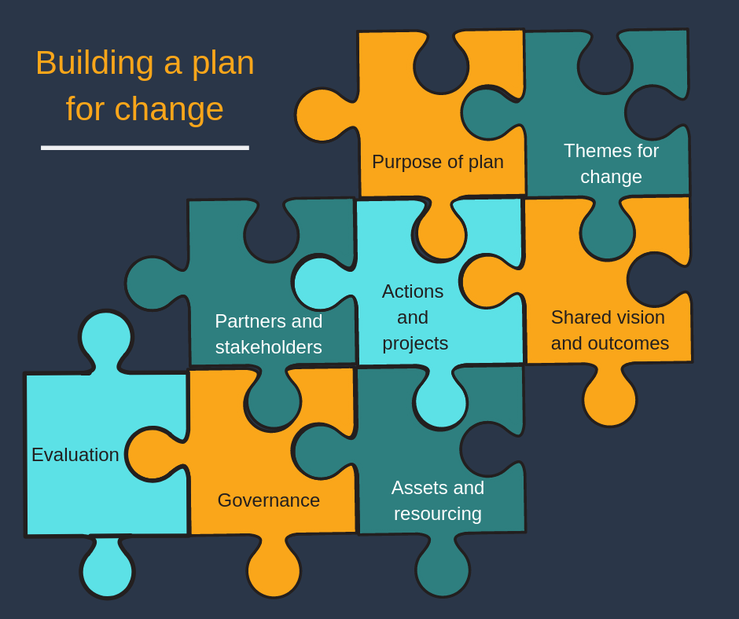

Generate ideas for solutions
Once you have your shared vision and created a theory of how you hope to ‘shift the needle’ in your community, it is time to move to action. Generating ideas for solutions is the place many people want to jump to. It is where the action and movement is! Sometimes the ideas that come out are not new ones, they could have been bouncing around in a community for some time, but sometimes these ideas need a little bit of structure and input from others to get off the ground. Other times, completely new and innovative ways of thinking may emerge.
Depending on what your shared vision and outcome is, activities in your place-based plan might include:
- undertaking deeper mapping, data analysis and research activities to further build understanding
- leveraging the cross-sectoral buy-in and influence of the place-based leadership group to take action around an agreed issue
- creating opportunities and new structures for greater community engagement and involvement in decision-making processes, service and system design
- developing a new collaborative program or initiative
- establishing networks and regular relationship-building opportunities, and creating mechanisms to share skills and information (such as a community of practice)
- creating opportunities for business-community partnerships and programs
- collectively advocating to others with influence around agreed issues
- re-designing systems, services, client pathways and referral pathways or other ways of working
- re-thinking ways of managing resources, sharing or pooling resources, changing distribution of resources or changing commissioning and investment patterns and processes
- mapping resources and funding and thinking about novel ways of resourcing services and systems
- brokering formal partnerships between key stakeholders
- sharing data and information on outcomes or even establishing shared data measurement systems
- hosting community building and awareness raising campaigns and events
- fundraising and seeking philanthropic support for an activity
- creating workshops and trainings, improving practices, or looking at other workforce development needs
- developing shared understandings and communicating to the broader community in a shared way
- communicating around the initiative
- evaluating the initiative and sharing learnings along the way
…and many more.
The process we have used time and again for the generation of ideas and solutions is Open Space Technology.
Tool: Open Space Technology
Open Space is a group process medium suitable to large groups, requiring very few resources but providing a good structure for community members’ ideas to emerge, refine them a little, and find out what energy there is from others to progress it. While it is a simple process it does require some preparation and thought, and we recommend reading Michael Herman’s guide to Open Space Technology.
There is a lot of information out there on Open Space, but don’t get put off. It is, in its heart, a simple process in which the agenda is set by the people in the room; in which space is given for deep thinking about issues and ideas; and in which the strengths of the people in the room are harnessed to address complex issues.
In short, Open Space Technology creates a ‘marketplace’ for ideas to emerge from the group. Anyone putting forward an idea is asked to write it on a piece of paper and put it up in marketplace (which is usually a dedicated wall in the room). As with many powerful processes, participants are encouraged to position their idea as a question – inviting others to come and help explore the question. Those putting forward an idea take responsibility for hosting that conversation in which the question is explored and plan of action formulated. Templates are often provided to support the conversation.
Sometimes similar ideas will emerge, and the hosts of those ideas may decide to merge. After all the ideas are up in the marketplace you may give the whole group some time to look at all the ideas and decide which one they would like to put their energy into. Each host with their idea should move to a designated spot to host their idea conversation.
There are further steps you may take to structure the refinement of ideas, and you can find out more about the process through Michael Herman’s guide, or by looking at the sample group process provided below. Once all groups have had adequate time to talk through their ideas, there should be an opportunity for providing a summary back to the larger group, and plan made for what will happen next across all ideas.
Link: Open Space technology by Michael Herman http://www.michaelherman.com/publications/inviting_leadership_guide.pdf
Link: Open Space Technology Introduction - https://youtu.be/M_jhcvCYBbg
Link: Open Space World: http://openspaceworld.org/wp2/
There are some conditions that will encourage new ways of thinking, generate new ideas and mature existing ideas:
- Diverse group!
We all come with different perspectives and ways of thinking through problems. If the group participating is diverse, the ideas that come out are often diverse. Someone’s business expertise, lived experience or community knowledge might be exactly what is needed to give an idea the push needed to get it off the ground and happening. Different members of the community will hold different pieces of the puzzle.
- Trust
It can be difficult to trust the process, as you never know what will come out! If you have spent a good amount of time visioning and creating connection within the group, trust that good ideas will emerge. We have experienced slow starts with groups, where there is nervous silence at first, but we have never experienced facilitating a process like this where nothing good comes out of it. The people hold the solutions, and they will come out eventually.

- Put aside limitations
Think bold and think big. Do not be limited by what you think you know. In particular, put aside concerns about how you will resource the ideas for now, and see what can come out of the conversation. At this stage, the aim is to create as many opportunities and ideas as possible. If an idea is really well thought out, it is likely to find resourcing along the way.

- Participate with passion
As with many participatory processes, the strength of Open Space is in the strength of the people participating. All participants have a part to play and have resources and skills and knowledge that can support ideas and projects to come to life.

Prioritising and planning
Now you have a number of ideas for possible actions and solutions, you will need to create a plan for how these ideas will come into being
Planning involves several key steps which may include:
- prioritise ideas for action, based on the ideas you have generated above
- agree on actions to take
- commit, align resources, and establish roles
- develop a plan of action
A good plan should cover all of the ‘W’s – starting with why, then what, when, where, who as well as the how. Elements of a good plan might include:
- Purpose of plan
- Themes for change
- Shared vision and outcomes
- Actions and projects
- Assets and resourcing
- Partners and stakeholders
- Governance mechanisms
- Evaluation processes, including indicator measurements and targets
It can be very challenging and time-consuming to draw together diverse threads into a comprehensive plan with clear priorities and agreed-upon actions. It is good to be aspirational, but it is also importance to stick to realistic, manageable actions. It can be helpful to focus on the highest impact opportunities to work together (known in collective impact as mutually reinforcing, high leverage activities), rather than trying to capture everything happening in the community in the plan. It can also be helpful to think about how to capture efforts to work towards the collective vision without necessarily imposing strict standardised structures on how people choose to work towards the shared goal.
Careful facilitation is required throughout a planning process or minority voices may still go unheard. In this respect, dedicate time to planning how you will facilitate your planning session. Refer back to Facilitate conversations in Finding shared vision for resources.
Some additional tools that can be used to help a group prioritise and identify a course of action include Dotmocracy, the ORID discussion method, and generative decision-making. Our sample community action planning document draws on some of these processes in a one-day workshop to help groups design local solutions to a shared vision. The project-planning template provides an example of a template that can be used to start unpacking what it would take to reach a particular goal.
Sample: Group Process for community forum to progress ideas, part of the Strengthening our place initiative https://www.qcoss.org.au/wp-content/uploads/2019/06/sample-group-process-_-leadership-group-REVIEWED.docx

Template: Project planning template, part of the Strengthening our place initiative
https://www.qcoss.org.au/wp-content/uploads/2019/11/Project-Template-for-planning.pdf

Link: Harnessing the Power Source for Collective Impact: Mutually Reinforcing Activities https://www.collectiveimpactforum.org/sites/default/files/Harnessing%20the%20Power%20Source%20for%20Collective%20Impact%20v4.pdf

Link: Article – Collective Impact 3.0 by Liz Weaver and Mark Cabaj https://www.tamarackcommunity.ca/library/collective-impact-3.0-an-evolving-framework-for-community-change

Link: Dotmocracy https://toolbox.hyperisland.com/dotmocracy
Link: The ORID method
https://www.bridgew.edu/sites/default/files/relatedfiles/ORID-discussion-method-6.3.14.pdf
Link: Generative decision-making process
https://medium.com/percolab-droplets/generative-decision-making-process-cf0b131c5ac4

Link: How to help a group make decisions
https://trainings.350.org/resource/how-to-help-a-group-make-decisions/
Once you have a plan, a great format for sharing it more widely is through a roadmap, or another visual representation. It can also be helpful to create a one-page version of your plan to better communicate it with the broader community.
Link: Building a Plan on a page by the Tamarack Institute
http://www.tamarackcommunity.ca/library/building-a-plan-on-a-page
Link: Your Project Business Plan: http://www.biglotteryfund.org.uk/pub_business_plan_guide.pdf
Link: Logan Together Roadmap http://logantogether.org.au/the-roadmap/
Sample: Homelessness Community Action Plans 2010-2013 for Brisbane, Cairns, Hervey Bay, Toowoomba, Caboolture, Gold Coast, and Mt Isa. https://www.qcoss.org.au/hcap

Incorporating monitoring, evaluation and learning
It is helpful to embed a cycle of integrated learning into place-based approaches right from the planning phase. Developmental evaluation supports ongoing monitoring, learning and research to ensure a place-based approach is fully effective.
Part of developmental evaluation is creating a culture of sharing and learning. Some things to remember in a culture of learning:
- It is okay to be vulnerable – remember that honesty feeds trust, and you need trust for the process to work. If something hasn’t worked, name it, ask some good questions about why, and then ask how it could be done differently
- Involve everyone in your learning. If you learn something but you don’t communicate it with others, it is lost learning.
It is important to stop and reflect at every key step of an initiative and build key reflection points into your plan. Use the feedback gathered along the way to adapt and change direction where needed.
Embedding monitoring and evaluation processes into your initiative from the start is vital to measuring progress towards your shared vision and shared outcome. This includes taking baseline measurements for indicators you are trying to make progress on; and building in the process of gathering data and stories, recording activities and examining learnings throughout the life of your initiative.
See also Digging into data
Link: Developmental evaluation by the Australian Institute of Family Studies https://aifs.gov.au/cfca/publications/developmental-evaluation

Link: Developmental evaluation by Better Evaluation https://www.betterevaluation.org/en/plan/approach/developmental_evaluation

Link: Evaluating social innovation https://www.fsg.org/publications/evaluating-social-innovation
Link: Building a strategic learning and evaluation system for your organization by FSG https://www.fsg.org/publications/building-strategic-learning-and-evaluation-system-your-organization

Link: Department of Social Services – New Framework and Toolkit for evaluating place-based delivery approaches https://www.dss.gov.au/new-framework-and-toolkit-for-evaluating-place-based-delivery-approaches

4 Enabling local collaborative governance
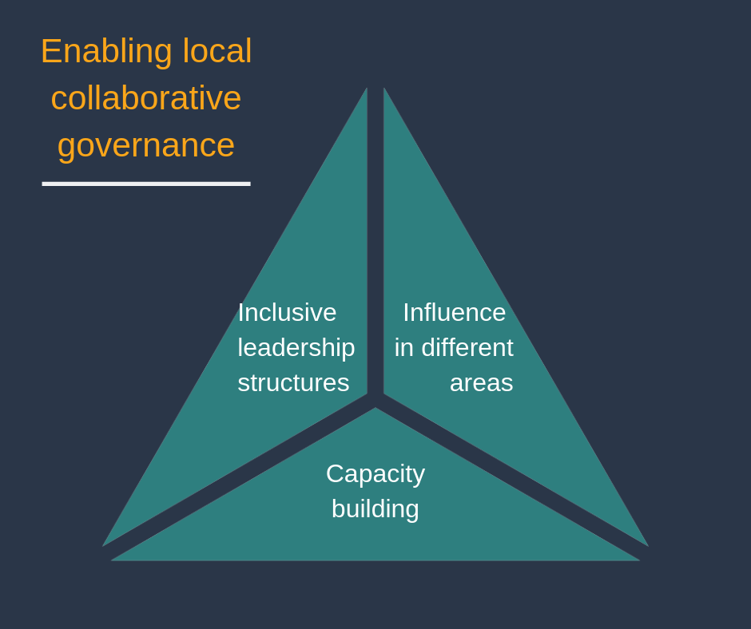
Local collaborative governance is a key feature of place-based approaches. It ensures that systems are driven by local people in place and involves establishing inclusive leadership structures in different areas of the community and with multiple levels of influence, and capacity building communities to lead systemic changes.

Leadership structures
In order to steer the place-based plan, it is essential to develop representative, collaborative leadership structures. Such a group is essential to have oversight of the work, maintain a focus on the vision and the commitments people have made, and make decisions about how the work will unfold as things move and change.
The form and complexity of governance will vary dependent on where the place-based approach sits on the place-based continuum. For example, under a collective impact approach, a formal structure with high levels of systemic influence is essential; on the other hand, a small-scale neighbourhood level project using a place-based approach may require a small strong working group to lead the work. Such structures should be locally driven, involve adequate levels of delegated authority to make systemic changes where relevant, and incorporate strong representation from the community.
Tip: Work with existing structures
During your mapping work, you will have identified existing networks and partnerships. To avoid ‘meeting overload’ and duplication of existing efforts, it is a good idea to work with existing structures. If your area already has a cross-sector leadership group, can the place-based governance structure become a working group within that existing structure? As long as it incorporates the features of local collaborative governance (including multiple levels of influence and community involvement), it can help drive the work.

Who is at your table?
It is very important to carefully consider who will form part of the leadership group. It is a good idea to consider your Tool – Community mapping checklist and your Tool - Mapping relationships and influence. Ask as many people as possible who they think should be represented. Who forms part of the leadership group will depend on the theme and plan of the place-based approach. Ideally, a leadership group should include:
- Community representatives with local lived experience/context expertise in relevant themes of the initiative
- Representatives from government agencies with some level of delegated authority to influence government agency operations and/or government resourcing
- Strategic-level leaders from community services organisations
- Strategic-level leaders from industry and business.
More complex place-based collective impact initiatives would require representation from all levels of government and across several portfolios, as well as leaders from all major service providers. It should also include as many people as possible with relevant context expertise.

The following framework from the Community Engagement Toolkit is useful to consider context expertise.
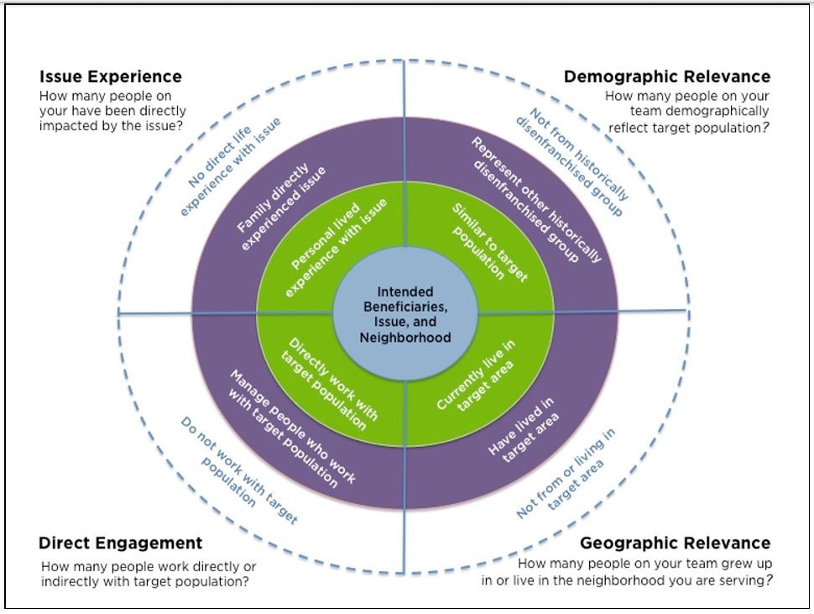Source: Community Engagement Toolkit https://collectiveimpactforum.org/resources/community-engagement-toolkit
When looking at your decision-making table, you should be aiming to include as many people as close to the centre of the circle as possible, representing as broad a diversity of people from the community as possible.
You may wish to invite participation in leadership structures from a broad audience. For example, you can invite expressions of interest from a broad range of people who might like to participate in leadership and working groups. You might establish local champions who can be a point of contact and advocate around the initiative. The process of inviting and engaging community members to be part of the initiative can take a significant amount of time.
Sample: Expression of interest for local champions – Southern Cross University and QCOSS
https://www.qcoss.org.au/local-champions-southern-cross-university-and-qcoss-expression-interest
Creating socially inclusive governance structures requires both resourcing excluded people to participate, and changing the way structures operate so that they are more inclusive. For example, people experiencing disadvantage might benefit from support and reimbursement for transport, sitting fees, food, and childcare. The timing of processes and meetings should be accessible to broader communities wherever possible – for example, by hosting some key meetings after hours. You should also engage in the same practices for being socially inclusive mentioned above in Hosting conversations in place – see Tip: Socially inclusive engagement and Tip: Socially inclusive facilitation.
The extent to which community members engage with a project will depend on their own energy and resources and may lose momentum over time. Remember that people in communities may wear many hats. They may play different roles at different times and move between positions in organisations. People across the community are often time poor and find it difficult to make the time to participate. It can help to have clear roles for community members, and lots of different opportunities for community members to be involved in and contribute to the initiative. These opportunities will range from being part of the core leadership team to providing input and advice.

Clear roles and purpose
When creating leadership groups, we have learnt it is important to establish clear roles for the group and group members; have some degree of formal terms of reference and formal processes; and maintain consistency in group members as far as possible.
Time should be taken to ensure leadership group members are clear on the role and purpose of the leadership group within the initiative, purpose of the group, and where there is more than one working group, the overall structure of governance. There must be a sense of local ownership of the vision, and a shared commitment to sharing the vision across their community and achieving the shared outcomes (see also Documenting and sharing the work).
Regardless of the differing ‘status’ or ‘importance’ of different group members, it is important that power is shared and no one organisation or government agenda overpowers another. Your role in the group must also be very clear – are you facilitating the work, are you a funder, or are you providing services or activities that work towards the shared vision? It is important that decision-making processes are transparent, and funding arrangements are handled with care and sensitivity.
“I think one of the greatest opportunities is hearing from all the parties and having an open mind to see not only what the collective group can do, but seeing what the opportunities are inside connections, or within the connections you form with the people at the table. My experience has been that as an entire group we obviously have a vision, but then there have been incidents in time, and I’m a big believer in allowing the time for things to naturally occur, so it might be next week, it may be next month, it may be next year, that another conversation is had and it resonates with you, and you’re able to pick up the phone to the connection you’ve made,” - Anita White, place-based leadership group member.
We have also learnt that having structures around meetings and purpose helps to drive the work. We recommend developing a terms of reference, and holding regular meetings with a clear agenda, purpose and actions arising. We have also learnt that a significant part of each meeting should be devoted to conversations and activities that build relationships.
Each group and place have their own dynamic and energy, and so as with all things place-based, the pace of activities, meetings and workshops should be flexible and adjusted to the needs of place. Meetings might need to be adjusted for Sorry Business, major community events, or even natural disasters and critical incidents.
Sample: Leadership group terms of reference, part of the Strengthening our place initiative

Link: Meetings on Community Door https://communitydoor.org.au/organisational-resources/boards-and-management-committees/meetings

Key learning: One Group to rule them all?
In the Strengthening our place Fraser Coast initiative, several groups evolved to lead different elements of the work. This developed over time as different structures emerged to manage different parts of the plan. This is consistent with the theory of constellation governance, a model of governance and leadership which enables people to organise around the things that energise them and are relevant to their work.
It is important where there are multiple structures that the terms of reference for each is clear, and that there are clear pathways for how they interact and communicate that everyone is aware of. It is also often useful if there is shared membership of at least one person across groups to share information between them (without duplicating membership completely).
Link: Listening to the stars: The constellation model of collaborative social change by Surman and Surman (2008). https://socialinnovation.org/wp-content/uploads/2016/10/Constellation-Paper-Surman-Jun-2008-SI-Journal.pdf

Supporting group development
The success of a place-based approach is dependent on the ability of those leading and participating to work well together, make decisions, negotiate, manage conflict and resolve disputes. Participatory processes are essential to supporting effective leadership groups.
There are many resources available on developing and working well as a group. It can be challenging bringing together and facilitating teams of people with diverse perspectives and priorities. In our place-based approach, we aim for diversity in our leadership structures, but this itself can present challenges. Modelling participatory processes in leadership group meetings demonstrates authenticity in the work; provides an opportunity to practice process in trusted environment; and builds capacity across the team to engage across community.
Psychologist Bruce Tuckman created a useful framework for understanding team formation and group dynamics, known as Forming, Storming, Norming and Performing.
Forming: the initial stage where group members learn about one another, the goals of the group and the resources available to achieve them. At this stage, group members are often getting to know one another, and interactions tend to be distant and polite. This will typically last for the first one or two meetings.
Storming: This stage is more tumultuous, as differences between group members start to emerge. Members tend to be more open with their opinions, meanwhile trust and collegiality is still developing. Often group members will debate, critique, confront and ‘test’ one another. This stage can be occasionally unpleasant and uncomfortable, but necessary for group members to get to know one another. This stage can often take up to three or four meetings before transitioning.
Norming: During this stage, the group starts to find clarity and function better as a team. People are more aware of each others strengths and areas for improvement, and more willing to take action to meet the group’s goals. Roles and responsibilities become more clearly defined, conflict is avoided and activity is more streamlined.
Performing: At this stage, group members actively trust and accept each other. Leadership within the team is flexible and can shift between group members at different times for different pruposes. Processes for making decisions are streamlined. Group members have a sense of freedom and a sense of belonging. Not all groups reach this stage.

Key learning: Consistency of group membership
While it is important to engage as broad a group as possible to lead and govern place-based approaches, we have also learnt that it is important to maintain some degree of consistency in the membership of leadership and working groups. Casual, changing membership and regular inclusion of new members can reduce commitment to the agreed activities, and interrupt the process of creating a group identity, consolidating relationships and trust. It can revert the group to an earlier stage of team-building, so the group is always stuck in forming and storming. It is important that group membership is somewhat stable, attendance is as consistent as possible, and that new members are supported and properly inducted into the group’s purpose and ways of working. See also Key learning: The need for stability in Scoping the place-based approach.

A number of decisions need to be made as part of a place-based leadership group. At increasing levels of complexity, actions in the plan might include radical shifts in ways of working together and managing resources. It is essential that decision-making processes are clear and inclusive. There are a number of theories and methods that can guide decision-making processes. There are some resources on this available in the Prioritising and planning section.
Community Door also has a number of resources around managing change and working in collaborations.
Link: Negotiation in collaboration
https://communitydoor.org.au/collaboration/negotiation-in-collaboration
Link: Managing conflict
https://communitydoor.org.au/organisational-resources/collaboration/stage-3-managing-change-arising-from-collaborative-practice-4

Link: Dispute resolution process
https://communitydoor.org.au/organisational-resources/collaboration/stage-3-managing-change-arising-from-collaborative-practice-5

Link: Working in Groups, on the Change Agency website
https://www.thechangeagency.org/campaigners-toolkit/training-resources/working-in-groups

Capacity building for leadership
To ensure governance structures are socially inclusive and citizen-led, it is important to support and skill community members to lead the development and implementation of the work. This is not to say that there is not capability within communities - in some cases there may be more of a need for connecting people (for example business with community sector), rather than hosting training.
Capacity building includes developing skills and providing resources for communities and workers. When scoping the assets of a community it is very useful to consider what the leadership needs are – do leaders need to be better connected to leverage off one another’s expertise, or are there some real gaps in the skills required to work collaboratively? Leaders and champions in place have found professional development helpful with a focus on:
- Systems thinking
- Collaborative practice
- Mentoring emerging leaders in community
While training and professional development can be a useful part of building local capacity, the learnings must be revisited and embedded. It is too much to expect that community members can attend one-off training and be equipped to address the complex issues they are faced with. Support in applying and testing out theory is useful and is best done over a period of months.
In some of the place-based approaches we have supported, we have created local champions training to do just this. It has involved calling on members of the community to express their interest in learning and refining skills required to lead place-based work in community and supporting them through the delivery of training and ongoing mentorship over a period of time.
Sample: Local champions training presentation
https://www.qcoss.org.au/rockhampton-and-fraser-coast-local-champions-capability-sessions

Additionally, we often need to revisit what we mean by leadership or ‘leader’. In the place-based approaches we have supported, we have considered anyone with the energy and willingness to guide work a ‘leader’.

Developing leadership means regularly ‘re-casting the net’ to develop leadership broadly in the community, including those who are deeply socially excluded. We draw upon learnings around pluralistic leadership, where leadership is a verb that people do at different times, rather than a quality people have or a position they hold.

Link: Pluralistic leadership https://ssir.org/book_reviews/entry/pluralistic_leadership

Link: Book: Everybody Leads, by Paul Schmitz https://www.leadinginsideout.org/books/

5 Enacting the plan
Because every community is different the process of enacting your plan will also be different. How you go about ‘doing the work’ will depend on what you are trying to achieve. In general, we have found it is important to maintain momentum, document and share the work regularly, and reflect and celebrate along the way.
Case study: How the Butchulla people are re-visioning an ancient rite of passage https://www.qcoss.org.au/publication/place-based-in-fraser-coast-a-case-study-how-the-butchulla-people-are-re-visioning-an-ancient-rite-of-passage/

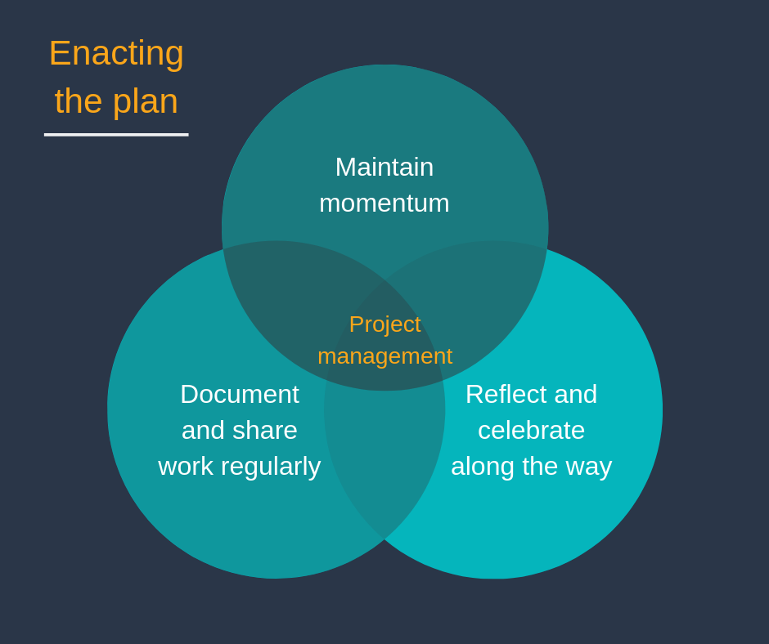

Project management
Once a place-based plan of action plan is in position, implementation may include:
identification of available resources - both within the community and outside; sourcing additional resources including funding; establishment and resourcing of local project teamsthinking about data and story you can collect to measure performance and impact.
It is important to remember that people have different ways of planning and may have varying levels of skills. There are many different project management tools you may like to draw on. One method is called agile project management which recognises that change is not linear but emergent. Some of the key principles and processes of agile project management align well with place-based approaches; relationships-based, responsive to change, working solutions, reflecting and adjusting.
Link: How to implement agile project management: https://knowhownonprofit.org/how-to/how-to-implement-agile-project-management-in-your-organisation
Link: Agile (Project) Management – not a contradiction: https://www.aipm.com.au/documents/industry-research/181126_agile_whitepapers.aspx

Link: Complex project management

Maintaining momentum and engagement
One of the most significant challenges is what happens after we have created a plan? What are the ways that people will remain motivated and energised to work on implementing their community actions? How will people remain accountable to each other? How do we ensure an ongoing commitment to engaging deeply with the community?
We’ve found that having regular catch-ups and having structures for ongoing support are important here. For instance, our leadership development training involved a group undergoing a two-day leadership program where they identified a community project they wanted to work on. Participants were then linked to a mentor and a regular community of practice for group accountability and support.
Regular leadership group meetings and opportunities to connect with mentors and backbone motivators can help drive the project. Establishing smaller working groups with lines of accountability and support can steer various parts of the work. Where activities are floundering, it is important to reflect as a group on what the barriers are and to think of ways to resource and support the work. Often the barriers include:
- lack of time and energy from participants to drive the plan;
- lack of buy-in or support from key formal leaders to support reform or dedicate resources;
- needing time to build broad engagement across stakeholders and the community;
- lack of resources dedicated specifically to support networking and collaboration; and
- lack of long-term funding for services and systems to support or justify improvements in practice
We believe in ‘going with the energy’, as espoused by participatory leadership where people give their time and resources to the things that are important to them. It may be that commitment to achieving the vision is waning, or that people are losing a sense of confidence in their ability to make a difference. Having a facilitator or backbone role who can spend time being a ‘roaming motivator’ can be helpful to maintain momentum.
Link: Making Meetings Work – Collective Impact Forum https://www.collectiveimpactforum.org/blogs/38876/making-meetings-work

Key learning: Cast the net wide
While there are times that a place-based approach might focus on a particular topic or issue, when a place-based approach is funded through a sector-strategy, it can be difficult to keep a broad range of professional and community representatives engaged.
There is a need to continually work to engage people who currently use or have used services in the past. This transfers and shares power with people affected by social challenges, builds the capacity of everyone involved, and helps deliver effective solutions to locally identified problems.
While this is challenging at the best of times, it is especially challenging when funding to support place-based approaches is funded around a pre-determined topic.
As the focus of Strengthening our place funding was the strengthening of the child and family support sector, it was difficult to engage people from outside of this sector. Some workers explained that they couldn’t justify spending time in their paid roles to be a part of something that did not directly link to their current work focus – even though they understood the long-term outcomes would be positive for them, their role, and their community.

Documenting and sharing the work
As you are implementing your plan, you will want to share your experiences and successes. It is also helpful to create opportunities for others to hear about the work you provide. You will also need to document the work as you go to track progress, share learnings and evaluate the outcomes of your initiative.
Documenting the work is important because it:
- often initiates reflection on the work
- records learnings for you and for others
- is an opportunity to provide the community evidence of their work and progress towards an agreed goal
- makes it easier to bring more people to the table if it is something that can be sent out, seen in local business or services, or used as a talking point at meetings
- builds some evidence for evaluating the outcomes of the work.
Ways that we, and others, have documented the work include:
- Case Studies
Writing case studies or following stories and sharing with others is a good way to drill deeper into the work, and document it in a way that is useful for others to learn from. Make what you did, how you did it and what you learnt clear

- Infographics
Infographic type documents are a great way to share information in a way that is easy to digest. It requires few words and utilises graphics to get the message across. (LINK – Summary of work for SoP Infographic)
- Harvest documentation
You can harvest information that is shared at a meeting or forum, and then share it back with those who attended and the broader community to record the event, process the information and share it widely. Harvesting can take many forms:
  - Graphic harvests - A graphic harvest is a “live” documenting of a meeting or forum using pictures and images. It is usually done by someone with some skills around documenting in this way, but it can be learned and is a useful skill to have. Like infographics, graphic harvests are an engaging way to get your message across without having to read through lots of text. They represent a summary of the key ideas and concepts of the meeting, forum, or even an initiative or project as a whole
  - Harvest sheets – Creating and retaining working paper from meetings, for example group notes and individual reflections. These can then be summarised and analysed after the event to reflect on the process and the learnings, and reflected back to attendees and the broader community
  - Photos - Taking photographs of the proceedings and notes that are taken can be a great way to share what happened
  - Interviews and attendee profiles - Conducting interviews with people who attended and reporting back on who they are and what they experienced
  - Website - Some place-based approaches have the resources to create and maintain a website. Websites are a great way to communicate up-to-date information with stakeholders, providing the internet is accessible and reliable in the community.
Consider who in community have skills and interests that align with documenting the work. For some people, documentation, particularly creative methods of documentation, will be something they have a lot of energy for.

Sample: Harvest from Changing Lives, Changing Communities Capricornia, a part of the Strengthening our place project
https://www.qcoss.org.au/capricornia-heres-how-you-are-changing-lives-changing-communities

Link: Summary of work in place, a part of the Strengthening our place project https://www.qcoss.org.au/project/strengthening-our-place/

Film clip: Video on the Art of Harvesting – https://vimeo.com/2679678
Sharing the work is important because it:
- values the people who are working on the ground
- helps maintain and build momentum
- keeps the community and broader stakeholders informed, even when they can’t be actively involved
We develop communication plans to consider who we want to reach and decide on the different ‘channels’ we use to share our work.
Link: Developing a communication plan
https://ctb.ku.edu/en/table-of-contents/participation/promoting-interest/communication-plan/main

Reflecting and celebrating along the way
Some methods we have used to integrate our learnings into the next steps of a place-based approach have been:
- Documenting learnings along the way in a central point, and then reviewing these learnings at meetings and during co-design phases so that they aren’t forgotten (it is a bitter pill to swallow when you have to learn something twice!)
- Using an external facilitator to ask tough questions (specifically used when reviewing how a partnership is going)
- Dedicating parts of meetings to reflect on the work. There is more about this in Review and renew
- Creating opportunities to celebrate key milestones and share our initiative with the broader community.
Film Clip: Strengthening our place Vignette - #6 - What are your key insights?”, part of the Strengthening our place initiative https://youtu.be/s0TMTMssHMw

6 Reviewing and renewing
In our view, place-based approaches often do not have a distinct end – while the facilitation of a formal place-based approach might conclude, the new ways of working, enhanced relationships, improved outcomes and even potentially the developed structures may continue. For this reason, we consider this later stage to be a time to review and renew the process.

Reviewing
In our experience, and from speaking to others, the why of evaluation is easy to establish, but the how can be challenging. This is because the work is dynamic and often long-term, and often the resourcing for evaluation is light.
An ongoing cycle of integrated learning is an essential feature of a place-based approach. Reflection and adaption occur throughout the work. However, it is useful at a final point to reflect back over a project in its entirety. It is important to jointly evaluate the overall process and impacts to capture the learnings and opportunities for future work. This should involve all the key stakeholders, including local participants.
Some of the methods we have used to review work include:
- Focus groups and reflective group brainstorms at the end of a funded project
A whiteboard or large pieces of paper, participatory facilitation, and a few good questions is all you need to generate a robust discussion. These allowed us to drill deeply into feedback and learnings, so we could check our understanding
- One-on-One interviews
Similar to focus groups, this gives the opportunity for drilling down into meaning in a more confidential and personal way. This might be good for those who are not able to come to face-to-face focus groups, or find it difficult to contribute to a group discussion
- Online surveys
Online surveys are generally quick to do, and can be sent to a wide range of people who may not be able to make it to face-to-face meetings
- Desktop review
Reviewing learnings via meeting minutes, notes from reflective conversations, and any reports generated relating to the work will assist in pulling together any data useful for reviewing and future planning.
Some broad questions that might support reviewing and evaluation activities include:
- Have we increased understanding of place-based practice?
- Have new collaborations and ways of working emerged?
- Have there been impacts for people using or affected by services and systems?
Sample: Group process for evaluation focus groups, part of the Strengthening our place initiative

Key Learning: What we learnt through our partnership, part of the Strengthening our place initiative
https://www.qcoss.org.au/wp-content/uploads/2019/06/Strengthening-our-partnership_what-we-learned-REVIEWED.docx
Key learning: Evaluating place-based approaches is a challenge. Evaluation in general takes significant time and resources. In the context of place-based approaches, it can be even more challenging. Place-based approaches often seek to improve ways of working across a system, and at its higher level of complexity, overcome deeply entrenched and challenging issues. Creating an evidence base for systemic changes is notoriously difficult and it can take many years before shifts in population indicators take place. Shared data and measurement embedded in place-based approaches can support later evaluation, but also can take significant time and resources to create. It can also be challenging to identify all of the impacts that are associated with a place-based approach; shifts in the ways of thinking and models of working, increases in leadership capability, and visioning and ideas generation can have ripple effects across the community that can be hard to track.
It is clear that evaluation must occur in stages – providing resources to evaluate the quality of the features and process of place-based approaches (the overall facilitation, level of community engagement, greater ability to work together, appropriate governance structures, and commitment to continuous learning); to evaluate the improvements in systemic working and individually evaluate the many activities and projects that form part of systems change; and finally to review and track long-term outcomes indicators at the population level. This level of evaluation is costly – it is commonly recommended that between 10 per cent to 20 per cent of a program budget is set aside for continuous learning and evaluation.

Renewing
It is valuable to create space for a community conversation at the end of certain time periods to reflect on progress, promote the work and ‘re-cast the net’ to bring in broader participation for the next stages. You may like to reconsider the Five Stages of Community Life (referenced in the Scoping the place-based approach phase), and return to assessing where the community is at and their readiness and desire to continue working on community change. Even where there are changes or reductions in resourcing for various structures, it is helpful to consider how established structures and capacities become self-sustaining into the future. There is technically no end to a place-based approach, but the way it is resourced and supported might change. Ultimately, the ebb and flow of energy and commitment of the entire community is what drives the impact. At the end of a phase of an initiative, there should be conversations around how structures and initiatives might evolve into other opportunities, or become permanent community infrastructure.
Before you step into another phase of work or another step in the plan, you might want to ask:
- Is anyone missing? Did we miss anyone in the previous work that should be included now?
- How might we build on what we have established? Do we want to continue working together in this way (e.g. continue meeting as a leadership group, or move or transform into other structures)?
- What has been essential and how might we harness (new or existing) resources to sustain those things?
- What would/will we do differently going forward?
- What are our next wise steps to take?
Link: Department of Social Services – New Framework and Toolkit for evaluating place-based delivery approaches https://www.dss.gov.au/new-framework-and-toolkit-for-evaluating-place-based-delivery-approaches

Final thoughts
The process of place-based approaches does not occur in a linear or standardised fashion.
Our learning has come from applying these principles and theories and working alongside the community.
We recommended ‘having a go’ and using opportunities to extend your practice through connecting with other practitioners. We hope to start a conversation about the features, principles and process of place-based approaches in Queensland. For practitioners working in Queensland, we have established a Queensland Place-based Community of Practice and look forward to working with others to further develop our collective understandings, frameworks and processes.

References
Aldrich, D. (2010). Fixing Recovery: Social Capital in Post-Crisis Resilience. Journal of Homeland Security(June).
Anderson, M. B. (1999). Do No Harm: How Aid Can Support Peace - Or War. Boulder, CO, USA: Lynne Rienner Publishers.
Ansell, C. &. (2008). Collaborative Governance in Theory and Practice. Journal of Public Administration Research and Theory(18), 543-571. Retrieved from https://sites.duke.edu/niou/files/2011/05/Ansell-and-Gash-Collaborative-Governance-in-Theory-and-Practice.pdf
Australian Government Department of Social Services. (2014). National Partnership Agreement on Remote Service Delivery Evaluation 2013. Canberra: Department of Social Service. Retrieved from https://www.pmc.gov.au/resource-centre/indigenous-affairs/national-partnership-agreement-remote-service-delivery-evaluation-2013
Australian Social Inclusion Board. (2011). Governance Models for Location Based Initiatives . Canberra, Australia.
Bandura, A. (1995). Exercise of personal and collective efficacy in changing societies. In A. Bandura (Ed.), Self-efficacy in Changing Societies. Cambridge: Cambridge University Press.
Berlinger, N. (2017). More than just sanctuary, migrants need social citizenship. Aeon. Retrieved from https://aeon.co/ideas/more-than-just-sanctuary-migrants-need-social-citizenship
Brooks, D. (2018). The Localist Revolution. The New York Times. Retrieved from https://www.nytimes.com/2018/07/19/opinion/national-politics-localism-populism.html
Buckmaster, L., & Thomas, M. (2009). Social inclusion and social citizenship: towards a truly inclusive society. Canberra, Australia: Parliamentary Library, Commonwealth of Australia. Retrieved from https://www.aph.gov.au/About_Parliament/Parliamentary_Departments/Parliamentary_Library/pubs/rp/rp0910/10rp08#_ftn52
Cabaj, M. (2017). Shared Measurement: The Why is Clear, the How Continues to Develop. Ontario, Canada: Tamarack Institute. Retrieved from https://www.tamarackcommunity.ca/library/shared-measurement-paper
Cabaj, M., & Weaver, L. (2016). Collective impact 3.0: An evolving framework for community change. Tamarack Institute. Retrieved from http://www.tamarackcommunity.ca/library/collective-impact-3.0-an-evolving-framework-for-community-change
Carrière, J. (2016). Neighbourhood Collective Efficacy: A Scoping Review of Existing Research. NCRP & Cities Centre Research Paper, 239(July 2016). Retrieved from http://neighbourhoodchange.ca/homepage/neighbourhood-collective-agency/
Caruana, C., & McDonald, M. (2011). Social inclusion in the family support sector. Melbourne, Australia: Australian Institute of Family Studies. Retrieved from https://aifs.gov.au/cfca/publications/social-inclusion-family-support-sector/relevance-social-inclusion-principles-family
Crimeen, A., Bernstein, M., Zapart, S., & Haigh, F. (2017). Place-based interventions: A realist informed literature review. Liverpool: Centre for Health Equity Training, South Western Sydney Local Health District and UNSW Australia.
Deloitte Access Economics. (2018). Social impact analysis - Morwell Neighbourhood House: Final Report. Melbourne, Australia. Retrieved from http://www.morwellnh.org.au/mnh_social-impact-analysis_may-2018_/
Ham, C., & Alderwick, H. (2015). Place-based systems of care: A way forward for the NHS in England. London, UK: The King's Fund. Retrieved from https://www.kingsfund.org.uk/publications/place-based-systems-care
Hardy, M., & Weaver, L. (2016). Perspectives from the Field: A Conversation about Collective Impact and Collaboration from Australia and Canada. Ontario, Canada: Tamarack Institute. Retrieved from https://www.tamarackcommunity.ca/perspectives-from-the-field
Harwood, R. (2014). Putting Community in Collective Impact. Stanford Social Innovation Review. Retrieved from www.ssireview.org/blog/entry/putting_community_in_collective_impact
Health, D. o. (2018). Retrieved from http://www.health.gov.au/internet/main/publishing.nsf/Content/Commissioning+Information+Sheets+for+Providers
Hogan, D., Rubenstein, L., & Fry, R. (2018). Framing Place-based Collective Impact Principles: A Public Policy Response to Childhood Developmental Vulnerability. Vol 2: Place-based Collective Impact Design Principles. Opportunity Child with Logan Together. Retrieved from https://opportunitychild.com.au/download/framing-place-based-collective-impact-principles-a-public-policy-response-to-childhood-developmental-vulnerability-volume-2/
IAP2. (n.d.). IAP2 Public Participation Spectrum. Retrieved from https://www.iap2.org.au/Resources/IAP2-Published-Resources
Izmir, G., Katz, I., & Bruce, J. (2009). Neighbourhood and Community Centres: results for children, families and communities. Social Policy Research Centre. Sydney, NSW: University of New South Wales. Retrieved from https://www.sprc.unsw.edu.au/media/SPRCFile/2009_Report16_09_Neighbourhood_and_CommunityCentres.pdf
Kania, J., & Kramer, M. (2011). Collective Impact. Stanford Social Innovation Review. Retrieved from http://ssir.org/articles/entry/collective_impact
Kania, J., & Kramer, M. (2011). Collective Impact . Stanford Social Innovation Review(Winter 2011). Retrieved from https://ssir.org/articles/entry/collective_impact
Kania, J., Kramer, M., & Senge, P. (2018). The water of systems change. FSG. Retrieved from https://www.fsg.org/publications/water_of_systems_change
Klein, H. (2004). Health inequality, social exclusion and neighbourhood renewal: Can place-based renewal improve the health of disadvantaged communities? Australian Journal of Primary Health, 10(3), 110-119.
Kretzmann, J. P. (2010). Asset-based strategies for building resilient communities. In J. W. Reich, A. Zautra, & J. S. Hall (Eds.), Handbook of adult resilience. . New York: Guilford Press.
Moore, T., & Fry, R. (2011). Place-based approaches to child and family services: A literature review. Parkville, Victoria: Murdoch Childrens Research Institute and The Royal Children's Hospital Centre for Community Child Health. Retrieved from https://apo.org.au/system/files/53223/apo-nid53223-76706.pdf
Moore, T., McHugh-Dillon, H., Bull, K., Fry, R., Laidlaw, B., & West, S. (2014). The evidence: what we know about place-based approaches to support children's wellbeing. Melbourne, Vic: Murdoch Childrens Research Institute and the Royal Children's Hospital Centre for Community Child Health. Retrieved from https://www.google.com/url?sa=t&rct=j&q=&esrc=s&source=web&cd=1&cad=rja&uact=8&ved=2ahUKEwiY9oPewJzhAhXSdn0KHcaMDbwQFjAAegQIABAC&url=https%3A%2F%2Fwww.rch.org.au%2FuploadedFiles%2FMain%2FContent%2Fccch%2FCCCH_Collaborate_for_Children_Report_The_Evidence_N
Onyx, J., & Bullen, P. (2000). Measuring Social Capital in Five Communities. Journal of Applied Behavioral Science, 36(1), 23–42.
Queensland Productivity Commission. (2017). Service delivery in Queensland’s remote and discrete Indigenous Communities. Retrieved from https://www.qpc.qld.gov.au/inquiries/service-delivery-in-queenslands-remote-and-discrete-indigenous-communities/
Queensland Productivity Commission. (2017). Service delivery in Queensland’s remote and discrete Indigenous Communities. Brisbane, QLD. Retrieved from https://www.qpc.qld.gov.au/inquiries/service-delivery-in-queenslands-remote-and-discrete-indigenous-communities/
Reddel, T. (2017). Belling the Cat – Commissioning for outcomes and evaluating place-based initiatives. aes17 International Evaluation Confernece. Department of Social Services. Retrieved from https://www.aes.asn.au/images/stories/files/conferences/2017/40KathrynMandla.pdf
Sampson, R., & Earls, F. (1997). Neighborhoods and Violent Crime: A Multilevel Study of Collective Efficacy. Science, 277 (5328), 918–924.
Sherif, M. (1958). Superordinate goals in the reduction of intergroup conflict. American Journal of Sociology, 63, 349-356.
South Australian Centre for Economic Studies. (2013). Economic and Social Impact Study - Community and Neighbourhood Centres Sector: Final Report. Adelaide, SA: Adelaide and Flinders Universities. Retrieved from https://www.communitycentressa.asn.au/documents/item/174
Surman, T., & Surman, M. (2008). Listening to the stars: The constellation model of collaborative social change. Social Space, 24-29. Retrieved from https://socialinnovation.org/wp-content/uploads/2016/10/Constellation-Paper-Surman-Jun-2008-SI-Journal.pdf
The Harwood Institute. (1999). Community Rhythms: The Five Stages of Community Life. Retrieved from https://theharwoodinstitute.org/news/1999/12/1/community-rhythms-the-five-stages-of-community-life
The Harwood Institute for Public Innovation. (1999). Community Rhythms: The Five Stages of Community Life. Bethesda, Maryland, USA: The Harwood Institute for Public Innovation. Retrieved from https://theharwoodinstitute.org/news/1999/12/1/community-rhythms-the-five-stages-of-community-life
Tuan, Y. F. (1977). Topophilia: A study of environmental perception, attitudes and values. . New Jersey: Prentice-Hall Inc.
Tuckman, B. (1965). Developmental sequence in small groups. Psychological Bulletin, 63(6), 384-399. doi:http://dx.doi.org/10.1037/h0022100
Vinson, T., & Rawsthorne, M. (2015). Dropping of the edge 2015. Australia: Jesuit Social Services / Catholic Social Services Australia. Retrieved from https://dote.org.au/findings/full-report/
Walsh, C., & O’Neil, M. (2013). Re-Thinking Social Policy: Place-Shaped As Well As People-Focussed. Adelaide, SA: South Australian Centre for Economic Studies. Retrieved from https://www.adelaide.edu.au/saces/docs/issues-papers/saces-economic-issues-37.pdf
Wilks, S., Lahausse, J., & Edwards, B. (2015). Commonwealth Place-Based Service Delivery Initiatives: Key Learnings project. Melbourne: Australian Institute of Family Studies. Retrieved from https://aifs.gov.au/publications/commonwealth-place-based-service-delivery-initiatives

Tool - Community Mapping Checklist
You and your organisation
- If your organisation has existing programs and services in region, what programs and services do you provide?
- Have you or other people in your organisation done work in place-building or community development before? What existing work have you done in this place?
- What existing relationships and influence do you have in the region? What existing relationships and influence do you have with people who make decisions that affect the region?
- What assets do you and your organisation bring to a place-based approach? What support might you need from other people, organisations or resources in order to succeed?
Previous mapping and planning work
- Are there existing community maps? Are there previous or existing community plans in place? What consultative processes have previously occurred in the community?
Geography, infrastructure and environment
- Where are the regional boundaries at a local, state and federal level? What are the boundaries for statistical areas (such as the Australian Bureau of Statistics)?
- What are the key geographical forms and landmarks that make up the place (for example, mountains, rivers, major public buildings)?
- What infrastructure and facilities are in the area – green spaces, council parks, national parks, major venues, sporting facilities, major highways, housing, and shopping centres?
- Are there key animals or places that are important to people in the area? (for example, the cassowary, the beach). Are there particular environmental issues, hazards or regular disasters?
Link: Google My Maps https://www.google.com.au/maps/d/

Link: Maps on Australian Bureau of Statistics http://www.abs.gov.au/geography
Research and history
Many communities have documented historical accounts and documents.
- What are the historical accounts of indigenous history, and key sacred sites and sites of mourning for local indigenous people?
- Are there published academic, particularly grounded or action research projects, relating to the place?
- Are there non-fiction histories or even historical fiction relating to the place?
Cultural resources and key events
- Are there customs and activities that conserve traditions?
- Are there markets or regular public events?
- What are the key events for the community? Are there major dates coming up?

Key stakeholders
Political representation and activity
- Who are the political representatives at a local, state and federal level? What party do they belong to? What are their key interests and what assets do they bring?
- Is there an active political opposition? What are their key interests and what assets do they bring?
- Is there current citizen campaigning around a particular issue? What are these groups called and where do they meet? What issues are in the forefront in this place? Are there issue-specific campaigns occurring or activists’ group meetings? Has there been recent public outcry?
- Who are the formal leaders and informal leaders here who might support the initiative? What assets do they bring?
Tip: Social media, in particular Facebook, can be a great resource for searching for organisations, informal leaders and issue-specific campaigns relating to an area. Try searching Pages or Groups using the place name.

Link: How to search on Facebook https://www.facebook.com/help/460711197281324/
Traditional Custodians, Elders and Aboriginal and Torres Strait Islander people
- Who are the Traditional Custodians of the land?
- Who are the Aboriginal and Torres Strait Islander Elders living and working in the region? Who are the Aboriginal and Torres Strait Islander formal and informal leaders? Note: They may come from Indigenous nations outside the region
- What the Aboriginal and Torres Strait Islander organisations in the region?
- What are the Aboriginal and Torres Strait Islander businesses in the region?
Link: Native Title Representative Bodies and Service Providers https://www.pmc.gov.au/indigenous-affairs/land/native-title-representative-bodies-and-service-providers

Link: Supply Nation – a database of verified Indigenous businesses https://supplynation.org.au/
Institutions
- What key educational institutions are there in the area– universities, schools, libraries?
- What key administrative and justice institutions are there in the area - town halls, courts, prisons?
- What key health institutions are there in the area – hospitals, Primary Health Networks (PHNs), Aboriginal Community Controlled Health Services (ACCHSs), GP clinics, medical and radiology centres?
- What key religious institutions are in the area - churches, temples and mosques?
- What key essential services are provided in the area – energy, water?
- What key media outlets are in the area? Who owns them?
- Who are the formal leaders of these institutions, and other people who might support the initiative? What assets do they bring? For example, academics working on related projects, church leaders running awareness campaigns, or newspaper editors vocal on a particular issue?
Link: List of Aboriginal Community Controlled Health Services (ACCHSs) https://www.naccho.org.au/member-services/naccho-member-services/
Link: List of Primary Health Networks (PHNs) http://www.health.gov.au/internet/main/publishing.nsf/Content/PHN-Contacts
Link: Media control databases https://www.acma.gov.au/theACMA/broadcasting-registers-media-ownership-control-acma
'Media Interests' snapshot https://www.acma.gov.au/theACMA/media-interests-snapshot
Programs and services
- What government services and departments are in the region and who are the main contacts for them? You might look up particular departments if you are interested in a particular issue (for example, Housing, Police, Child Safety).
- What community services are available in the region? What neighbourhood centres are in the region? Who are the major community organisations supporting the area and what services are they providing? These might include services for homelessness and housing, employment support, aged care, disability, counselling and mental health, family supports, support for asylum seekers, immigrants and culturally and linguistically diverse people, and specialist Aboriginal and Torres Strait Islander services.
- Who are the formal leaders and informal leaders here who might support the initiative? What assets do they bring?
Link: List of Queensland Government Departments https://www.qld.gov.au/about/how-government-works/government-structure
Link: Directory of Community Organisations https://www.mycommunitydirectory.com.au/
Networks and relationships
- Are there existing networks, regular meetings or communities of practice in the region?
- Are there representatives or local peak/advocacy organisations?
- Are there existing partnerships between particular organisations or people?
Community and cultural groups
- What music, drama, literature and art activities are happening in the community?
- What community groups and social clubs exist, such as parent groups, sporting clubs and other interest groups, business networks, online communities, peer support groups, and other community groups?
- Who are the formal leaders and informal leaders here who might support the initiative? What assets do they bring?
Business and industry
- What are the major industries in the region, and who are the major employers? For example, agriculture, tourism or mining.
- What local businesses are there, and are any currently involved in community projects? For example, the local real estate and property developers, retail stores, hair, beauty and other personal services.
- Who are the formal leaders and informal leaders here who might support the initiative? What assets do they bring?
Informal leaders
- Are there other informal leaders? Who are the most influential people in the community? What assets do they bring?

Tool - Mapping relationships and influence
It can be useful to map formal and informal leaders, and their relationships and networks.
Consider each person you would like to map:
- Name, job title and organisation?
- Possible interest in the place-based approach? Are they supportive of the initiative?
- Possible influence on the place-based approach?
- What and who influences them? What is their authorising environment?
Start with a large piece of paper, several pieces of paper on a floor or wall, or a whiteboard. Start writing out the names of relevant people. You can also keep it at an organisational level if you prefer.
You can draw the map radiating out from a key person or use multiple ‘central hubs’ to show groups of people. You can group them together based on closeness of their relationship. You might colour-code the people in your map. For example, you might use a similar colour or draw a similar colour box around people who are in the same organisation or network.
Draw different lines between people or organisations to indicate their relationship. For example, you might use different coloured lines or different kinds of lines (dotted, bold, or double lines) to show different kinds of relationships. Do certain people work together? Do some influence or have power over others? Do some have disagreements?
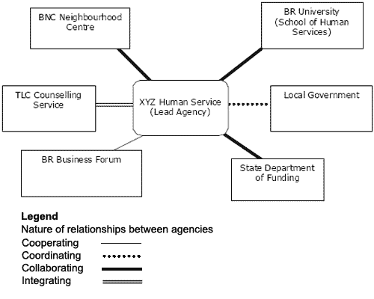
It can also be useful to map power and influence. For example, you might group people according to whether they are likely to support your project, and whether they have any influence over it. For an example, see the Change Agency’s Power Mapping Template.
Link: https://www.thechangeagency.org/wp-content/uploads/2018/08/Power-Mapping-template.doc

Tool – Starting conversations in place
Some of these questions have emerged from User Centred Design and understanding ‘pain points’ in system change.
Introducing yourself
- Name…
- Your country
- Where you live and work
- We are looking at opportunities to improve … create change around … build … in the region
- We were hoping to talk to you about
Building relationship
- Did you grow up here? Where is your family from?
- What is your favourite part of this region?
- What kinds of ways does your work contribute to the community?
Emerging themes
- What are the key issues affecting this community?
- What would help you most in your work?
- If you could change one thing about how the system works, what would it be?
- Complete this sentence, “If only I could just …”
Broadening contacts
- Who else do you think might be in interested in this work? Who else should I speak to?
- Is there anyone who has good connections with particularly hard-to-reach people?
- Who represents culturally and linguistically diverse people?

Tool - How to facilitate a Check-in
Checking in and checking out are processes used to open and close a meeting. The purpose of checking in is to ensure everyone in the group is seen, heard and acknowledged. It also helps people leave their busyness behind and be fully present at the meeting they have come to. Simply put, check-in helps to focus everyone and lets every voice be heard from the start.
Each person gets to have their say, usually by moving clockwise around the group. Questions or prompts used for check-in could include things like, “What brought you to this meeting today?” or “One thing I’d like to get out of our conversation today is…”. Think about who is coming to the meeting and what the purpose of the meeting is – this will guide you in how serious or playful your check-in should be. Remember not everyone will know each other, so the check-in should involve each person introducing themselves.
Similarly, check-out is a way to close a meeting that ensures everyone leaves being heard. It gives an official close to the meeting while providing a touching point for how people are thinking or feeling at the end of the conversation. Again, think about the purpose of the meeting and who is there, as this will determine how casual or formal your check-out can be. The check-out might ask for one word to describe how people are feeling at the end of the meeting, or might ask something like, “what did you get out of our conversation today?” or “what’s your next step once you leave this meeting?”
Check-in and check-out processes are not the time for discussion. At the very least, check-in and check-out times provide a safe platform for the most vulnerable group members to have their voice heard without being talked over, disagreed with or railroaded. It is important that the facilitator of the conversation models this. Some groups use a talking-piece (a small, tangible item) to assist them to keep to this principle during check-in and check-out. This can be a nice way to acknowledge place, too! Using a rock, feather, branch from the place you are meeting might serve this purpose.

Tool – Keeping meetings energising and engaging
A great way to keep people connected, alert and engaged at your workshop or meeting is to use a variety of ice-breakers and energisers. The International HIV/AIDS Alliance writes that, “Facilitators use games for a variety of different reasons, including helping people to get to know each other, increasing energy or enthusiasm levels, encouraging team building or making people think about a specific issue. Games that help people to get to know each other and to relax are called icebreakers. When people look sleepy or tired, energisers can be used to get people moving and to give them more enthusiasm. Other games can be used to help people think through issues and can help to address problems that people may encounter when they are working together. Games can also help people to think creatively and laterally.”
Download their free book, “100 ways to energise groups: Games to us in workshops, meetings and the community”, here: https://www.aidsalliance.org/assets/000/001/052/ene0502_Energiser_guide_eng_original.pdf?1413808298.
Here is one energiser that we find is a fun way to move into spaces of possibility and silliness when people are feeling stuck:
Energiser: Yes, and…!
- Ask people to stand up and get into pairs. Some teams can be threesomes if there is an odd number
- Start the pairs with a prompt e.g. Let’s plan a community event! OR Let’s move to Mexico!
- One person starts by making a declarative statement about the prompt, such as, “We will have hot dogs at the event!”
- Their partner says, “Yes, and . . . ?” and then adds something to the idea. In this example it might be, “Yes, and we could make pavlova for dessert.” From that point on, the partners exchange ideas, always starting with the phrase, “Yes, and . . .”
- It is important for this to go on long enough, 2–5 minutes, so that the participants run out of obvious statements and the ideas have to get a little goofy or crazy.

Tool – Sample group processes and Terms of Reference
As part of the Strengthening our place initiative (https://www.qcoss.org.au/strengthening-our-place-2/) several processes were developed, as well as Terms of Reference, Program Logics and a wrap up of what we learned. You can download copies at the links below:

Sample group processes

Link: Community action planning
https://www.qcoss.org.au/wp-content/uploads/2019/06/sample-group-process-_-action-planning-REVIEWED.docx

Link: Project evaluation meeting with a place-based leadership group
https://www.qcoss.org.au/wp-content/uploads/2019/06/sample-group-process-_-leadership-group-REVIEWED.docx

Link: Creating a shared vision
https://www.qcoss.org.au/wp-content/uploads/2019/11/Sample-group-process_creating-shared-vision-REVIEWED.docx

Terms of Reference
A Terms of Reference is documentation of how a group agrees to work together. It describes clearly what the purpose of the group is, who is part of the group (and criteria for membership), and what the commitment or responsibilities of the group members is.

Link: https://www.qcoss.org.au/wp-content/uploads/2019/06/Sample-Terms-of-Reference-REVIEWED.docx

Program logics
A program logic documents how you intend to contribute to outcomes. It will display in a simple format what the activities and intended outputs will be, and how they will lead to meeting your goals and achieving proposed outcomes.

Link: https://www.qcoss.org.au/wp-content/uploads/2019/06/Sample-Program-Logics-REVIEWED.docx

What we learned
Strengthening our place was a partnership between the Queensland Family and Child Commission (QFCC) and Queensland Council of Social Service (QCOSS). The partnership supported the child and family support sector to engage in collaborative, community-led place-based responses in Central Queensland while documenting and promoting the value of place-based approaches across Queensland in improving outcomes for children and families. A reflection on our place-based partnership was written in November 2018 at the end of Phase Three of Strengthening our place with some key learnings and project outcomes identified.

Link: https://www.qcoss.org.au/wp-content/uploads/2019/11/Strengthening-our-partnership_what-we-learned-REVIEWED.docx

Tool – Interview vignettes
Hear directly from practitioners around their experiences with place-based work in these short interviews. These short segments were produced as part of the Strengthening our place initiative (https://www.qcoss.org.au/strengthening-our-place-2/).
Links:
#1 How did you agree on a place?
https://www.youtube.com/watch?v=eC1vVCNu-F4

#2 What have been your experiences of local engagement with place-based work?
https://www.youtube.com/watch?v=2xxv3Yvpc08

#3 What have been the opportunities?
https://www.youtube.com/watch?v=9zu4OoTlOzU

#4 How have you been able to measure your impact?
https://www.youtube.com/watch?v=_lNt2duq8Lk

#5 How important is shared vision?
https://www.youtube.com/watch?v=Cz3OZuIfV-w

#6 What has been your key insight?
https://www.youtube.com/watch?v=wYGk7qPoCC8

#7 What's your advice to communities wishing to engage in place-based work?
https://www.youtube.com/watch?v=cCc7qqVhhag

#8 What steps could government take next to support the work?
https://www.youtube.com/watch?v=LGI5VAXF5B0

#9 What has changed in the process?
https://www.youtube.com/watch?v=bxZlqR28yXY

For a brief history of some Australian place-based approaches see Moore, et al (2014, p. 10), and Reddel (2017, p. 9)
Vinson & Rawsthorne (2015)
Klein (2004, p. 37)
Queensland Productivity Commission (2017)
For some reviews and evidence of impact see Wilks, Lahausse, & Edwards (2015, p. 4), and Crimeen, Bernstein, Zapart, and Haigh (2017, p. 34).
p7, Hogan, Rubenstein, & Fry (2018)
Cabaj and Weaver (2016, p. 9) report that allowing independent or even competing activities can sometimes support the achievement of a common vision or aspiration. They advocate focusing on ‘high-leverage activities’ that are most likely to achieve the shared aspiration, and loose or tight working relationships as the situation requires.
Australian Department of Health (2018)
Harwood (2014)
David Brooks in The Localist Revolution (2018)
p38 (Australian Social Inclusion Board, 2011)
p31 (Australian Social Inclusion Board, 2011)
p33-34 (Australian Social Inclusion Board, 2011)
p36, (Australian Social Inclusion Board, 2011)
(Ham & Alderwick, 2015), (Queensland Productivity Commission, 2017, p. 124)
For more see the IAP2 Public Participation Spectrum (IAP2)
Australian Social Inclusion Board (2011)
For more of levels of public participation, see IAP’s Public Participation Spectrum (IAP2)
For more on this subject see Buckmaster and Thomas (2009), and Berlinger (2017)
Walsh & O’Neil (2013)
Caruana & McDonald (2011)
Kretzmann (2010)
p485, Kretzmann (2010)
Flexibility was a key element of place-based approaches identified in Wilks, Lahausse, & Edwards (2015)
The concept was enunciated by Mary B. Anderson in her book Do No Harm: How Aid Can Support Peace—or War (1999)
The Harwood Institute for Public Innovation (1999)
Hogan, Rubenstein, & Fry (2018)
See for example Deloitte Access Economics (2018), South Australian Centre for Economic Studies (2013) and Izmir, Katz, & Bruce (2009)
Onyx & Bullen (2000)
Kania, Kramer, & Senge (2018)
Tuckman (1965)

