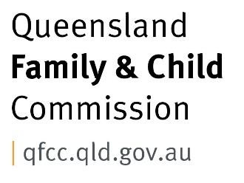

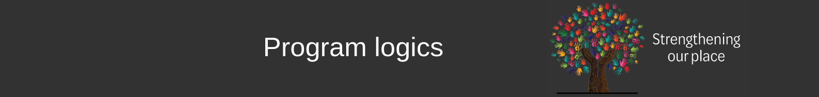

A program logic documents how you intend to contribute to outcomes. It will display in a simple format what the activities and intended outputs will be, and how they will lead to meeting your goals and achieving proposed outcomes. Program logics are like your work map!
When evaluating the third phase of Strengthening our place, the Leadership Groups in both Capricornia and Fraser Coast said that this had been one of the most useful parts of the process for them. This is because it:
- assisted in bringing everyone up to speed (especially when people came and went due to employment changes),
- was an opportunity to ensure everyone was on the same page, including what success would look like, or talk about their differences in perspective;
- built knowledge and skills in writing a program logic, which was useful for other work they were doing, and;
- helped avoid the risk of “magic leaps” (thinking we can “magically” get to an intended outcome by doing activities that do not really feed that intended outcome – a common problem!)

The process
Samples of the program logics written with both Fraser Coast and Capricornia Leader Groups are provided below. These were started in a meeting running approximately three hours, with under ten people. They were then refined and operationalised in further meetings. There are many web-based resources to support the development of a program logic, and you can find further information in the QCOSS Place-Based Approach.
Some of the questions that will support you to develop a program logic include:
- What do we want to achieve and who is contributing to this aim?
- Why do we need to change?
- How are we going to do it?
- What will we do?
- What is the outcome we will reach in the end?

Learnings from developing program logics
- The development of the program logic in each community was very useful for both clarity and focus, but it also assisted the Leadership Groups to communicate their goals to those who were contributing resources, or to those who were new to the group
- Given the long-term nature of place-based work, the outcomes you seek could be years away. In hindsight, our program logics could have included both short, medium and long-term goals. Feeling like there was lots of time between getting any runs on the board was a common reflection amongst the Leadership Groups, and perhaps having shorter term outcomes would have assisted in making visible the progress towards the long-term goal.
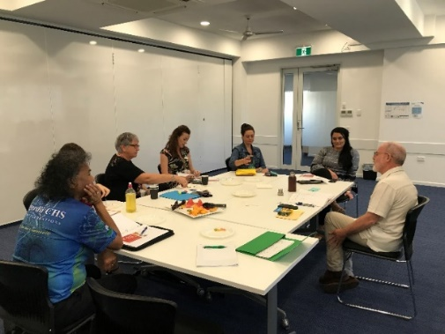
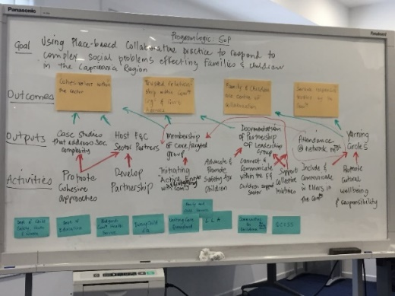
- It can be difficult to find the balance between tweaking and refining a program logic, and letting the vision become railroaded by new perspectives (for example, by a new member of the group with different ideas). Depending on the terms of reference that a group has, the role of finding this balance will lie within the group, or with whoever has committed to facilitating. This is part of why the process of developing a program logic is so important - those contributing become clear about why they are doing what they are doing and become better at articulating this to others.
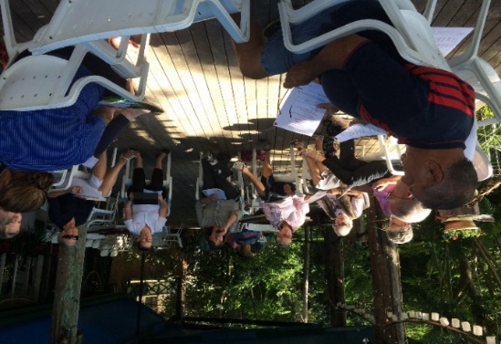
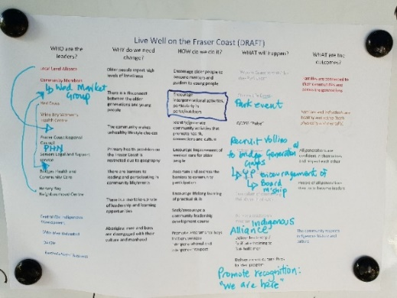

Fraser Coast Leadership Group's white board planning
Fraser Coast Leadership Group at a planning meeting
Capricornia Leadership Group sitting in circle planning
Capricornia Leadership Group's white board planning

Fraser Coast program logic
WHO are the leaders? |  | WHY do we need change? |  | HOW do we do it? |  | WHAT will happen? |  | WHAT are the outcomes?
Community Members  Neighbourhood Centre  Women’s Health Centre  Local Level Alliance  Local Government  Primary Health Network  Seniors Support Service  Community Service Provider  Health Care Provider  Indigenous Community Service Provider  Seniors Group  Department of Aboriginal and Torres Strait Islander Partnerships  Aboriginal Elders Group |  | Older people report high levels of loneliness  There is a disconnect between the older generations and young people  There are barriers to leading and participating in community life/events  There is a low take-up rate of leadership and collaboration opportunities  Aboriginal men and boys are disengaged with their culture and manhood |  | Encourage intergenerational activities, particularly in parks/outdoors  Identify/generate community activities that promote health, connections and culture  Ascertain and address the barriers to community participation  Encourage Young People to apply for Board membership  Seek/encourage a community leadership development course  Promote programs for boys that encourages intergenerational and inter-gender respect |  | Park Events  QCOSS delivery of “Pulse” engagement  QCOSS delivery of “Changing Lives, Changing Communities” Forum  Promotion of the “We Are Here” campaign  Forming of an Indigenous Alliance (of service providers)  Delivery of leadership / facilitator training to Butchulla men  Delivery of a cross cultural Boys to Men program |  | Families are connected to their communities and across the generations  Families and individuals are healthy and active (both physically and mentally)  All generations are confident in themselves and respect each other  People of all generations step up to become leaders  The community respects Indigenous history and culture

Capricornia program logic
Goal | Using Place-based collaborative practice to respond to complex social problems effecting families and children in the Capricornia Region
Outcomes | Cohesiveness within the sector |  |  |  | Trusted relationships within community organisations and government agencies |  |  |  |  |  | Families and children are centre of collaboration |  |  |  |  | Service responses are trusted by the community
Outputs | Case studies that address social complexity |  |  | Host Family & Children support sector partners |  |  | Network meeting attendance |  |  | Membership of core/targeted group |  |  |  | Documentation of the Leadership Group partnership |  |  | Spaces that honour Aboriginal and Torres Strait Islander wisdom and contribution (case study)
Activities | Promote cohesive approaches | Develop partnerships |  |  | Initiating Active (and listening) engagement with community |  |  | Advocate and promote safety for children |  |  | Connect and communicate within the Family and Children support sector |  | Support collective initiatives |  |  | Include & communicate with older people in the community |  |  | Promote cultural wellbeing and responsibility
Stakeholders | Department of Child Safety, Youth and Women |  | Department of Education |  |  | Aboriginal Health Service |  |  | Collective Impact Organisation |  |  | Community Service Provider |  |  | Child and Family Support Service |  |  | QCOSS

