Features of place-based approaches
Defining a place-based approach can be challenging because in one sense, any work that occurs in place could be described as ‘place-based’. However, there are several features that QCOSS believes are critical components of a place-based approach, namely:
- agreed place
- shared vision and commitment to outcomes
- working together
- community engagement
- local collaborative governance
- a cycle of integrated learnings
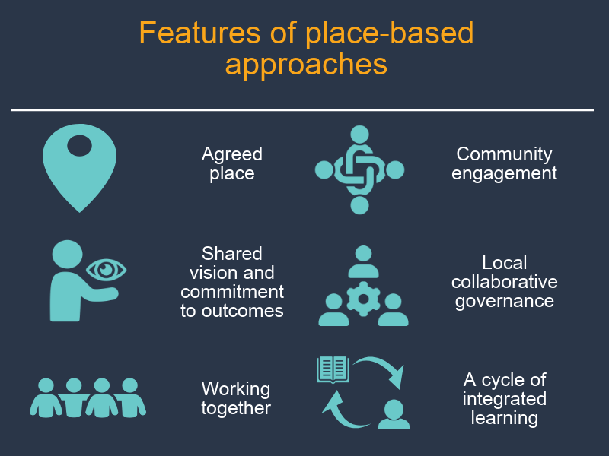

Agreed place
The first feature of a place-based approach is that a sense of place is embedded in the work and shared amongst participants. Place-based work, and place-based approaches in particular, are inherently spatially and geographically bound and embed localism in the ways of working and governing.
Place is more than just the physical or geographical forms of an area. Tuan (1977) argued that places were essentially "centres of meaning constructed out of lived experience". People are attached to place; build memories and identities in place; and are shaped and affected by the natural and built environment around them. In the Australian context, understandings of the importance of place are strongly influenced by Aboriginal and Torres Strait Islander knowledge around connection to ‘country’, the interdependence and reciprocal relationship between the land and the people. This is reinforced by the isolation of, and distance between, many communities in Australia.

Recent reflections on place have shifted to thinking not just about place, but community-in-place. This perspective acknowledges that within place there may be multiple experiences of place and multiple communities within place, rather than one cohesive place-based community. Generally, place-based approaches focus on localised areas, rather than large regions or entire states.
Defining and agreeing upon place can be less straightforward than it looks. Some understandings of place are influenced by government boundaries or defined regions, while local perspectives may differ about where actual suburban or regional identities begin and end. In many instances it may not be necessary to be as proscriptive as to draw lines on a map, but to explore and build shared understandings of a generalised and shared understanding of community in place. The decision to work in place, and the decisions and criteria that define the boundaries of place, should be clear and transparent.
Key features: Place-based approaches have…
… a focus on place and community-in-place

Link: Connection to country https://www.commonground.org.au/learn/connection-to-country
Link: Project for Public Spaces, “What is Placemaking”: https://www.pps.org/article/what-is-placemaking

Shared vision and commitment to outcomes
Place-based approaches involve bringing key stakeholders and community members together to establish a collective vision for the future, and to commit to changing to achieve that vision. It also involves creating accountability through committing to shared outcomes or impacts. This requires a shared understanding about the systemic causes of social issues, and agreement around the need for change and the future direction needed.
Shared vision is essential to place-based approaches. Focussing on a future vision galvanises people around a central goal and sustains motivation. It builds collective efficacy and supports collaborative action by bringing disparate parties together around a superordinate goal. Place-based approaches also tend to have a long-term view of change and rely on community energy and urgency for change. The emphasis on shared purpose and collective change ensures a continued focus on improving conditions in the community and avoids fragmented efforts that may have little impact in the long run.
Shared outcomes help us to make a vision tangible. Outcomes we are working towards can include; population-level outcomes– the change people wish to see in their community; as well as process outcomes - such as changes in service delivery data, collaboration, trust, and shared governance. It can be helpful to have specific, measurable outcomes indicators – that is, some way to operationalise your outcome and measure progress towards the outcome. Some of the more complex place-based approaches track progress towards outcomes through shared measurement systems, often involving standardised ways of gathering, recording and analysing service data and reporting – although shared measurement is not necessary for a place-based approach, and can be resource intensive to establish. More on this in committing to shared outcomes.
Effecting change at the population level can be hard, and often takes a long time to achieve. It is important to have a process and designated time-points to track progress of different activities contributing to the initiative – more on this in a cycle of Integrated learnings.
Key features
Place-based approaches have…
- a shared vision for change
- a long-term view of change
- energy and urgency for change
- a collective commitment to generating change for the community
- shared outcomes
- shared understanding of the issues.
Jargon alert: A stakeholder is someone who might have an interest in how a place-based approach develops or the issues it seeks to address. In a place-based approach, stakeholders include anyone who the initiative might affect – community members, government representatives, industry and businesses, services and community groups, sporting, parent and peer support groups, and so on. Stakeholders in a community might also wear multiple hats. For example, they might be a business owner, a mother and the president of their sporting club. Everyone is a community member, first and foremost, regardless of positions they hold.

Jargon Alert: In research language, when we operationalise an outcome, we find a way of measuring something that may be hard to measure. For example, we may have a vision for everyone to feel secure in their home. We may therefore commit to achieving a specific outcome of improving housing stability in your are. We may then operationalise this into an outcomes indicator such as an increase in the number of dwellings reported as fully owned. In this way, we can measure the outcome and track progress towards the vision.

Jargon Alert: Shared measurement systems require diverse organisations to employ the same techniques for gathering, analysing and reporting data. All project members agree to measure particular activities and outcomes through standardised ways of recording services or outcomes. This can involve establishing new data collection systems such as a shared databases, and sharing data regularly or in live-time with other project members.
Link: Paper ‘Shared Measurement: The Why is Clear, the How Continues to Develop’ by Mark Cabaj (2017) https://www.tamarackcommunity.ca/library/shared-measurement-paper

Jargon Alert: Collective efficacy refers to a group or community’s belief or confidence in their own ability to succeed.

Jargon Alert: A superordinate goal is a term from psychology for goals that are big enough and compelling enough for individual parties to overlook differences and work together in pursuing them.

Jargon alert: Collective impact is a collaborative approach to addressing complex social problems in communities. According to Kania and Kramer (2011), collective impact requires stakeholders from across sectors to work together towards a common agenda and to use a shared measurement system to remain aligned. It includes stakeholders engaging in mutually reinforcing activities and engaging in continuous communication. Finally, it includes establishing a backbone support or container for change - a separate organisation or group of organisations and staff with a very specific set of skills to drive collaboration across the initiative.

Link: Article – Collective Impact by John Kania and Mark Kramer https://ssir.org/articles/entry/collective_impact

Link: Article – Collective Impact 3.0 by Liz Weaver and Mark Cabaj https://www.tamarackcommunity.ca/library/collective-impact-3.0-an-evolving-framework-for-community-change
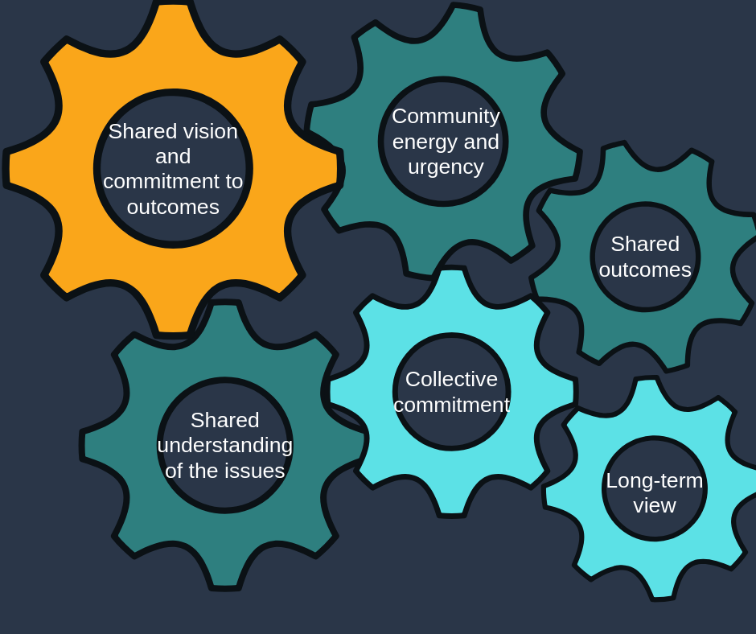
Figure 1 a diagram of how all the features of place-based approaches work together

Working together
Place-based approaches involve a commitment to working together to achieve a shared vision. By nature, place-based approaches are collaborative, bringing together skills, assets and resources across the community. They often involve community members, the community sector, industry, universities, all levels of government and different government departments all working together in new and different ways. A collaborative approach is essential to overcome fragmentation, siloing, duplication and lack of coordination in existing systems, as well as identify where new or different resources may need to be invested.
Place-based approaches go beyond networking or service integration within a sector. They involve thinking outside the box about who might not ordinarily be involved in responding to a particular social issue, but still has a role to play - for example, businesses, recreational groups, or traditionally unrelated government departments. In this way, place-based approaches require both working together and working differently.
The extent of working together will depend on the place-based approach. Across a continuum of place-based approaches [link], working together might involve increased collaboration between parties and agreeing to apply separate resources to achieve a shared vision. It might not be necessary to tightly collaborate on individual activities – people may have different ways of reaching the same goal.
At higher levels of complexity, working together is more likely to involve systemic changes, such as a highly planned approach, the sharing and pooling of resources across sectors, and reforming service systems to be more supportive and integrated across sectors. More complex place-based approaches will generally require governments to work cross-portfolio, to collaborate between different levels of government, and to work in partnership with the community and private sectors and citizens. At its highest level, it might involve changes to commissioning such as pooling of government investments across different levels of government or across government portfolios, although this high level of collaboration has not yet been trailed in Australia (see also the place-based feature of Local collaborative governance)
Key features

Place-based approaches…
- include thinking innovatively about who contributes to generating social change
- include a commitment to working together across community, governments, industry and universities.

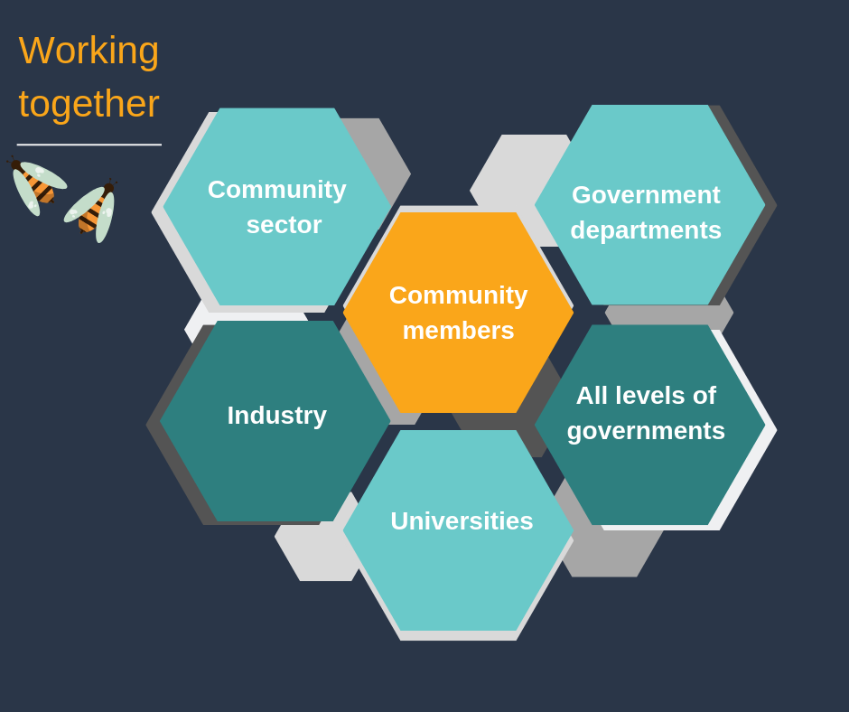
Jargon alert: Commissioning
Commissioning is a cycle through which services are planned, developed, resourced and delivered based on need, and evaluated to inform delivery.
Link: Commissioning engagement cycle https://www.england.nhs.uk/participation/resources/commissioning-engagement-cycle/
Link: Framework for Place-Based Approaches, Department of Communities, Disability Services and Seniors
https://www.communities.qld.gov.au/industry-partners/place-based-approaches

Community engagement
In our experience, genuine community engagement is a fundamental and essential feature of an effective place-based approach. Through genuine engagement of the public, systems and programs are more likely to respond to community needs and therefore be more effective. Furthermore, partnering with community members builds social inclusion, self-efficacy and civic empowerment.
Without community engagement, there is likely to be little buy-in from those working in place, or from the people the initiative is designed to support. Failing to properly engage people with a lived experience and citizens in place is also a lost opportunity to harness the assets and strengths of those most affected by policies and programs. Indeed, practitioners in collective impact approaches have reflected that a key shortcoming in past projects has been a failure to genuinely engage with intended beneficiaries of initiatives.
Finally, but most importantly, it is the right of citizens to be engaged in initiatives, policies and systems that affect them. When undertaking community engagement, QCOSS draws upon our Principles of place-based approaches [link], including engaging in the first instance with Traditional Custodians, being citizen-led, inclusive, assets based, being committed to place and aiming to do no harm.
In our experience, genuine community engagement starts early and takes a long time. Always, always longer than you think! It involves building relationships, building capacity, and leveraging off existing strengths. The level of community engagement undertaken will depend on the scope and resources of the place-based approach. It is essential to factor time and resources into your planning to enable meaningful engagement.
When undertaking community engagement, it is important to remember that community members may have wide-ranging barriers to participation and may struggle to be involved in standard, formalised processes. They may require resourcing to join in, and their level of participation is likely to vary over time. Ongoing systemic barriers can prevent participation, and understandably individuals can have limited time for long-winded processes. They will often come to systems and engagement processes with a specific issue they need solved. It is important to determine clear roles to community members to sustain their engagement and offer opportunities for community members to work on parts of the system that are important to them. We call this “going with the energy”.
It is also essential to partner with different organisations in community who may be led by community members and/or have strong relationships with the community they serve.
Key features: Place-based approaches have…
Genuine engagement with the broader community, including local people, groups and community-based organisations

Link: Putting Community in Collective Impact by Rich Harwood www.ssireview.org/blog/entry/putting_community_in_collective_impact
Link: Community Engagement Matters Now More than Ever by Paul Schmitz and Melody Barnes https://ssir.org/articles/entry/community_engagement_matters_now_more_than_ever
Link: Paper: Community engagement: A key strategy for improving outcomes for Australian families by Child Family Community Australia https://aifs.gov.au/cfca/sites/default/files/cfca39-community-engagement.pdf
Link: Article: ‘Most public engagement is worse than worthless’ by Ruben Anderson https://www.strongtowns.org/journal/most-public-engagement-is-worse-than-worthless

Local collaborative governance
Another key feature of a place-based approach is the emphasis on local decision-making, and the development of citizen-led collaborative governance mechanisms. Drawing on the principle of being citizen-led, local people take the lead in the collaborative governance of a place-based approach. An emphasis on localism invites a different kind of power - where centralised power is “impersonal, uniform, abstract, rule-oriented”, decentralised local power is “personalistic, relational, affectionate, irregular and based on a shared history of reciprocity and trust.” This requires some level of devolution of authority and responsibility to locally based and highly engaged leaders, and leadership capacity building of people in community.
Where community engagement empowers citizens to have a say, local governance ensures that regionally-based leaders and concerned community members are engaged in the actual decision-making processes. This embeds local knowledge in systems, ensuring they are tailored and responsive to the people they effect. It increases community buy-in, thereby securing a mandate for change, building a community-wide movement for change, and creating local ownership of initiatives. It builds capability, leadership and resilience in communities, restores community confidence in processes, and helps to overcome public disillusionment.
The Governance Models for Location Based Initiatives report (2011) by the Australian Social Inclusion Board recommended a community governance mechanism, comprising of representatives for diverse interests across the community. This includes citizens, not-for-profits, business (particularly major employers), all levels of government, philanthropy and special interest groups. They also recommended, “a level of devolution that allows significant and meaningful local involvement in determining issues and solutions, [and] capacity building at both local level and in government, without which greater community engagement or devolution of responsibility will be impossible.”
The Australian Social Inclusion Board also noted one of the barriers to successful place-based approaches is an inability of governments to coordinate effort across portfolios, jurisdictions, and levels of government. They recommended improved mechanisms for coordinating government efforts, such as a coordinating role across levels of government, location-based coordination teams across governments and agencies, or even co-location of different levels of government and government agencies. They also recommended devolvement of responsibility for spending and decision-making to senior public servants located in place. There is a movement in public policy towards greater local decision-making, and even major restructuring of commissioning processes (such as pooling of government investments).
In our experience, where possible, governance structures should include representatives from institutions with multiple levels of influence. Systemic change is complex, and regardless of what theme or type of issue you are hoping to address, the issues and solutions will almost always span across many parts of the system. It is useful to recognise the supporting roles and responsibilities of existing democratic decision-making structures that manage public resources and establish rules. This may include Ministers or Departmental staff, Mayors or Council delegates; and also those who are leaders in other governance and government structures, such as community and industry boards, Commissioners, and Native Title holders.
It should also include citizens with a broad a range of experiences. Public participation in decision-making and governance processes exists on a spectrum, from informing citizens or consulting them, through to collaborating with them in decision-making, or at the highest level, empowering them to make decisions themselves. A place-based approach should aim to involve as high a level of citizen participation as possible.
When involving citizens, it is important to remember the purpose of citizen involvement is not to make citizens responsible for problems they didn’t create. Instead, involvement empowers them to hold a central role in developing solutions to issues that affect them. It is also important to remember that the same barriers for participating in community engagement activities apply to inclusive governance activities.
At its simplest, place-based approaches should involve governance structures with representation from government, services and the community. At its most complex, place-based approaches might involve a Cross-sector Leadership Table with devolved responsibility to manage major localised system reform, planning for the region, pooled resources and joint commissioning.
Key features: Place-based approaches have…
Collaborative, local governance structures with multiple levels of influence and strong community representation

Jargon alert: Governance can be defined as the structures, processes and relationships that determine how a group of people organises itself and makes decisions. In a practical sense, the umbrella of governance might include the rules that need to be followed in a situation or process, and how they are enforced. These rules might include information about who make decisions about activities and resources (including money) and manages risks; and the processes they use to get input that guides their decisions – such as talking to people, calling meetings, and conducting surveys and research. Good governance ensures a place-based approach stays on track, makes it clear who is authorised to make decisions and manage risks associated with them. It also ensures those making decisions have good ways of involving relevant opinions.

Collaborative governance includes stakeholders who are representative of the beneficiaries of the work you are doing together, and is consensus based rather than managerial or authoritative. Setting up and maintaining collaborative governance in a place requires some participatory processes. QCOSS has been using and refining participatory processes for a long time and have several resources to assist this part of your practice. See Facilitate conversations in Finding shared vision for more information.

Link: Article - 'Collaborative Governance in Theory and Practice' Ansell, Chris &, Alison Gash (2008). (Ansell, 2008) https://sites.duke.edu/niou/files/2011/05/Ansell-and-Gash-Collaborative-Governance-in-Theory-and-Practice.pdf

Link: People Power: Summary Report by Locality https://locality.org.uk/wp-content/uploads/2018/03/LOCALITY-LOCALISM-REPORT-1.pdf

Film Clip: Strengthening our place Vignette - #8 - What steps could government take? https://youtu.be/HyenEc4H31E

Cycle of integrated learnings
The final feature of place-based approaches is that they involve a cycle of iterative, integrated learnings. This is underpinned by a strong focus on evidence-based practice, and a commitment to constantly reviewing the approach to ensure it is effective, flexible and adapted to the needs of place. This way of working on a place-based approach based on a body of work called Action Learning or Action Research.
Place-based approaches are used to help address the most complex and entrenched challenges for which the solutions are unknown and where current activities and services have been unable to shift the dial. In the context of the Cynefin framework, this is a place of complexity – where there are no right answers but where you can start to see patterns of success emerge through undertaking small scale projects that probe the system and are “safe to fail”. In this environment continuous monitoring and learning is critical to ensure you continue to make progress
Evaluating the effectiveness of place-based approaches is challenging because, by nature, connections between people and changes in systems are hard to measure. Resourcing can come and go, and structures and processes may change over time. It may take a long time before any major changes are visible.
Developmental evaluation is one method that can be helpful in evaluating impact where changes are needed in complex systems. It involves testing, experimenting and prototyping activities, and monitoring processes and progress right from the beginning of an intervention.
While population level outcomes are seen many years after you begin, close monitoring and continuous learning and research throughout the life of an initiative is important to ensure that the model is fully effective. There is a whole body of work emerging around seeing that a place-based approach is on course. Place-based approaches can track early and emerging trends, such as outcomes for smaller groups of people in a community, or changes in leadership, resourcing, practices, norms and policies. Those who are resourcing the work either with their effort and energy, or finances, will also want to know that the initiative is on the right track.
Data plays an important role in place-based approaches. It can help to identify and understand specific community needs and opportunities, and can unpack where experiences might be unique to smaller regions or specific groups in a community. Data can also help to measure whether and where progress is being made. It is also important to look for opportunities to understand what is happening in a community and measure changes through qualitative measures – listening for the stories of people in place.
At their simplest, this feature of place-based approaches involves taking an evidence-based approach to designing interventions, reviewing activities throughout the process and being prepared to adapt to the local environment, and evaluating outcomes at the end of an agreed time. At their most complex, place-based approaches involve ongoing monitoring, evaluation and learning, prototyping and reviewing, with agreed mechanisms to track progress and agreed measures for population-level impacts of an initiative. They may even include shared measurement of data across services.
Place-based approaches have…
… a commitment to being informed by data, research and story
… evaluation across processes, activities and long-term outcomes
… a cycle of continuous learning and points of reflection embedded throughout the practice.

Jargon Alert: Developmental evaluation is an approach that acknowledges many things can lead to social change in complex systems and calls for innovation and iteration in developing initiatives for social change. The role of the evaluation is to monitor and record the process of innovation.

Jargon Alert: Cynefin, pronounced kuh-nev-in, is a Welsh word that signifies the multiple factors in our environment and our experience that influence us in ways we can never understand. The cyefin framework is used to aid decision-making by sorting issues into five situational contexts.

Link: Cynefin Framework Introduction by Dave Snowden http://cognitive-edge.com/videos/cynefin-framework-introduction/

Link: A Developmental Evaluation Primer - Jamie A.A. Gamble: https://cdn2.hubspot.net/hubfs/316071/Resources/Publications/Developmental%20Evaluation%20Primer.pdf?t=1542902059328z
Link: Evaluating social innovation https://www.fsg.org/publications/evaluating-social-innovation#download-area
Link: Action research and action learning for community and organisational change by Bob Dick http://www.aral.com.au/
Link: Presentation - Implementing shared measurement https://www.fsg.org/tools-and-resources/implementing-shared-measurement
Link: Paper ‘Shared Measurement: The Why is Clear, the How Continues to Develop’ by Mark Cabaj (2017) https://www.tamarackcommunity.ca/library/shared-measurement-paper

p7, Hogan, Rubenstein, & Fry (2018)
Cabaj and Weaver (2016, p. 9) report that allowing independent or even competing activities can sometimes support the achievement of a common vision or aspiration. They advocate focusing on ‘high-leverage activities’ that are most likely to achieve the shared aspiration, and loose or tight working relationships as the situation requires.
Australian Department of Health (2018)
Harwood (2014)
David Brooks in The Localist Revolution (2018)
p38 (Australian Social Inclusion Board, 2011)
p31 (Australian Social Inclusion Board, 2011)
p33-34 (Australian Social Inclusion Board, 2011)
p36, (Australian Social Inclusion Board, 2011)
(Ham & Alderwick, 2015), (Queensland Productivity Commission, 2017, p. 124)
For more see the IAP2 Public Participation Spectrum (IAP2)
Australian Social Inclusion Board (2011)

